TutorTube: Cellular Respiration Spring 2021
Introduction
Hello and welcome to TutorTube, where The Learning Center’s Lead Tutors help you understand challenging course concepts with easy to understand videos. My name is Natalie Taylor, Lead Tutor for Biology and Chemistry. In today’s video, we will explore cellular respiration and the steps within the process. Let’s get started!

Learning Agenda

For today’s learning objectives, we will learn the steps within the process of cellular respiration, and we will learn the products of respiration at each step and as a whole.

What is Cellular Respiration?

Cellular Respiration is a series of metabolic reactions that take place inside cells. It is used to convert chemical energy nutrients and oxygen into ATP. ATP stands for adenosine triphosphate, and it is the main source of energy inside your cells!

The general equation for cellular respiration is shown in the bottom corner:
C₆H₁₂O₆ + 6O₂ → 6CO₂ + 6H₂O + ATP

Essentially, one glucose molecule is combined with 6 oxygen molecules to produce 6 carbon dioxide molecules, 6 water molecules, and some ATP. The amount of ATP produced can differ, but it usually ranges in about 34-38 ATP being generated overall.

Glycolysis

Glycolysis is the first step in cellular respiration, and it occurs in the cytoplasm of the cell. This process does not require oxygen but does need some ATP to occur. The step begins with one glucose molecule being broken down in a series of steps. While it uses 2 ATP to start, the process forms 4 ATP molecules (resulting in a net gain of 2). It also results in 2 NADH molecules (which are electron carriers) and 2 pyruvate molecules being formed.
As shown in the bottom left hand corner of the screen, the reactants include the glucose molecule (C₆H₁₂O₆) and 2 ATP. The products of glycolysis are 2 pyruvate molecules (C₃H₃O₃⁻), 2 NADH molecules, and a net gain of 2 ATP molecules. As seen in the image, the steps of glycolysis are split up into 3 main sections: energy investment (where the ATP is inputted), cleavage (where the glucose is split into the two pyruvates), and energy generation (where the ATP and NADH are formed.
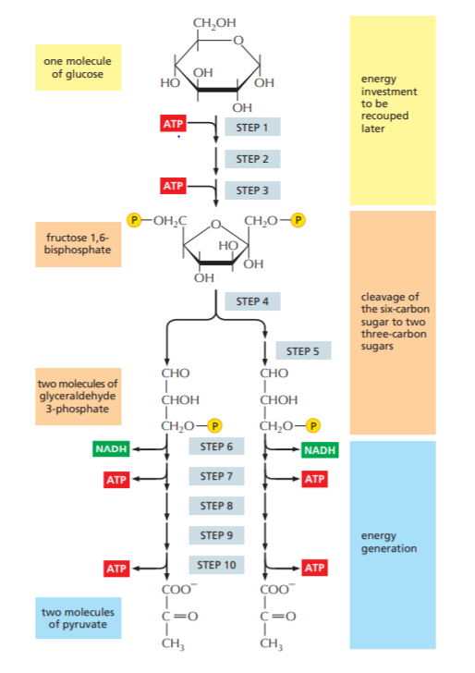
Image 1 (Johnson, Alberts, Morgan, Hopkin, Roberts, Raff, & Walter)
The Krebs Cycle

The Krebs Cycle, also referred to as the citric acid cycle is the next step of cellular respiration. The process occurs in the matrix of the mitochondria, and it does require oxygen to occur. The mitochondrial matrix is a gel-like material that is in between the inner and outer membrane of the mitochondria, and it can be seen in the image in the upper right corner. The section of the matrix is circled.
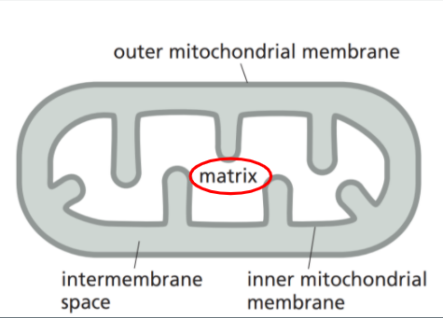
Image 2 (Johnson, Alberts, Morgan, Hopkin, Roberts, Raff, & Walter)

The Krebs Cycle is a cyclical process where the pyruvate from glycolysis is converted into Acetyl CoA. Through the cycle, a majority of the electron carriers needed for the final step of respiration are created. From one pyruvate molecule, it forms one acetyl CoA, 1 GTP (an energy source similar to ATP), 3 NADH molecules, 1 FADH molecule, and 2 CO₂ molecules. Keep in mind that 2 pyruvates are produced from glycolysis, so from the starting glucose, two pyruvates would undergo the citric acid cycle - thus doubling the products. As seen in the image of the citric acid cycle, the pyruvate is converted to acetyl CoA, which is followed by many steps that form the electron carriers.
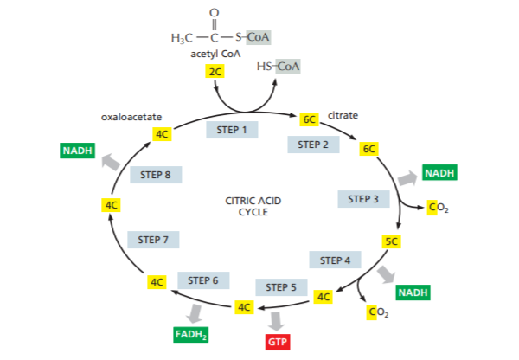
Image 3 (Johnson, Alberts, Morgan, Hopkin, Roberts, Raff, & Walter)

The Electron Transport Chain

The Electron Transport Chain is the final step of respiration, and it occurs in the inner mitochondrial membrane. As seen in the image in the upper right corner, it is inner lining of the membrane that encases the matrix.
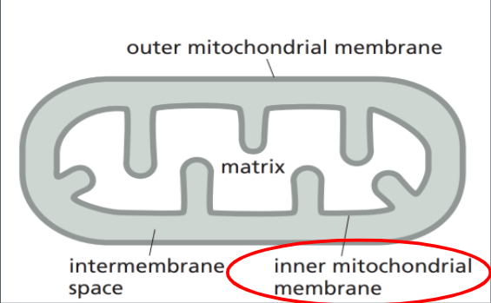

Image 4 (Johnson, Alberts, Morgan, Hopkin, Roberts, Raff, & Walter)

This process does require oxygen as it serves as the final electron acceptor. During this step, the electron carriers that were produced previously (NADH and FADH) transfer their electrons to a protein complex along the inner membrane. The electrons are moved along the membrane by these carrier proteins, and this creates a proton gradient (basically, a big clump of H⁺ molecules). These hydrogen molecules from the protein gradient are then used to power ATP synthase - which is an enzyme that forms ATP from ADP (essentially adding the third phosphate group). Oxygen acts as the final electron acceptor at the end of the chain, resulting in the formation of water. The electron transport chain creates a majority of the ATP from cellular respiration, usually averaging a production of 34 to 38 ATP molecules in this step. This image shows the electron transport chain in action. Notice how the electron carriers from the citric acid cycle are going straight into the electron transport chain to donate those electrons! The carrier proteins pump the hydrogens across the membrane to be used by the ATP synthase enzyme shown. Also, notice how at the end of the protein chain, oxygen acts as the final electron acceptor to form water!
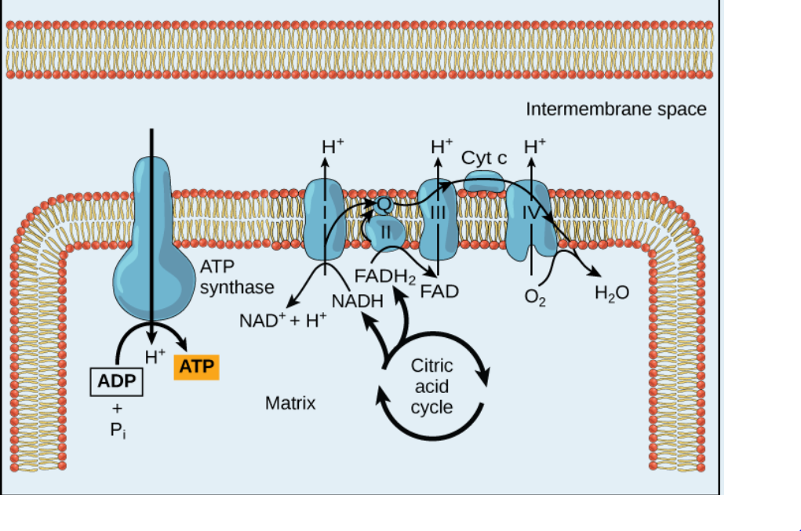
Image 5 (Johnson, Alberts, Morgan, Hopkin, Roberts, Raff, & Walter)

This next image is a little less detailed, but it still shows the electron transport chain at work. The electrons are moving through the chain to pump the hydrogen molecules into the intermembrane space (in between the inner and outer membrane) Then, that H+ is used to power ATP synthase.
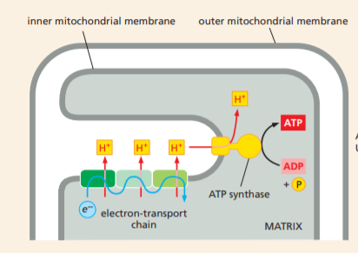
Image 6 (Johnson, Alberts, Morgan, Hopkin, Roberts, Raff, & Walter)

Summary

In summary, cellular respiration is a metabolic pathway used for the creation of energy in AEROBIC cells. They have to be able to take in oxygen because oxygen is needed in two of the three steps! There are three major steps in respiration. First, glycolysis must break down glucose. It requires some ATP to start, and it occurs in the cytoplasm. The Krebs Cycle converts pyruvate into Acetyl CoA, produces a majority of the electron carrier molecules, requires oxygen, and occurs in the mitochondrial matrix. Finally, the electron transport chain uses the electron carrier proteins to pump protons into a gradient to be used for ATP Synthase to function. This step requires oxygen and produces a majority of the ATP in cellular respiration. The final products of the entire process are carbon dioxide, water, and ATP.
Outro
Thank you for watching TutorTube! I hope you enjoyed this video. Please subscribe to our channel for more exciting videos. Check out the links in the description below for more information about The Learning Center and follow us on social media. See you next time!
References
Johnson, A, Alberts, B, Morgan, D, Hopkin, K, Roberts, K, Raff, M, & Walter, P (2019). Essential Cell Biology. W.W. Norton & Com

