TutorTube: DNA Replication Fall 2020
Introduction
Hello and welcome to TutorTube, where The Learning Center’s Lead Tutors help you understand challenging course concepts with easy-to-understand videos. My name is Ethan, Lead Tutor for biology and chemistry. In today’s video, we will explore DNA Replication. Let’s get started!

Purpose
We’ll start with the purpose of DNA replication, and then go through how replication is done in prokaryotes.
The main reason DNA needs to be replicated is because cells do not live forever. All living organisms are made of cells that contain the same DNA that tells the cell what, how, and when to do things. Cells are the unit of life. As with all living things, they degrade over time. When new cells need to be produced, the DNA of the original cell must be replicated to pass on its own DNA. The two mechanisms of cell replication are mitosis and meiosis shown in figure 1. For these processes to yield functional cells with an entire genome, the DNA must be replicated before cell division.
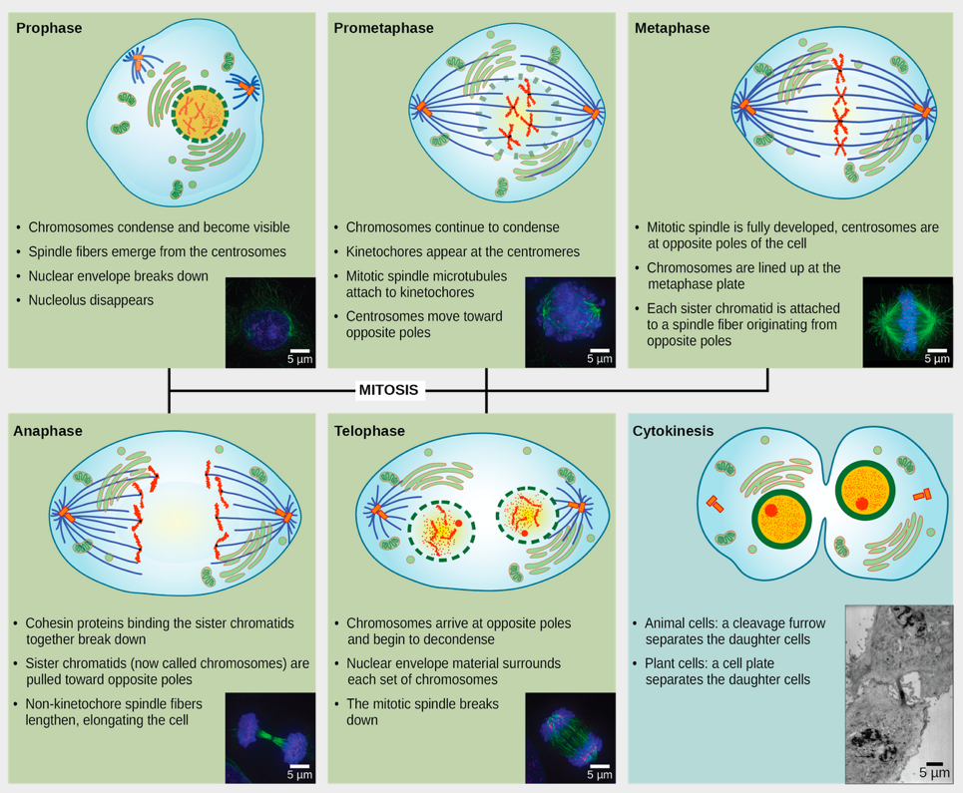
Figure 1
Here’s a picture of a typical cell life cycle. Cells spend most of their time in interphase, which includes G₁, S, and G₂ phases. The G phases are growth phases. The S phase is where DNA replication takes place. Following interphase is either mitosis or meiosis, both of which divide the cell. Our focus is on what takes place in the S phase to allow DNA to replicate.
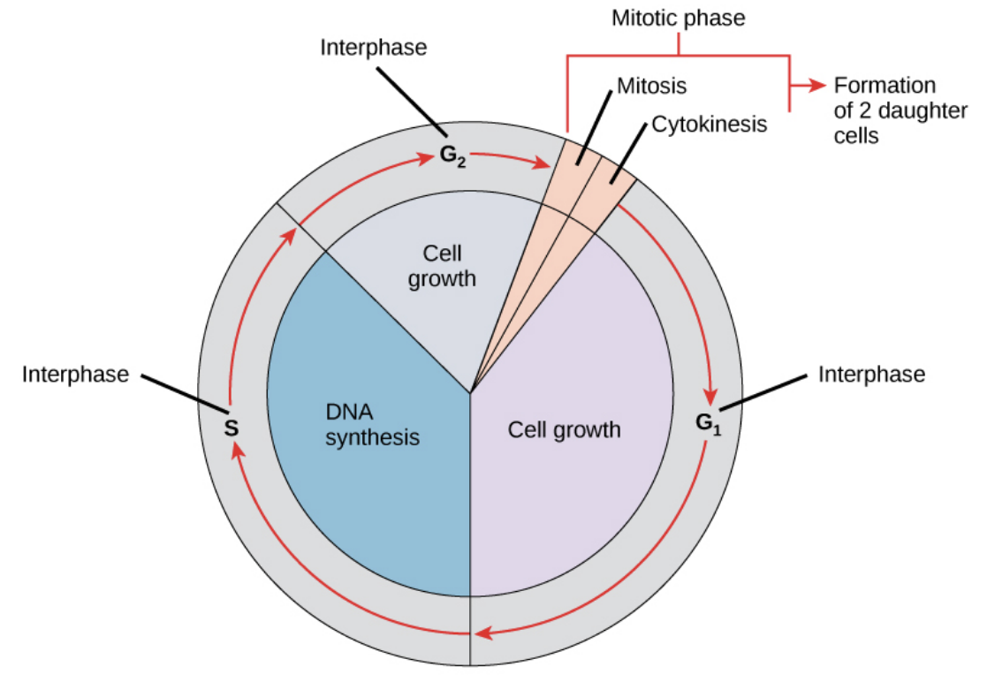
Figure 2

DNA Replication: Prokaryotes
Now that we know the purpose of replicating DNA, we need to know how it’s done. First, let’s talk about the structural elements of DNA that need to be adjusted for replication. Normally, DNA is a double-stranded, right-handed helix. Each strand has directionality including a 5’ end and a 3’ end. The strands are anti-parallel to one another, meaning that they are aligned parallel but in opposite directions. One strand’s 5’ end will line up with the other strands 3’ end and vice versa.
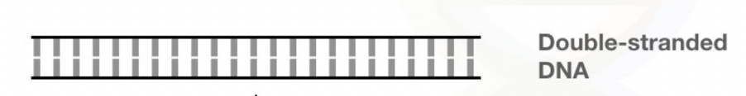
Figure 3

DNA replication is carried out by enzymes. For the enzymes to have access to the DNA, it needs to be unwound. This is the first step in replication. Additionally, replication will always start at the same spot called the origin of replication.
Here you can see the directionality of DNA. Notice how each strand has only two nucleotides as well as a 5’ and 3’ end. The 5’ end has a phosphate group while the 3’ end has a hydroxyl group. The force that holds the two strands together are hydrogen bonds between bases from each strand.
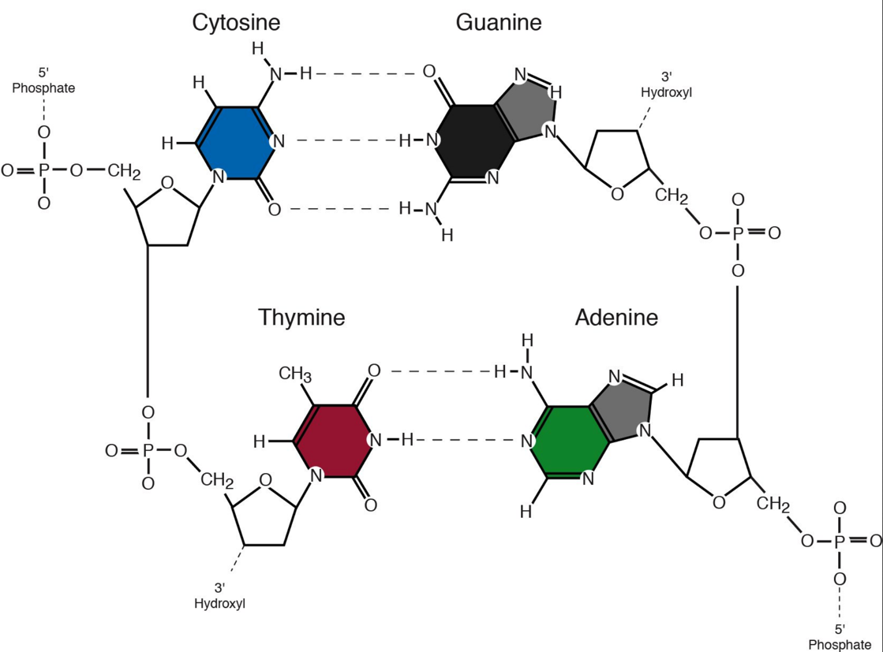
Figure 4
Now, let’s go through the general steps that need to happen for DNA to be replicated. First, the DNA must be unwound. Second, small RNA molecules called primers must bind. Third, the DNA is extended from those primers resulting in a DNA strand complementary to its template. Since both strands are used for replication, we will end up with an exact copy of the original double strand of DNA. Be sure to notice that each resulting strand is half template DNA and half newly synthesized DNA. We call this form of replication semi-conservative because half of the new strands are the old strands. Those are the dashed lines between the bases.
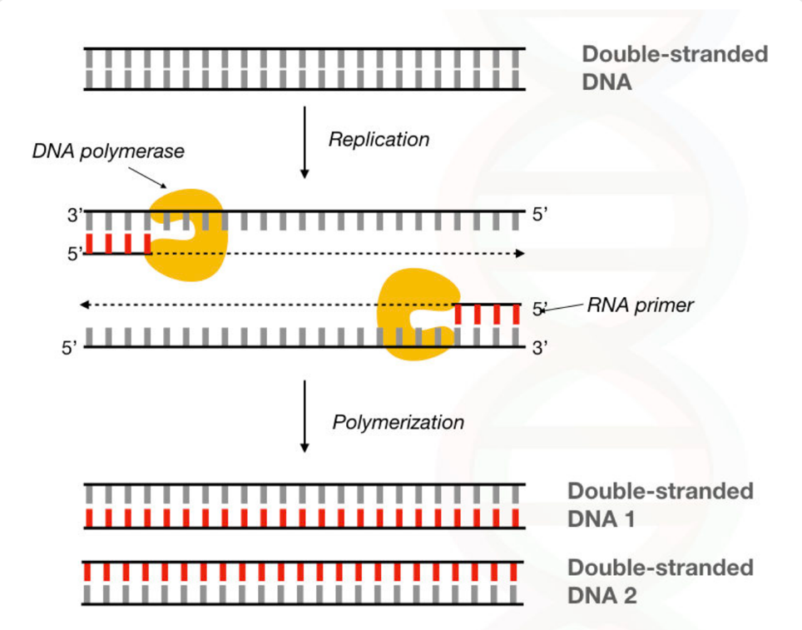
Figure 5
Here is the process of DNA replication as it happens all at once. We’ll go through the steps within this diagram one by one. As stated previously, the first step is to unwind the double-helix of DNA. This is done by an enzyme called helicase. Most of the time, when you see a biology term that ends in -ase, it is an enzyme. Helicase works by breaking the hydrogen bonds between the two DNA strands.
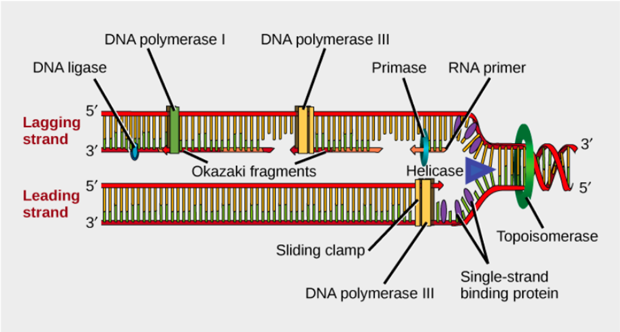
Figure 6
The next enzyme that acts is primase. Primase puts down an RNA primer at the beginning of the origin of replication. This is necessary because the next enzyme that actually extends and replicates the DNA is DNA polymerase III, and DNA polymerase III can only replicate the DNA with an existing primer. DNA polymerase III, shown here, depends on the hydroxyl group found on the primer to start replication. DNA polymerase III can also only replicate in the 5’ to 3’ direction on the growing DNA strand.
Another important enzyme is topoisomerase. Topoisomerase relieves supercoiling of the DNA. As the DNA is unwound by helicase, the ends of it will begin to coil tighter and tighter. This tension is relieved by topoisomerase by placing a cut and reattaching the DNA together.
Next, is DNA polymerase I. This is a different enzyme than DNA polymerase III. DNA polymerase I removes the RNA primer that was initially laid down to start replication and replaces it with DNA.
One other important enzyme is called single-stranded binding protein that prevents the two template DNA strands from binding back together and preventing replication.
Finally, the last step is to ligate the newly synthesized strand together. When DNA polymerase I replaces the RNA primer with DNA, it doesn’t connect that DNA to the adjacent DNA. This job is done by DNA ligase.
The last thing we need to cover is how DNA replication looks on a larger scale. Since DNA polymerase III can only replicate the DNA from 5’ to 3’, there is a leading and lagging strand that results on each strand being synthesized. The leading stranding is synthesized in the same direction as the direction that the DNA is being opened up further and further. The lagging strand is synthesized in the opposite direction, so it must set down a new primer each time more of the DNA becomes available as it is unwound by helicase. This means the leading strand will have only one primer, while the lagging strand will have multiple primers. These fragments of new DNA that form on the lagging strands are called okazaki fragments.
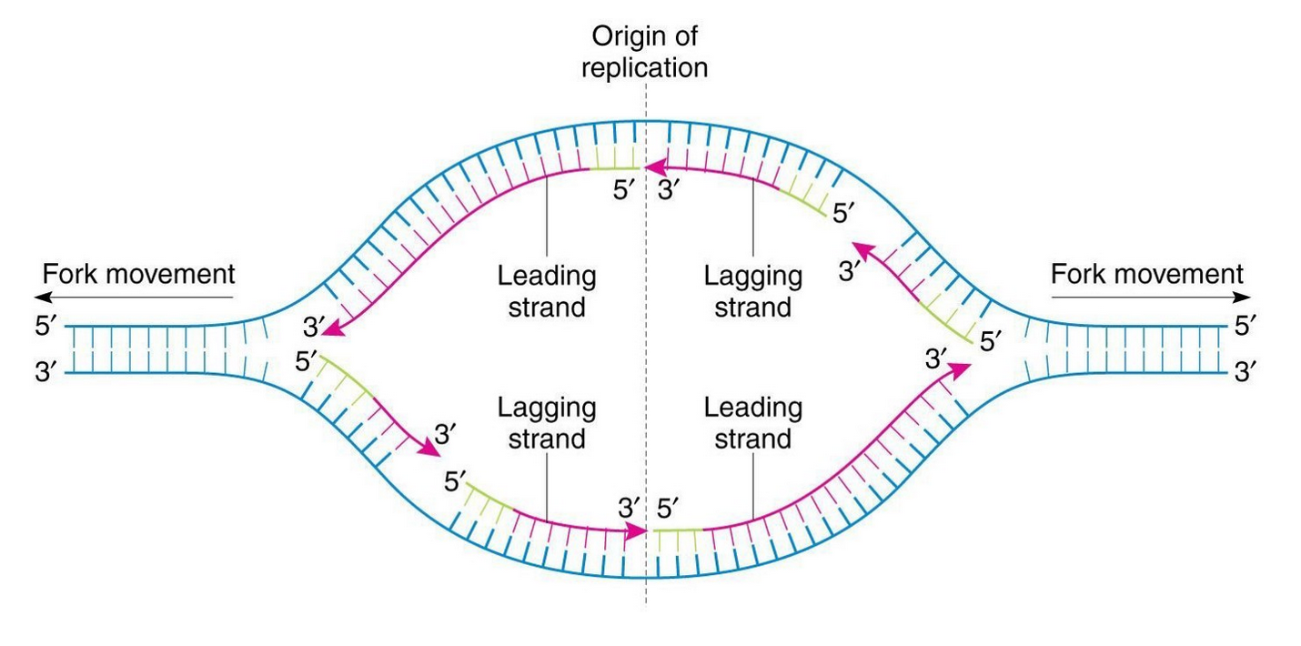
Figure 7
Be sure to notice that the whole reason we have a leading and lagging strand is because the DNA is only being replicated in the 5’ to 3’ direction. All replication events will have this same structure where the two leading strands are on opposite corners of the replication bubble and the two lagging strands are on opposite corners of the replication bubble.

Outro
Thank you for watching TutorTube! I hope you enjoyed this video. Please subscribe to our channel for more exciting videos. Check out the links in the description below for more information about The Learning Center and follow us on social media. See you next time!

References
Figure 1: 10.2 The Cell Cycle—Biology 2e | OpenStax. (n.d.-a). Retrieved November 12, 2020, from https://openstax.org/books/biology-2e/pages/10-2-the-cell-cycle
Figure 2: 10.2 The Cell Cycle—Biology 2e | OpenStax. (n.d.-a). Retrieved November 12, 2020, from https://openstax.org/books/biology-2e/pages/10-2-the-cell-cycle
Figure 3: Comparison Between: DNA Polymerase Vs RNA Polymerase. (2019, October 21). Genetic Education. https://geneticeducation.co.in/comparison-between-dna-polymerase-vs-rna-polymerase/
Figure 4: Structure and Function of DNA | Microbiology. (n.d.). Retrieved November 13, 2020, from https://courses.lumenlearning.com/microbiology/chapter/structure-and-function-of-dna/
Figure 5: Comparison Between: DNA Polymerase Vs RNA Polymerase. (2019, October 21). Genetic Education. https://geneticeducation.co.in/comparison-between-dna-polymerase-vs-rna-polymerase/
Figure 6: 14.4 DNA Replication in Prokaryotes—Biology 2e | OpenStax. (n.d.). Retrieved November 12, 2020, from https://openstax.org/books/biology-2e/pages/14-4-dna-replication-in-prokaryotes
Figure 7: Notes, B. E. (2019, July 13). DNA REPLICATION. Medium. https://medium.com/@biologynotes/dna-replication-302203b5c3d8

