TutorTube: Ear Anatomy and Physiology Fall 2020
Introduction
Hello and welcome to TutorTube, where The Learning Center’s Lead Tutors help you understand challenging course concepts with easy to understand videos. My name is Grace Lead Tutor for Audiology and Speech-Language Pathology In today’s video, we will explore Ear Anatomy and Physiology. Let’s get started!
Auditory Pathways
The peripheral auditory pathway consists of the outer, middle and inner ear as well as the 8th cranial nerve. The 8th cranial nerve, called the vestibulocochlear nerve, is responsible for maintaining body balance and hearing. The central auditory pathway consists of the brainstem and brain.
Sections
You can see the three basic sections of the ear in figure 1. We have the outer ear that includes the pinna and the external auditory meatus. The middle ear that consists of the tympanic membrane, ossicles, and eustachian tube. The inner ear consists of cochlea, vestibule, and semicircular canals. Let’s look into these sections further.
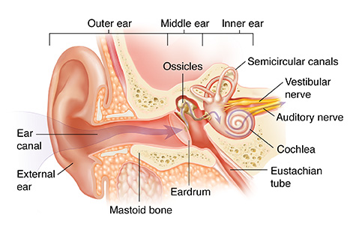
Figure 1 (“Anatomy of the Ear”)

Outer Ear
The pinna (AKA the auricle) is made up of cartilage, collects sound, and helps localize sound. We can see an example of the pinna in figure 2. Let’s go through and label parts of the pinna. Here we have the helix, scapha, antihelical fold, antihelix, antitragus, lobule, tragus, entrance to external auditory meatus, concha, and fossa.
The external auditory meatus (or ear canal) connects the outer ear to the middle ear and funnels the sound to the eardrum. This can be seen in figure 3 labeled by the red arrow.
The function of the outer ear is to collect sound.
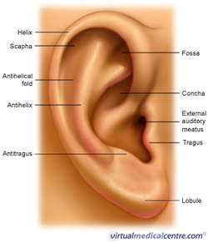
Figure 2 (“Ear”)
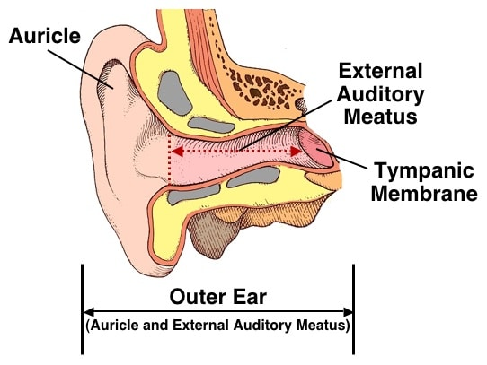
Figure 3 (Stabb, Wayne)
Middle Ear
The tympanic membrane (or eardrum) is the barrier between the outer and middle ear. When sound travels from pinna to the external auditory meatus the sound waves make the tympanic membrane vibrate, which then moves the ossicles. The ossicles are the 3 bones of the middle ear and they are: malleus, incus, and stapes. These provide a way for energy to travel from the tympanic membrane to the inner ear. You can see the eardrum and the ossicles in figure 4.
The eustachian tube is connected to the middle ear cavity and helps maintain equilibrium between atmospheric pressure and middle ear pressure. The eustachian tube is labeled as the auditory tube in figure 4.
The function of the middle ear is impedance matching. This means the middle ear increases pressure arriving at the cochlea in order to overcome the resistance to the flow of sound energy.
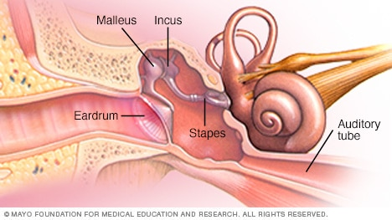
Figure 4 (“Slide Show”)
Inner Ear
The cochlea is a snail shell-like shape that holds three fluid-filled chambers. The scala vestibuli (which contains perilymph fluid), the scala media (which contains endolymph fluid), and the scala tympani (which contains perilymph fluid). The cochlea can be seen in figure 5 and the inside of the cochlea in figure 6.
The vestibule is an egg shaped cavity that holds the round window (which helps the middle ear communicate with the scala tympani) and the oval window (which helps the middle ear communicate with the scala vestibuli).
The semicircular canals are fluid-filled tubes that sense your head’s orientation which helps you to keep balance and coordination.
The function of the inner ear is to change the signal to neural impulses to be interpreted by the brain.
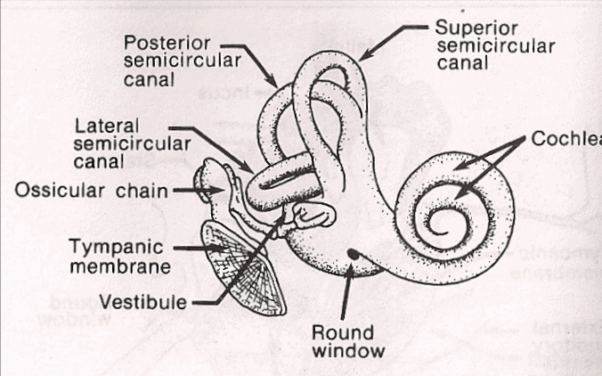
Figure 5 (“The Inner Ear”)
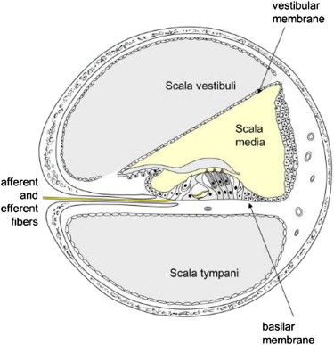
Figure 6 (“Spiral Lamina”)
Hearing Process
- Outer ear collects sound
- Middle ear matches the acoustic signal with fluid within cochlea
- Inner ear performs analysis on signal
- Auditory pathway transports and further processes signal
- Cerebral Cortex interprets signal
Outro
Thank you for watching TutorTube! I hope you enjoyed this video. Please subscribe to our channel for more exciting videos. Check out the links in the description below for more information about The Learning Center and follow us on social media. See you next time!
References
Figure 1: “Anatomy of the Ear.” Saint Luke's Health System, www.saintlukeskc.org/health-library/anatomy-ear.
Figure 2: “Ear.” BIOLOGY4ISC, biology4isc.weebly.com/ear.html.
Figure 3: Staab, Wayne. “The Human Ear Canal - I: Wayne Staab, PhD Hearinghealthmatters.org/Waynesworld/.” Wayne's World, 10 June 2014, hearinghealthmatters.org/waynesworld/2014/human-ear-canal/.
Figure 4: “Slide Show: How You Hear.” Mayo Clinic, Mayo Foundation for Medical Education and Research, 26 Mar. 2020, www.mayoclinic.org/diseases-conditions/hearing-loss/multimedia/ear-infections/sls-20077144?s=3.
Figure 5: “The Inner Ear.” The Inner Ear (Cochlea) Is Where Transduction Takes Place., www.csun.edu/~vcoao0el/webct/de361s81_folder/tsld003.html.
Figure 6: “Spiral Lamina.” Spiral Lamina - an Overview | ScienceDirect Topics, www.sciencedirect.com/topics/medicine-and-dentistry/spiral-lamina.

