Table of Contents
Understanding Academic Coaching………………………………………………...……3
Academic Coaching Worksheet………………………………………………………...…3
Motivation & Goal Setting
SMART Goals…………………………………………………………………………..……4
EAGLE Approach …………………………………………………………………..……..5
Motivation Flow Chart………………………………………………………………...…..6
Time Management
Prioritization………………………………………………………………………………....7
Organizing Time…………………………………………………………………………….8
Hourly Schedule Template……………………………………………………………….9
The Curve of Forgetting…………………………………………………………...…….10
The Study Cycle……………………………………………………………………..……11
Focused Study Sessions…………………………………………………………..….…..11
Note Taking & Learning Strategies
What to Write and How to Write It………………………………………………..…..12
Digital Notes……………………………………………………………………………….12
Exploring Note Taking Methods…………………………………………………….....13
Effective Reading Skills……………………………………………………………..……15
Succeeding in Online Classes……………………………………………………..…..16
Learning Styles………………………………………………………………………...…..17
Memory Strategies………………………………………………………………...……..19
Test Taking
Test Taking Tips………………………………………………………………………..…..20
Using Your Test Results for the Future……………………………………………..…..20
Managing Test Anxiety……………………………………………………………...…..21
Self-Care
Sleep Matters…………………………………………………………………………..….22
Self-Care Tips from the Academic Coaches…………………………...………..…23
University Policy
Satisfactory Academic Progress………………………………………………………24

Understanding Academic Coaching
This is a collaborative process to assist you in developing a personalized plan for meeting your academic goals. Topics are determined by learners and their coaches to customize an action plan that meets your needs, but common topics include developing a time management strategy, studying more effectively, and finding motivation.
Academic Coaching IS… | Academic Coaching is NOT…
Collaboration to set academic goals and creating a plan to achieve them | Counseling
Sharing success tips and strategies and referring the student to helpful resources | Academic advising
Advocating for student’s success | Career-specific advising
Generalized academic support | Tutoring

Academic Coaching Worksheet
Barriers to success:
SMART Goal:

Resources:

Self-Care Priorities:
Action Plan:
1.
2.
3.
SMART Goals
Specific | - Can you articulate more clearly what you are trying to do?  - Can you summarize this in one thought?  - Refine that thought. Can you summarize a bottom line?
Measurable | - How will you know that you attained your goal?  - Can you quantify or put numbers on your outcome?  - What effect will your goal have on your life/effectiveness?
Achievable | - Is this goal dependent on someone else?  - Are there any things that would prevent you from accomplishing your goal?  - Do you have defined steps to take to achieve this goal?
Relevant | - What would you like to do?  - What things would you like to change most?  - Is there anything else important that you have not shared?
Timely | - When will you reach this goal?  - Can you give me a time limit?  - How long would it take to create a sustainable habit?
Goal:
S
M
A
R
T
The EAGLE Approach
Don’t know what to do next? Use these steps to make your education a priority!
Explore
What do you understand or don’t understand?
Is anything confusing or causing problems?

Analyze
What do you want to learn?
What could be preventing you from succeeding?

Evaluate
Is there anything you still don’t understand?
What approaches worked or didn’t work?

Lead
Is there a new approach you can take to understand the topic better?

Guide
What materials and resources do you have?
How might they help you?

This system was developed by a successful coaching student, Jonathan Stewart, with the assistance of his Academic Coach, Kyle Pearson in 2019.
Find more copies of the EAGLE Approach worksheet at learningcenter.unt.edu/onlineresources.

Creating a Motivation Flow-Chart
Make sure to reference the SMART goal system so you can have the best possible outcome!

- Map out your goals:
- Level 1: Think of the ultimate, long-term goal for your college career, like getting the ideal job after graduation, graduating early, on time, or at all.
- Level 2: Identify specific objectives to help you get there, like earning a specific number of hours or GPA, learning better study skills, etc.
- Level 3: Finally, create short-term goals that need to be completed in order to accomplish your Level 2 objectives These goals are fairly easy and you should be able to start working toward these objectives immediately, like attending SI sessions, passing a final exam, etc.
- Customize your flow-chart to suit your motivational needs. You can create multiple charts for different long-term goals, add more levels to further break down your goals, or give it a fun design!
- Display your flow-chart in a creative and effective way to remind yourself of your goals. Analyze your daily habits and put your flow-chart where you will see it every day. Examples: refrigerator door, bathroom mirror, phone lock screen, desktop screensaver, etc.
Example

Prioritization
“The key is not to prioritize what’s on your schedule, but to schedule your priorities” – Stephen Covey

Identify your Priorities:
- Think about your week. What are all of the things you need to do? This includes self-care activities!
- What are all of the things you want to do?
- What are all of the things you typically do that aren’t yet on the list?
Then, determine the ones with the most pressing deadlines or greatest potential impact on your wellbeing and get started.

Needs Wants

Identify Your Rewards

Organizing Your Time

Using a Planner or To Do List
There are a ton of different kinds of planners and to do lists—many of which you’ve likely already used and some that will be totally new to you. Check-out some options on the Learning Center website and test out the most popular planner template we have on the next page. To set-up an effective planner or to do list, you need to follow these steps:
- Identify everything you need and want to do, like going to class, working out, meeting up with friends, watching TV, working, and studying.
- For a planner, write down any deadlines or major events as soon as you know about them. Many students like to do one big pass at the beginning of the semester so they know what’s coming.
- Then break-up large scale projects over several days and determine when you’ll do each part. For a planner, you may want to assign an amount of time to spend or specifically schedule time blocks.
- Make sure to include activities for self-care and rewarding your progress.
This is a very popular option sold by Amazon.
Google Calendar
A ton of students prefer more digital means to remember everything they have going on, and Google Calendar allows you to easily keep track of any schedule you may have and while providing opportunity for customization.
Great things about the Google Calendar:
- You can compile everything into one calendar or choose to keep different parts of your life separate while still maintaining easy access.
- You can easily share your availability with others when trying to schedule something and invite people to events as a reminder.
- You can add attachments to calendar events—a bonus for group work!
- Import your Canvas calendar and set custom notifications.
An Academic Coach can help you create this calendar and strategize!

Regular Priorities for the Week | Est. Time | Time | Monday | Tuesday | Wednesday | Thursday | Friday | Saturday | Sunday
 |  | 7am
 |  | 8am
 |  | 9am
 |  | 10am
 |  | 11am
 |  | 12pm
 |  | 1pm
Special Priorities for the Week  (Birthdays, one-time events, etc) |  | 2pm
 |  | 3pm
 |  | 4pm
 |  | 5pm
 |  | 6pm
 |  | 7pm
 |  | 8pm
 |  | 9pm
 |  | 10pm
Like this schedule option? Print free copies from the Online Resources section of the LC website or get copies from an Academic Coach at your next session. |  | 11pm
 | Total Time | To Do List

The Curve of Forgetting

No matter how hard we work, the amount of time and frequency we spend studying will always impact our retention of the information. Spaced learning is the key to success! Don’t believe us? Check-out this study from the University of Waterloo (2005).
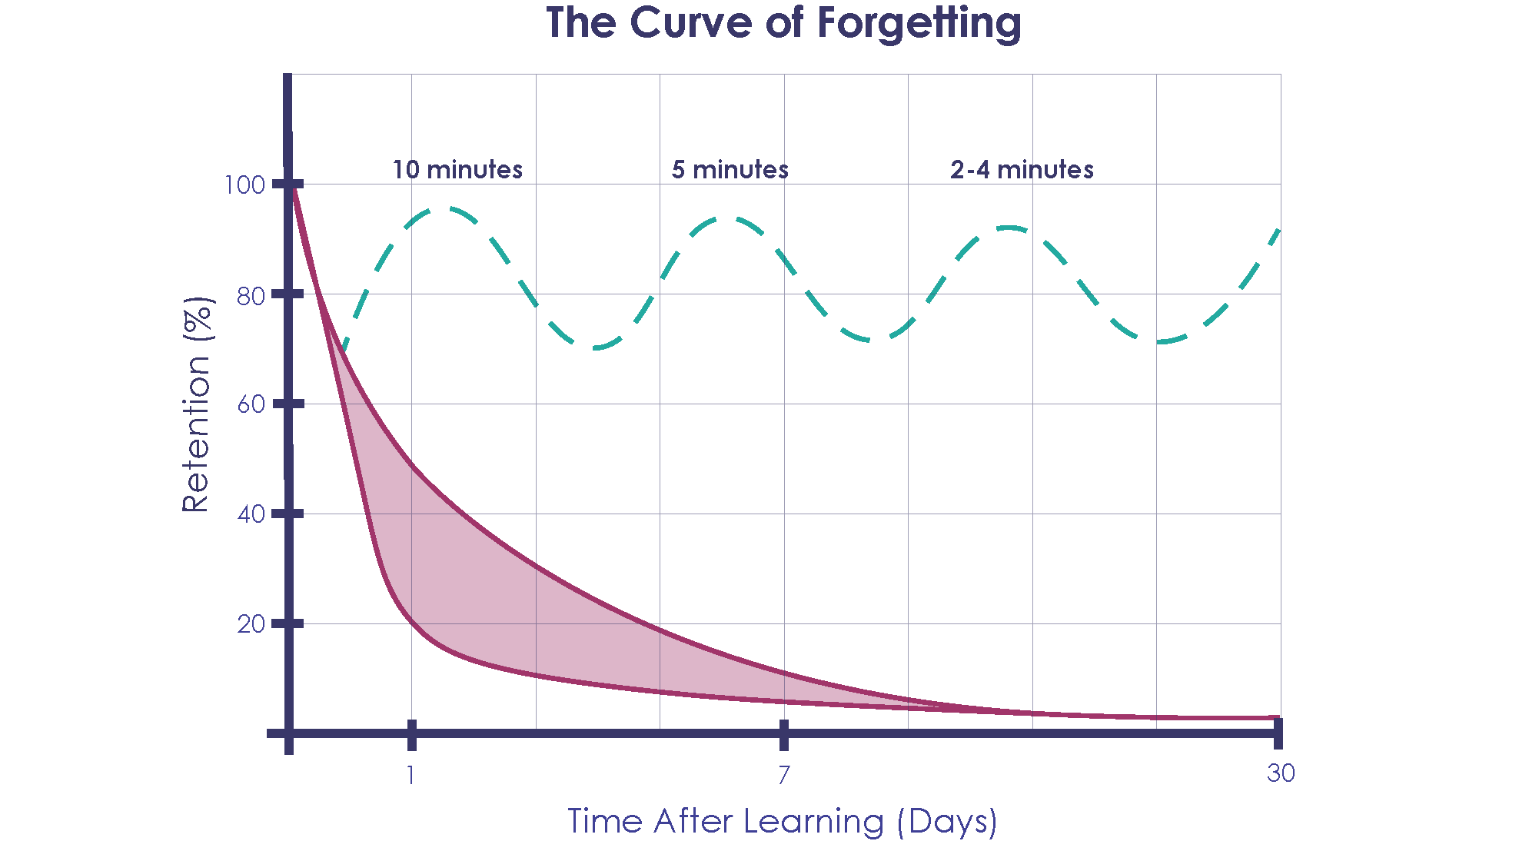
Day 1 – At the end of a class or finishing a reading assignment, you know 100% of what you’ll ever know based off that period of time learning. Hopefully you paid attention!
Day 2 – If you do nothing to review that information, you’ll lose 50-80% of it in one day.
OR: Just ten minutes of review restores your memory to almost 100%!
Day 7 – By the end of the week, you’re lucky to retain 10% of what you learned.
OR: Now you only need five minutes to ‘reactivate’ your memory!
Day 30 – By the end of the month (test time), you retain 2-3% of what you learned.
OR: You can spend 2-4 minutes to refresh yourself.
Spend about 30 minutes every week day and two hours over the course of the weekend reviewing your class and reading notes to benefit from spaced learning and make your effort worthwhile. This counts as part of your planned study time.
Adapted from the Avid Center’s 2005 “The Curve of Forgetting” handout.
The Study Cycle
The Study Cycle is used by successful college students across the country to improve retention and stay on track in class.
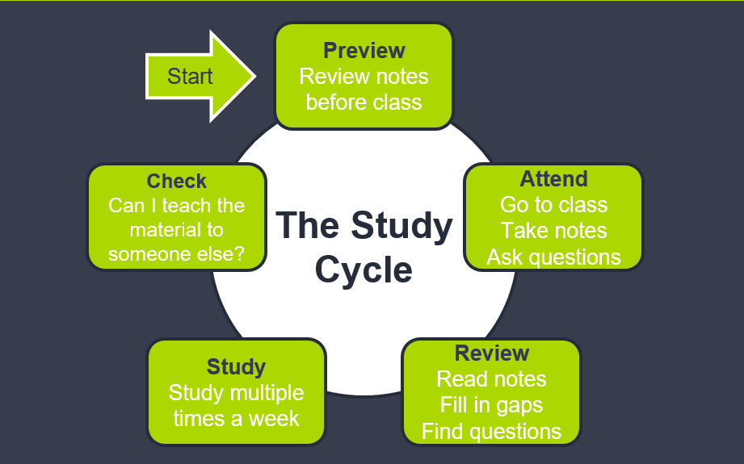
Focused Study Sessions
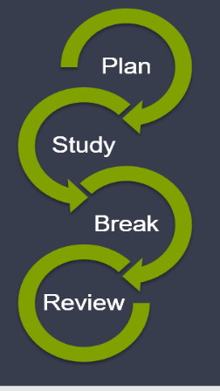
Planning study sessions helps us keep track of our progress and work more efficiently to retain information without exhausting ourselves. The amount of time you spend on each step is adaptable, but we’ve included sample times for your reference.
- Plan – Spend a few minutes determining what you want to finish during this session. (2-5 mins)
- Study – Cover the material with focus until you’ve complete one or more planned chunks of the task. (20-50 mins)
- Break – Take a brief pause to clear your mind. (5-15 mins)
- Review – Go back through the material before moving on. (5-10 mins)

Adapted from Frank Christ’s PLRS system and LSU’s Center for Academic Success’s “The Study Cycle.”
Notes: What to Write and How to Write It

Don't write down everything that you read or hear.
Be alert and attentive to the main points. Concentrate on the "meat" of
the subject and forget the trimmings.

Notes should consist of keywords or very short sentences.
If a speaker gets sidetracked, go back and add more information.

Take accurate notes.
You should usually use your own words, but try not to change the meaning. If you quote directly from an author, quote correctly.

Think a minute about your material before you start making notes.
Don't take notes just to be taking notes! Take notes that will be of real value to you when you look at them at a later date.

Have a uniform system of punctuation and abbreviation that will make sense.
Use a skeleton outline and show importance by indenting while leaving lots of blank space for later additions and organization.

Don't worry about missing a point.

Keep notes in a consistent space, like a notebook or binder.

Shortly after making your notes, go back and rework them.
Add extra points and spell out parts you may not remember easily in the future.

Review your notes regularly utilizing the Focused Study Session model.
©Academic Skills Center, Dartmouth College 2000
Digital Notes
Many students like to take their notes digitally. However, you need to be careful about how you use them because most learners retain less from digital notes.
- Use an outline or provided Power Point, but make sure to add to it in your own words.
- Don’t just take photos of the slides or board.
Don’t just transcribe
the material!

- Don’t try to organize them until after class or completing the reading assignment.
- Technology can be unreliable, so bring paper and a pen as a back-up.
- Record the lecture and save the audio file with your notes.
- Review them later that day and consider re-writing them by hand.

Note Taking Methods

The T Chart System
Header: Date, Class, Topic

In this section, take all of your class notes.
- Outlining
- Mapping
- Charting
In this section write down key words, and main ideas.
- Types of note taking

In this section write a summary of the main ideas of that chapter or lecture.
There are a variety of note-taking methods, including outlining, mapping, and charting.

How to use the T Chart Method:
- Divide paper - On ruled paper, draw a line about 2 ½ inches in from the left of the page and leave enough room at the bottom of the page for a summary section.
- Write Notes – Use the larger section to take lecture or reading notes. Skip lines between topics.
- Recall, Review & Clarify – using the 2 ½ in. section on the left, write the main ideas, dates, names and other short cues that will help recall info.
- Summarize – Using the notes that you took in Step 2-3, summarize in the bottom section of the paper. In this section, you want to reduce the material to key concepts. You may also want to write a question at the end to be answered during the lecture or reading.

Outlining Method
Dash or indented outlining is one of the most common methods. It is very effective for most lectures and recitations.

The information which is most general begins at the left, with each more specific group of facts indented with spaces to the right.
The relationships between the different parts are communicated through indenting.

Example:
Note Taking
- 4 Methods of Note Taking
  - Outlining
  - Mapping
  - Charting
  - Cornell

Use this format when there is enough time in the lecture to think about and make organizational decisions when they are needed. This format can be most effective when your note-taking skills are sharp and the speaker is well-organized and clear.

Leave plenty of white space not only in the left-hand margin but also in between section on the page.

Mapping Method
Mapping is a graphic view of a lecture. It is a method that provides a visual organization of topics, sub-topics, cause and effect, and flow of dates and events. This method can be used when you have a guest lecturer or a professor with whom you’re unfamiliar.
Example:

Extrasensory perceptions
3 Types

Telepathy Clairvoyance Psychokinetic
Sending messages Forecasting the Perceiving events
future external to situation

Charting Method
Charting will help track information when you need to extract primary data and facts (people, places, events, dates, etc.) This method helps to provide an ‘at a glance’ view of notes for an easier review of memorization for facts, comparisons, and relationships.
Example:
Period Important People Events Significance
1941-45 FDR WWII USA involvement

Effective Reading Strategies

PQRST Method for Textbook Reading and Note-Taking
This method helps readers retain information longer and with greater clarity.
The Five Steps
- Preview: Read the introduction, conclusions, bold headings, and vocab.
- Questions: Pose questions to yourself about what you’re reading.
- Read: Read with a deep level of processing.
- Summarize: After reading, think back to what you’ve read. Recite it aloud or write it down.
- Test: Create study materials that challenge your understanding of the text.
Developed by Thomas & H.A. Robinson, Spache and Berg and R.P. Robinson.
Close Reading Method for Article/Essay Reading and Note Taking
This method is ideal for less structured texts, especially in higher level classes.
- Look into the author’s background and career.
  - What does this author usually write about?
  - Does this text align with their previous philosophies?
  - How might their background contribute to the text?
  - Are there other texts that can help clarify these points?
- Annotate the text with anything surprising or interesting.
- Seek out patterns and contradictions to help solidify main arguments.
- Actively ask yourself questions & try to answer them through the reading.
Developed by Patricia Kain (1998).

Succeeding in Online Classes
- Start and Stay Organized
  - Use all the same materials for this class as you normally would for an in-person section.
  - Read the entire syllabus right away.
  - Check your email at least once every 24 hours.
- Check the Tech!
- Make sure you have reliable access to any required software and access codes and plan ahead for any internet connection issues.
- Familiarize yourself with the UIT Helpdesk in case anything goes wrong. They can help troubleshoot and create tickets proving a technical issue.
- Know Your Campus Resources
  - Online options for tutoring exist for many classes at UNT. Talk to your coach or check-out our Campus Resources tab on the LC website.
  - Utilize office hours—virtual or in-person—to get to know your instructor. We can help you make a game plan if you’re new to this.
  - Get the textbook like you would for any other class.
- Build a Schedule that Works for You
  - Stick to a regular ‘class time’
  - Study regularly, even if you don’t have regular exams
  - Account for in- and out-of-class time. Students in online classes need to study up to twice as much to retain the same information.
- Attend Class and Actively Participate
  - Many online classes do have attendance policies that count towards your final grade. They can see your activity in Canvas!
  - Actually do any assigned discussion posts. They most closely resemble what you might be missing from an in-person section.
  - Make sure you do all of the reading and watch/listen to any lectures that may be provided.
- Find the Right Work Space
- Effective learning needs to happen in an organized space.
- Don’t work while in bed.
- Determine if you work better in loud/music-filled/silent places.
- Determine if you work better in seclusion or amongst company.

Learning Styles

The VARK Method of assessing preferred learning styles can help you determine new study strategies that you may find more enjoyable and effective. You can learn what your style preferences are for free by visiting vark-learn.com.

Keep track of your questionnaire results here:

V _____ A _____ R _____ K ______

Visual
You want the whole picture so you are probably holistic in your approach.
You are interested in color and layout and design. You are probably going to draw something. Strategies you may want to consider include making use of: flow charts, graphs, pictures, and color-coding.

Aural/Auditory
You prefer to have things explained to you, though written words are not as valuable as those you hear. Strategies you may want to consider include: attending all lectures, discussing topics with classmates, study groups, remembering interesting anecdotes and examples from lecture, and using a tape recorder in class (with the instructor’s permission!)

Read/Write
You like to emphasize words and lists. You believe the meanings are within the words, so any talk is good by handouts and texts are better. Strategies you may want to consider include: concept lists, reviewing vocabulary, and reading the textbook and lecture notes thoroughly.

Kinesthetic

You want to experience the exam so you can understand it. The ideas on the page are only valuable if they sound practical, real, and relevant to you. You need to do things to understand. Strategies you may want to consider include: capitalizing on labs, field trips, exhibits, and performances and using all of your senses in class. Fidget tools are usually great for these students.

 | Visual | Aural | Reading/ Writing | Kinesthetic
Be Successful when in the Classroom | - Break down notes or assignments into steps or an outline  - Follow along text/refer to visuals in book  - Highlights/underline with lots of colors | - ACTIVETLY Listen  - Ask questions  - Repeat answers/discuss with class/instructor | - Always take notes  - Detailed, organized, linear notes are better  - Follow along in text | - Notes all over page – listen first, write later  - Highlighting  - Mistakes okay – learn from doing  - Boardwork
Be Successful when Studying | - Highlight notes  - Bulleted review sheet  - Mental picture of notes | - Discuss with group  - Talk self through notes/read notes aloud  - Get quizzed by someone else | - Rewrite/rearrange notes  - Reread text/notes  - Summarize what was read | - Recall stories & personal examples  - Create a process  - Walk & recite information  - Explain to others
Be Successful when Taking Tests | - Acronyms  - Mental pictures of notes/text  - Drawing in margins | - Murmur questions to self  - Use your internal dialogue if you have one | - Read directions and questions several times  - Write terms/concepts on a test page as soon as you get it | - Stretch, move around at your desk  - Write down important stuff first (acronyms, etc)  - Skip around on exam questions

Memory Strategies

Creating the Right Environment
- Color-coding helps create connections through categorization.
- Red and blue help facilitate better memory by 31%.
- Specific scents also have their own benefits:
  - Rosemary enhances proscriptive memory.
  - Peppermint creates focus.
  - Basil battles fatigue.
  - Lemon is a super scent that benefits several factors.
- Sit in the same seat in class and study in the same few places to help improve recall.
Mnemonic Devices
Acronyms & Expressions
You may remember using these tricks from childhood, and they still work!
Use an acronym, like ROY G B(I)V to represent the sequence of colors in the rainbow or an expression like “my very educated mother just served us nachos” to remember the order of the planets in our galaxy.

Music and Rhymes
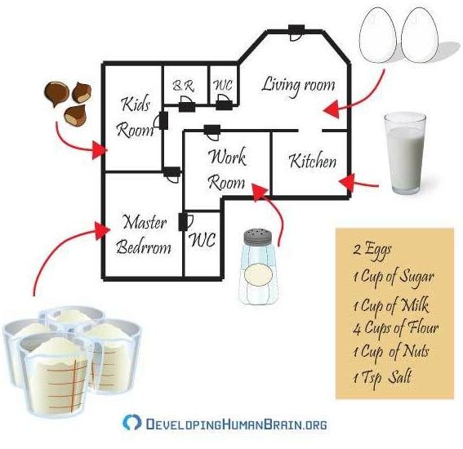
Remember how you learned the alphabet? It was probably a song to the tune of Twinkle Twinkle Little Star! Non-musical rhymes work, too!

Method of Loci
- Think of a specific location with which you’re familiar, like your house or a route you take frequently.
- Then, assign objects in that space to concepts or terms you need to remember.
- Mentally explore the space and find each item.

Spaced vs Massed Learning to Benefit Your Memory
The real key to retaining information for both the short- and long-term is repeated review of the material.
- Cramming, whether revisiting the content for the first time or a second time in a long study session, doesn’t yield positive results.
- However, if you study in short bursts spaced out over time, your ability to recall and actually utilize the information is significantly better.

Test Taking Tips
- Make sure you have all the materials you need for the exam (a blue book, pencil, pen, etc.) and know the location of your exam.
- Pay attention to your teacher’s verbal and written directions as the test is being distributed.
- Preview the test before beginning and make a plan of attack.
  - Read directions carefully; small words can change the answer completely.
  - Use point values for sections to determine what to answer first.
- Make sure your identifying information is on all test materials.
- Write down any recall clues at the top before looking at the questions.
- Remember: it is not a race; you do not have to be the first one done.
- Answer the easiest questions first.
- Do not dwell on questions you don’t know; skip them and come back.
- Use what you have learned in the first part of the exam to help you answer later questions.
- If guessing is not counted against you, always answer every question.
- Your first answer is almost always the correct one.
- Read over your answers before you turn it in.
Using Your Test Results for the Future
- Read over any marks from the professor.
- Go over the test with the professor and ask any questions you may have.
- Check for grading accuracy but don’t immediately debate your grade unless the instructor asks you to point out errors at that time.
- Keep the test to review for later tests.
- Set a goal for yourself for the next section of the class and the next test.
- Seek outside assistance early if needed from a tutor or other resource.
- Evaluate your time management and study strategies. A Coach can help you make a game plan if you’re struggling to identify what’s not working.
Use your returned tests to study for comprehensive exams.
- ‘Retake’ the test, focusing on everything you know you know.
- Take it again, filling in the more difficult gaps.
- Take a last time, reviewing what you couldn’t figure out and noting what you’re comfortable with.

Test Anxiety

What does text anxiety look like?
- Sweating
- Shortness of breath
- Headaches
- Rapid heartbeat
- Nausea
- Light-headedness and fainting
- Sleeplessness

How to Reduce Test Anxiety
- Directed Attention
    - Accept that anxiety is there
    - Do not devote energy to resisting anxiety
    - Attempt to direct attention to the test
- Feeling well-prepared can give a confidence boost
    - Time management
    - Study skills
    - Spaced learning methods
    - Avoid cramming
    - Participate in class
- Practice Relaxation techniques before, during, and after the test
Managing Test Anxiety

The Tensing and Differential Relaxation Method
- Put your feet flat on the floor.
- With your hands, grab underneath the chair.
- Push down with your feet and pull up on your chair at the same time for about five seconds.
- Relax for five to ten seconds.
- Repeat the procedure two or three times.
- Relax all your muscles except the ones that are actually used to take the test.

The Visualization Method
1. Close and cover your eyes using the center of the palms of your hands.
2. Prevent your hands from touching your eyes by resting the lower parts of your palms
on your cheekbones and placing your fingers on your forehead. Your eyes must not be touched, rubbed or handled in any way.
3. Think of some real or imaginary relaxing scene. Mentally visualize it. Picture the scene as if you were actually there.
4. Visualize this relaxing scene for one to two minutes.

Deep Breathing
1. Sit straight up in your chair in a good posture position.
2. Slowly inhale through your nose.
3. As you inhale, first fill the lower section of your lungs and work your way up to the upper part of your lungs over the course of 4 seconds.
4. Exhale slowly through your mouth over 8 seconds.
5. Wait a few seconds and repeat the cycle.

Visiting a Health Care Provider
Some students who experience test anxiety (or performance anxiety) experience a change in their brain chemistry, which may manifest in several ways, like:
- A rush of endorphins that help calm you down but make thinking clearly more difficult
- A rush of adrenaline that increases your heart rate or blood pressure and makes it more difficult to feel calm

If you feel these physical effects, visit a health care professional who can help you determine what you can try to feel better during times of high anxiety.

Sleep Matters

“Sleep is an investment in the energy you need to be effective tomorrow.”
- Tom Rath
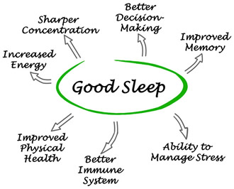
Sleeping well before an exam is associated with a 10% score increase because it helps integrate new learning with knowledge we already have.

Tips for Getting Good Sleep
- Maintain a regular daily schedule whenever you can.
- Don’t go to bed hungry or after just eating.
- Pay attention to your internal clock. You’ll feel better during the day if you wake up at an earlier time than you intended if you naturally wake up.
- Aim for 7-9 hours any time you can.

Self-Care According to the Academic Coaches

Take care of your mind, body, and soul & focus
on each part of you when it’s the most in need.
- Mind: Write yourself a love letter!
- Body: Slow down and take a walk.
- Soul: Use the meditation room to clear your head.
Write down 5 things a day that didn’t total suck and put them in a jar. At the end of the month—or whenever you’re having a bad day--look back at some things that brought you joy and make those part of your day-to-day life.

Take an hour every morning or night to do something that adds value to your life. Try cooking a meal for yourself, going for a walk, listening to a podcast, or talking to someone you haven’t checked-in with in a while.

Find a hobby that gets your mind off of stress and deadlines. Try to be creative while being simple enough to be able to pick it up any time. When you have a tangible final product or end result, you also get the satisfaction of accomplishing something..
Learn to say no sometimes.

When you’re having trouble focusing, clean up your space. When your environment is cluttered, it often impacts your ability to think clearly and may cause frustrating distractions.

Although this seems silly, if your mind is foggy—if you’re tired—if you don’t understand something—take a break and drink some water.

Satisfactory Academic Progress
Federal and state regulations governing student financial assistance require that an institution develop standards to measure academic progress toward a degree. Students applying for financial aid will be monitored for Satisfactory Academic Progress (SAP) whether or not financial aid was applied for or received during any academic period in which the student was previously enrolled. You will not be eligible for financial assistance if you do not meet the academic progress requirements. Student Financial Aid and Scholarships monitors SAP at the end of each term. You must be meeting the minimum standards for SAP by the end of any given enrollment period at UNT to maintain financial aid eligibility.
Qualitative Requirements
The minimum cumulative UNT GPA for undergraduate students is 1.8 for the first term of enrollment and a 2.0 for all subsequent semesters.
The minimum cumulative UNT GPA for graduate students is 2.67 for the first term of enrollment and a 3.0 for all subsequent semesters. SAP will be measured according to graduate student classification, whether or not a bachelor's degree has been earned.
Pace of Progression
You must successfully complete at least 67 percent of the cumulative attempted credit hours. Attempted hours include:
- all hours you enroll in at UNT or any other college
- repeated courses
- courses you may have failed, taken an incomplete, or withdrawn from
- transfer credit hours
Pace of Progression is measured by dividing the cumulative number of hours successfully completed by the cumulative number of hours attempted.

Examples:
After two terms, Tim has attempted a total of 24 hours but has only completed (earned a passing grade) 16 hours. Tim’s pace of progress is equal to 66.6% (16/24=66.6%), which is unacceptable because it is below 67%.
After four terms, Elsa has attempted a total of 60 hours but has only completed (earned a passing grade) 45 hours. This student’s pace of progression is equal to 75% (45/60=75%), which is acceptable because it is not below 67%.
Maximum Hour Limit
Undergraduate students cannot exceed hours above 150 percent of their required degree plan at any institution of higher education, to include all registered, earned, or attempted hours. If you exceed the maximum number of hours allowed by your degree plan, your financial aid will be cancelled.
To calculate the number of hours for your financial aid eligibility:
# of hours required for your degree plan X 150% = Max. # of hours eligible for financial aid
Example:
Gavin is a new transfer student with 191 earned/attempted hours with a degree plan that requires 120 hours to complete. His degree plan allows for 180 hours of financial aid availability, so he has exceeded his limit. He does have the option to pursue an appeal for Financial Aid probation and continue to receive limited funds.
For a graduate program (master’s or doctoral), the maximum timeframe cannot exceed the published length of the program measured by the number of years at UNT.
Post baccalaureate and Graduate Academic Certificate programs will be monitored for maximum timeframe based on their twelve month or twenty-four month period of aid eligibility.
In addition, university withdrawal, dropped, duplicated or never completed hours are counted as well as hours earned in the Armed Forces. Any hours excluded under the UNT Admission's Academic Fresh Start option are included as attempted hours for financial aid purposes.
Appeal Process
If you fail to meet SAP requirements and lose financial aid eligibility, you may submit a written appeal with supporting documentation for reinstatement of financial aid eligibility if you had mitigating circumstances.
Repeated Coursework
Per Federal Regulation, a student is not eligible for Title IV (federal) financial aid for any course they repeat more than once if they have previously passed the course.
For example, a student took BIOL 1710 in the fall and earned a D. The student can retake the course once and receive financial aid for that course. If the student attempts to retake the course again, no federal financial aid funds can be used to help pay for the class.

To learn more about SAP and access the Appeal Request Form for the current year,
visit financialaid.unt.edu/SAP or call 940.565.2302

