TutorTube: Ideal Gas Law (Boyle and Avagadro) Fall 2020
Introduction
Hello and welcome to TutorTube, where The Learning Center’s Lead Tutors help you understand challenging course concepts with easy to understand videos. My name is Ethan, Lead Tutor for chemistry and biology. In today’s video, we will explore Ideal Gas Laws. Let’s get started!
Objectives
This is the second video in a series of two videos covering the Ideal Gas Law. If you haven’t seen first video, I would recommend watching it before this one. A link for the first video is in the description below. In this second part, we’ll learn the last two of the four individual laws as well as a more complicated example where we will solve for density of a gas using the Ideal Gas Law.

Individual Gas Laws: Boyle
Boyle’s Law is the first law we’ll cover, and it involves pressure and volume. It states that pressure is inversely proportional to volume when number of moles and temperature are kept constant. This means if we take a container and squish down its volume, the pressure must increase. This is like squeezing a balloon until it reaches a pressure that the material can’t withstand, and it pops.

Our equation is P1V1 = P2V2. Since n and T are constant, we just cover them up to derive our equation. Essentially, all we’re left with is the numerator from our Idea Gas Law equation.

$$P_{1}V_{1}= P_{2}V_{2}$$

Here’s a problem illustrating Boyle’s law. We have five moles of Argon gas maintained at 80°C. The pressure is 1.1atm with a volume of 0.75L. If the balloon is squished down to 0.25L, what will be the new pressure? So, here we don’t need to consider the five moles. All that matters is that the amount of gas doesn’t change and the temperature doesn’t change. We’re given P1 which is 1.1atm, V1 is 0.75L, V2 is 0.25L, and we’re looking for P2. We can set up our equation, solve for P2, and plug in our values. We end up getting a new pressure of 3.3 atm. And, this makes sense. We squished our balloon which decreased its volume, so we should see an increase in pressure. Here the pressure changed from 1.1atm to 3.3atm.

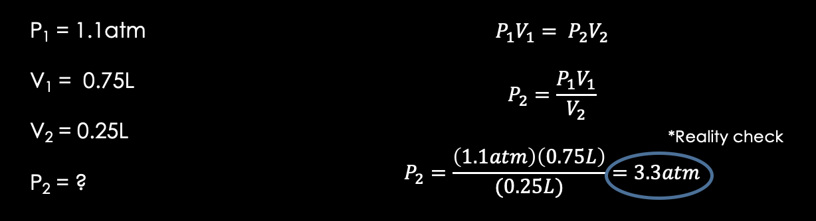
Figure 1: Solving example question for Boyles Law P1V1 = P2V2.

Individual Gas Laws: Avagadro
The last of the gas laws is Avagadro’s Law. This law states that the number of moles is directly proportional to the volume that the gas is in whenever pressure and temperature are kept constant. So, the more gas you add into a container, if you want to maintain constant pressure and temperature, you need to increase the volume.
The equation we have is V1/n1 = V2/n2 since we are keeping P and T constant.

$$\frac{V_{1}}{n_{1}} = \frac{V_{2}}{n_{2}}$$

Here’s an example problem. A container of 15g of Oxygen with constant temperature has a volume of 2L. Twelve grams of Nitrogen are added in. What new volume is needed to keep the pressure constant? So, temperature and pressure are kept constant. We have the initial amount of gas that is 15g of Oxygen. We also have twelve grams of Nitrogen gas that we are adding in, and we want to find out how the volume changes given an initial volume of 2L. First, let’s convert our masses of gas to number of moles. For Oxygen with a molar mass of 16g/mol we get 0.93 moles. So, our n1 is equal to 0.93, but our n2 is not equal to the moles of Nitrogen. Our n2 is equal to our new total moles of gas which is moles of Oxygen plus moles of Nitrogen added in. And, therefore, our n2 is 1.79.

Now, we just plug in our values after solving for V2, and we get 3.8L. Does this make sense? We increased the amount of gas, so we should see an increase in volume. And, we do.

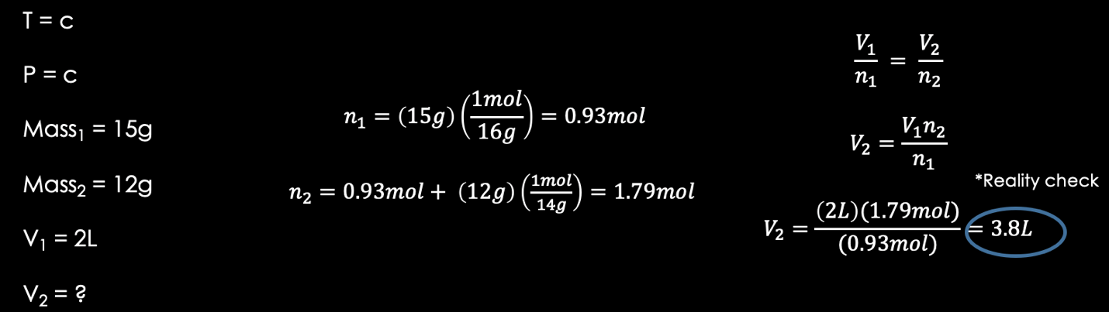
Figure 2: Solving example question for Avagadro's Law V1/n1 = V2/n2.

Further Application
Here is some further application of the Ideal Gas Law. Beyond predicting values of pressure, or volume, or temperature, we can actually use it to find the density of a specific gas at a given pressure and temperature. Here, we have O₂ gas at 0.75atm and 25°C.
First, I just converted our temperature to kelvin. Now, we have two equations. We have the Ideal Gas Law and the equation for density which is mass/volume. Let’s try to solve for density in terms of just pressure and temperature. We can first represent the mass as just the molar mass of our O₂ times the number of moles. Because molar mass as units of g/mol, multiplying by moles gives us grams. So, m equals MM· n where MM is molar mass. Also, mass is equal to density times volume, found by rearranging our equation for density.
Now, we have two values for mass that we can set equal to one another and solve for volume. Next, let’s plug in our value for volume into our Ideal Gas Law and simplify. We can cancel n on both sides and rearrange to set everything equal to density by multiplying density over to the right and dividing by RT. Now, we have that density equals pressure times molar mass divided by the gas constant times temperature.

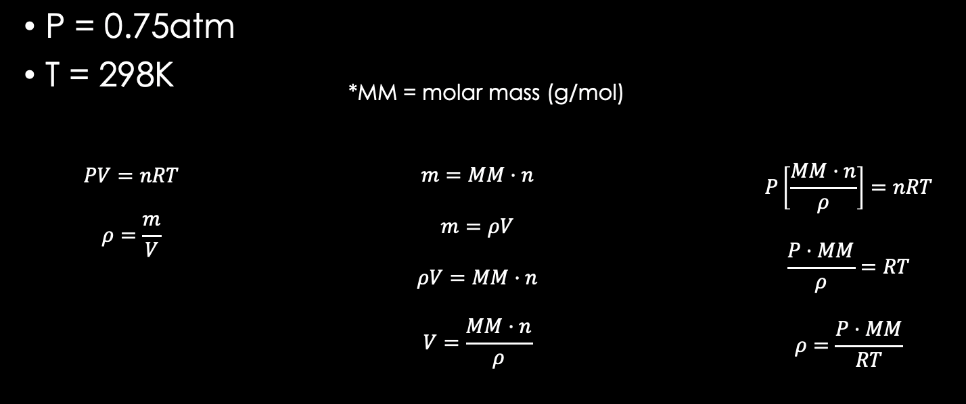
Figure 3: First steps in solving for the density of oxygen gas at 0.75atm and 298K.

Okay. Looks like we have on equation with only one unknown, so we can solve it. Let’s plug in our values and make sure all our units match. For MM, we have to consider that the molecule we are dealing with is O₂. So, MM is two times the molar mass of one Oxygen atom. Once we solve, we end up getting a density of 0.98, and our units are g/L since everything else cancels. Therefore, we can say that at room temperature (25°C) and pressure of 0.75atm, O₂ gas will have a density of 0.98g/L.

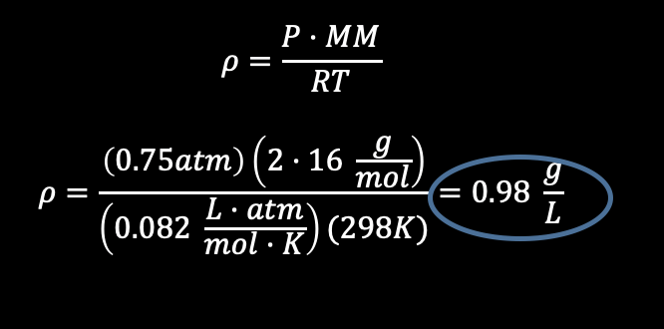
Figure 4: Final steps for finding density of oxygen gas at 0.75atm and 298K.

Here are some good resources for all things related to Ideal Gas Law and the four individual gas laws. This link is provided in the description box below. It has various different units that you can use and values of R depending on what units you are given.

https://chem.libretexts.org/Bookshelves/Physical_and_Theoretical_Chemistry_Textbook_Maps/Supplemental_Modules_(Physical_and_Theoretical_Chemistry)/Physical_Properties_of_Matter/States_of_Matter/Properties_of_Gases/Gas_Laws/The_Ideal_Gas_Law

Outro
Thank you for watching TutorTube! I hope you enjoyed this video. Please subscribe to our channel for more exciting videos. Check out the links in the description below for more information about The Learning Center and follow us on social media. See you next time!

