TutorTube: Photosynthesis Spring 2021
Introduction
Hello and welcome to TutorTube, where The Learning Center’s Lead Tutors help you understand challenging course concepts with easy to understand videos. My name is Natalie Taylor, Lead Tutor for Biology and Chemistry. In today’s video, we will explore photosynthesis and the steps within the process. Let’s get started!

Learning Agenda

For today’s learning objectives, we will learn the steps within the process of photosynthesis, and we will learn the products of photosynthesis at each step and as a whole.

What Is Photosynthesis?

Photosynthesis is a series of metabolic reactions that take place inside cells. It is used to convert inorganic carbon, water, and sunlight into organic carbon, oxygen, and ATP (aka chemical energy).

The general equation for photosynthesis is shown in the bottom half of the screen:
6CO₂ + 6H₂O + sunlight → C₆H₁₂O₆ + 6O₂ + ATP

Essentially, 6 carbon dioxides react with 6 water molecules and sunlight to form glucose, 6 oxygen molecules, and ATP.

Who Can Perform Photosynthesis?

Not all cells can perform photosynthesis! Only specific cells that have the chlorophyll pigment can perform the process. All photosynthetic organisms must have the chlorophyll pigment, but organisms differ in where they store them. The chlorophyll inside plants are housed in the chloroplast, whereas the chlorophyll in certain bacteria can be found in the cytoplasm. Most plants, algae, and cyanobacteria are photosynthetic organisms.

Important Plant Terms

Before we talk about the processes in photosynthesis today, there are a few terms to know about plants and their structure. The chloroplast is a plastid that is a membrane-bound organelle in most plants. It contains the chlorophyll needed for photosynthesis to take place. The stomata are small holes or pores in the plant’s leaves or stem to allow for gas exchange. The xylem is a vascular system (primarily in vascular plants) that transports water and nutrients from the roots upwards. Chlorophyll is stored in thylakoid sacs. Those thylakoid sacs can be stacked together to form granum. Lastly, the stroma is the empty space inside the chloroplast (essentially the space around the thylakoids).
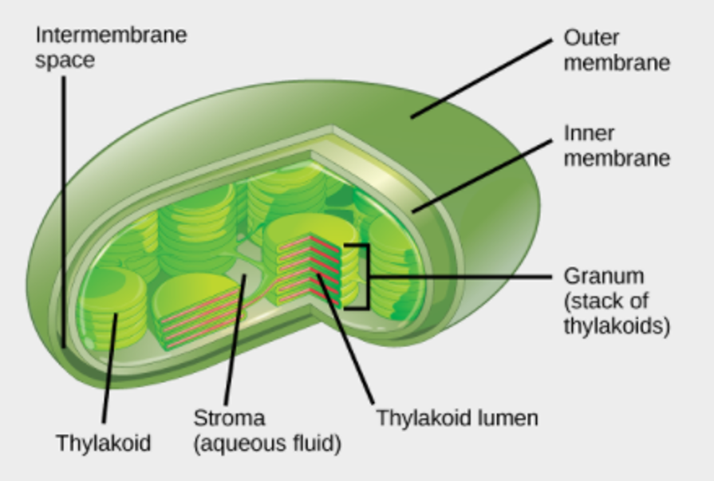
Image 1 (Overview of Photosynthesis)

This image displays a chloroplast. Notice how it has two membranes (inner and outer) and the thylakoid, stroma, and granum are labeled.

Light Dependent Reactions

Photosynthesis is split into the light dependent and light independent reactions. First, are the light dependent reactions. The process begins in a protein complex called Photosystem II. This complex runs along the thylakoid membrane and the chlorophylls are inside.
It all begins with sunlight (light photons) going into the chlorophyll. The photons excite electrons in the chlorophyll, and then those excited electrons get transported to the electron transport chain. Now, having lost electrons, chlorophyll wants to refill that empty spot. So, water is split, the electrons released go back to stabilize the chlorophyll, and H+ and oxygen molecules are formed. The oxygen byproduct is very important for humans since we need that oxygen produced by plants to breathe!

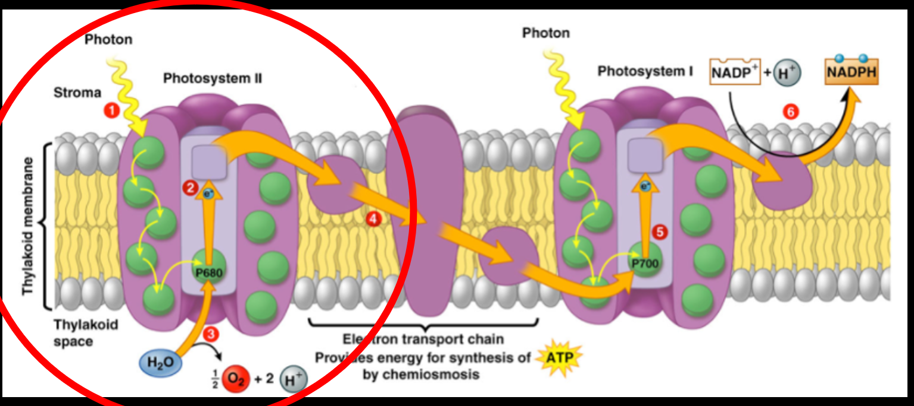
Image 2 (Johnson, Alberts, Morgan, Hopkin, Roberts, Raff, & Walter)

This is an image of all the parts of the light dependent reactions. The parts we just discussed, that occurred in Photosystem II, are circled. Notice how the excited electrons leave the protein complex to continue down the membrane. Also, notice that there are multiple chlorophyll electrons in Photosystem II being excited by the sunlight photons. This process, while we tend to look at it on a simple level, occurs simultaneously with hundreds of other electrons being excited and transported.

Now, all the excited electrons are transported by mobile electron carriers through the electron transport chain! They are being taken to the cytochrome complex. This is another protein complex that acts as an intermediate between Photosystem II and Photosystem I. In the cytochrome complex, the excited electrons release a small amount of energy to power the pumping of H+ molecules across the membrane and into the thylakoid. At this point, the thylakoid is starting to really fill up with H+ ions. This is contributed from both the H+ pumping in at the cytochrome complex and the H+ formed by the splitting of water in Photosystem II. These H+ molecules are then used to power ATP synthase! ATP synthase (acting the same way that it did in cellular respiration) converts ADP to ATP by adding a phosphate group.

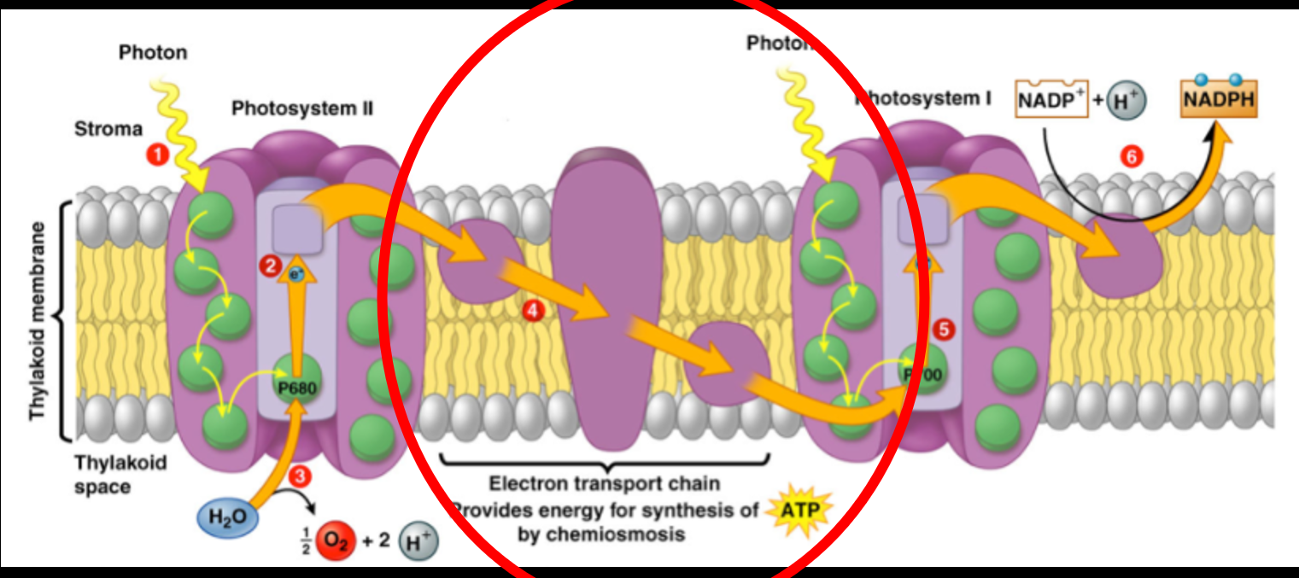
Image 2 (Johnson, Alberts, Morgan, Hopkin, Roberts, Raff, & Walter)

In this image of the light dependent reactions, the cytochrome complex is circled. Notice how the electrons that are moving across the electron transport chain are slowly decreasing in energy over time.

Now, the mobile electron carriers leave the cytochrome complex and continue to move down the membrane to Photosystem I (which can also be referred to as PSI). In PSI, the electrons are reenergized by a photon. Then, they are moved to the NADP+ reductase enzyme. NADP+ reductase uses the energy from 2 electrons to attach an H+ molecule onto NADP+ to form NADPH. NADPH is then transported around the cell to supply energy.

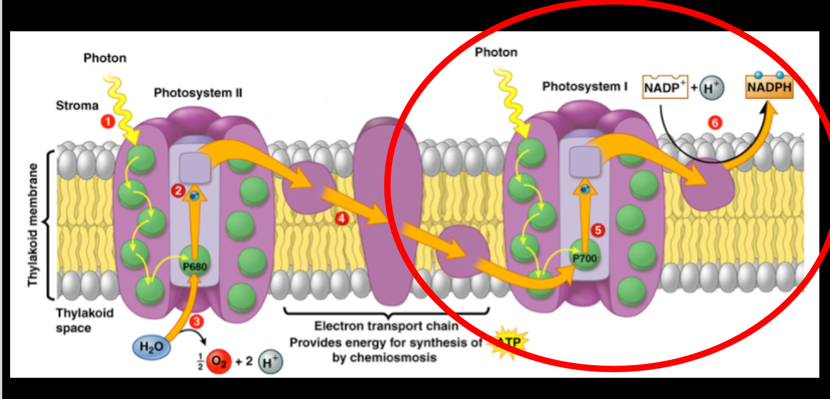
Image 2 (Johnson, Alberts, Morgan, Hopkin, Roberts, Raff, & Walter)

In this image of the light dependent reactions, Photosystem I is circles. Notice how once the electrons go back into PSI and the sunlight photons reenergize them to a high energy state. Then, the electron energy is used to power NADP+ reductase to form NADPH. This concludes the light dependent reactions.

Light Independent Reactions

Photosynthesis now moves on to the light independent reactions. This is a cyclical series of steps. Often times, this series of reactions can be called the Calvin Cycle. The steps occur in the stroma of the chloroplast – remember that is the empty space around the thylakoid sacs. There are 3 major steps in the Calvin Cycle: carbon fixation, reduction, and regeneration.

The first step of the process is carbon fixation. Carbon dioxide (CO₂) enters the cell (from the stomata that allow for gas exchange). Then, Ribulose bisphosphate (RuBP) attaches to the CO₂. Ribulose-1,5-bisphosphate carboxylase-oxygenase (RuBisCo) help that attachment and ensure the connection between RuBP and CO₂. RuBisCo helps convert the inorganic carbon (CO₂) into organic carbon. However, sometimes RuBisCo fixes to water instead of the CO₂, and it formed phosphoglycolate (a toxic byproduct). To control and break down the phosphoglycolate, plants have evolved to produce enzymes that convert the byproduct into glycerin and other compounds.
RuBP and CO₂ together make a really unstable compound. To stabilize, it breaks into two pieces. The splitting forms 2 molecules of 3-phosphoglycerate. For purposes of looking at a complete cycle, we are going to look at 3 CO2 molecules going into the Calvin Cycle, thus forming 6 molecules of 3-phosphoglycerate.

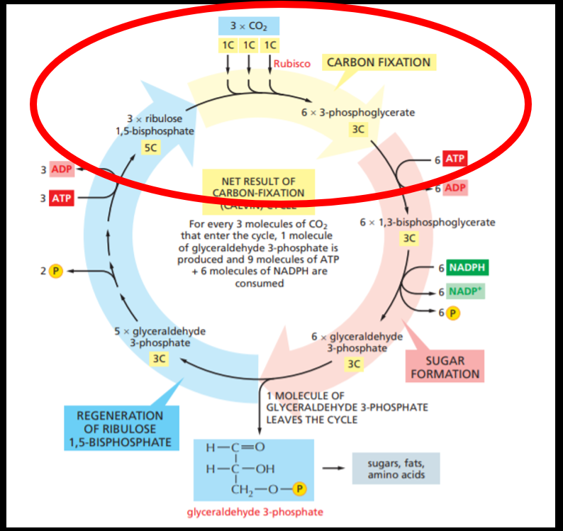
Image 3 (Johnson, Alberts, Morgan, Hopkin, Roberts, Raff, & Walter)

In this image of the Calvin Cycle, the section featuring carbon fixation is circled. Notice the 3 carbon dioxide molecules going in to form the six 3-phosphoglycerate molecules.

The next step of the Calvin Cycle is reduction. At this point, ATP attaches a phosphate to 3-phosphoglycerate and NADPH attaches an H+ onto the 3-phosphoglycerate. This results in the formation of 2-glyceraldehyde-3-phosphate – also known as G3P. G3P is a high energy carbon that can be converted into a variety of carbohydrates, such as glucose, cellulose or starch. Those carbohydrates can then be used by the cell. From the six molecules of 3-phosphoglycerate that went into this step, six G3P molecules are formed.

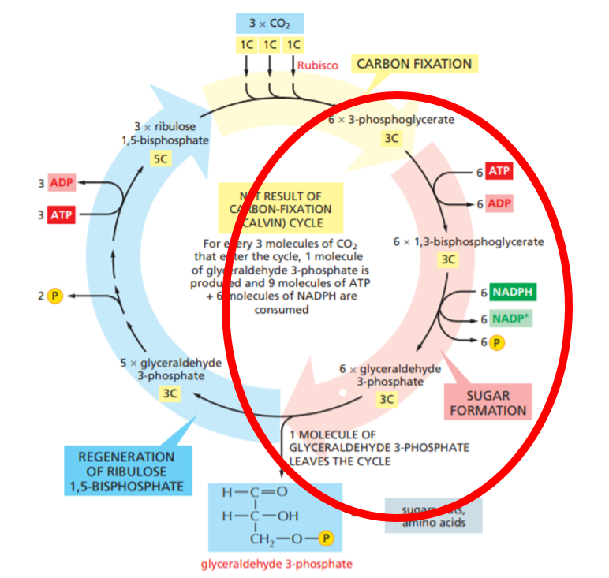
Image 3 (Johnson, Alberts, Morgan, Hopkin, Roberts, Raff, & Walter)

In this image of the Calvin Cycle, the reduction portion is circled. Notice that once the ATP donates a phosphate, it produces an intermediate product of 1,3-bisphosphoglycerate. Then, when the NADPH adds the hydrogen ion, the G3P is fully formed.

The last step of the Calvin Cycle is regeneration. From the 6 G3P produced, five are converted back into 3 RuBPs. Remember, RuBP was the start of our cycle that attached to carbon dioxide. This allows the cycle to continue and restart after every cycle. The one G3P remining then leaves the cycle to be used by the cell.

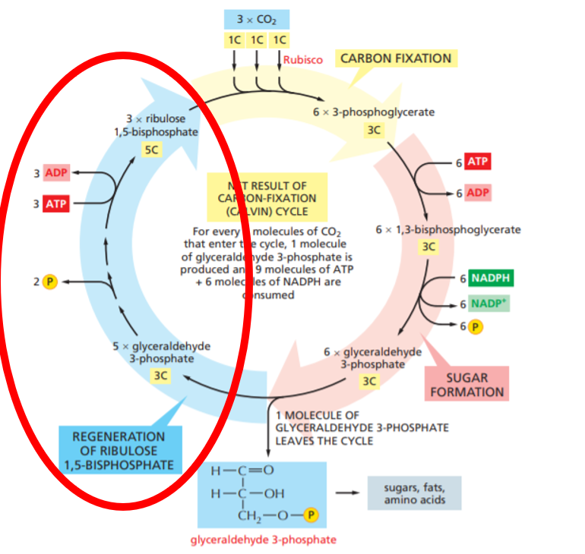
Image 3 (Johnson, Alberts, Morgan, Hopkin, Roberts, Raff, & Walter)

In this image of the Calvin Cycle, the regeneration portion is circled. Notice that energy (ATP) is input into this reaction to ensure the transformation of G3P into RuBP.

Summary

In summary, photosynthesis is a series of metabolic reactions that take place inside cells that converts inorganic carbon and water into organic carbon, oxygen, and ATP. Remember, only cells with the chlorophyll pigment can perform photosynthesis. There are 2 major steps of for this metabolic process. First, the light dependent reactions. The light dependent reactions occur in the thylakoid membrane and results in the formation of ATP and NADPH (chemical energy that can be used by the cell) and oxygen. The light independent reactions occur in the stroma and converts inorganic carbon into organic carbon that can be used by the cell.

Outro
Thank you for watching TutorTube! I hope you enjoyed this video. Please subscribe to our channel for more exciting videos. Check out the links in the description below for more information about The Learning Center and follow us on social media. See you next time!

References
8.1 Overview of Photosynthesis - Biology 2e. (n.d.). Retrieved February 26, 2021, from https://openstax.org/books/biology-2e/pages/8-1-overview-of-photosynthesis
Johnson, A, Alberts, B, Morgan, D, Hopkin, K, Roberts, K, Raff, M, & Walter, P (2019). Essential Cell Biology. W.W. Norton & Com

