TutorTube: Polarity in Molecular Shapes Spring 2021
Introduction
Hello and welcome to TutorTube where the Learning Center’s Lead Tutors help you understand challenging course concepts with easy-to-understand videos. My name is Rebecca, Lead Tutor for Biology and Chemistry. In today's video, we will explore how to predict polar and nonpolar compounds using their molecular shapes. Let's get started!

Definitions
In the first video, we defined polar and non-polar molecules:
A polar molecule occurs when there is an unequal sharing of electrons in a bond. This occurs when one element forming a bond is more electronegative than the other. The more electronegative atom, which is chlorine in this example, will have a partial negative charge because the electrons are more attracted to it, while the less electronegative atom, hydrogen, will have a partial positive charge.
When one side of the bond is more electron dense than the other, the dipole moment will be represented as an arrow pointing towards the more electronegative atom, chlorine, and the plus end of the arrow will be on the less electronegative atom, hydrogen.
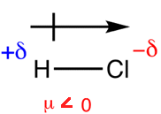
Figure 1: Dipole Moment of Hydrochloric acid
A nonpolar molecule occurs when there is equal sharing of electrons within a bond. This is because both elements have equal electronegativity.
Some compounds that have polar bonds may still be a non-polar compound. This happens when dipole moments with equal magnitude, but with opposite direction cancel each other out.
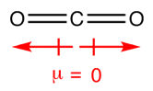
Figure 2: Dipole Moment of Carbon dioxide

VSPER (Valence-Shell Electron-Pair Repulsion) Shapes
Now let’s look at the VSPER (valence-shell electron-pair repulsion) shapes and how molecular shapes affect polarity in compounds. It is essential to know the difference between electron structure and molecular structure/geometry when studying the VSEPR theory. The electron structure refers to the arrangement of the electron groups around the central atom, while molecular geometry illustrates the arrangement of atoms/elements around the central atom. The electron and molecular structures share some commons names when there are no lone pairs of electrons around the central atom. In the presence of lone pairs on the central atom, the molecular shape has a different name from the electron structure.

Non-Polar Molecules Distinguished Using Molecular Structures
Generally, the dipole moments of molecules that don’t have lone pairs on the central atoms will cancel each other out as long as the terminal atoms are identical. These types of compounds have a symmetrical distribution of charge, so they are non-polar. Notice that since there are no lone pairs on the central atom, the electron and molecular structure have identical names.
Table 1: Summary of Non-Polar Molecular Shapes
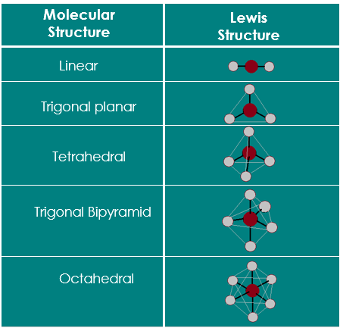
This table shows a summary of non-polar molecular shapes namely linear, trigonal planar, tetrahedral, trigonal bipyramidal and octahedral.
There are two exceptions where a symmetrical distribution of charges is retained in the presence of lone pairs on the central atom that is bonding to identical terminal atoms. The first is seen in trigonal bipyramidal electron structure when there are 3 lone pairs on the central atom causing a linear molecular shape in the compound. This way, the dipole moment cancels out since the terminal atoms are identical and the bonds are pointing in opposite directions of each other, making the compound is non-polar. The second exception is in the octahedral electron structure where the central atom has 2 lone pairs that cause the molecular shape to be square planar. Such a shape has a symmetrical charge distribution resulting in 0 net dipole moment as all the bonds have equal magnitude and are pointing in opposite directions to each other. Hence, compounds with square planar geometry are nonpolar.
Table 2: Exceptions where Molecular Shapes have symmetric charge distribution in the presence of lone pairs on the central atom
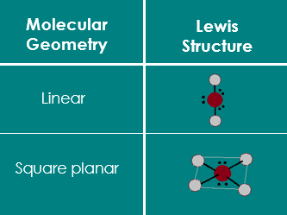

Distinguishing Polar and Non-polar compounds using Molecular Structures
Now I’ll go over the entire VSEPR theory chart and we’ll go through each electron structure and molecular structure one by one.
The first electron structure is linear, this can only exhibit a linear molecular shape. As I explained earlier, there is a symmetrical distribution of charges in this shape so a compound with this geometry is non-polar. Beryllium hydride is a good example for this since the central atom, beryllium, bonds all its valence electrons equally to two hydrogen atoms.
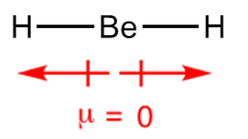
Figure 3: Lewis structure and Dipole Moment of Beryllium hydride
The second electron structure is Trigonal planar. It can have two variations of molecular shapes depending on the presence of lone pairs on the central atom and the number of bonds that it’s forming. The molecular geometry can be trigonal planar or bent.
If the central atom is fully bonded to 3 identical atoms, such as in boron trichloride, then the molecular structure is a trigonal planar, which is same name as the electron structure, and is non-polar due to its symmetric charge distribution.
Figure 4: Dipole Moment of Boron trichloride
On the other hand, if the central atom is only bonded to two other atoms and has a lone pair, then the molecular structure will be bent. This structure does not have a symmetrical distribution of charge and has a non-zero net dipole moment. Thus, this compound is polar. For example, sulfur dioxide has a central atom, sulfur, double bonded to two identical atoms, oxygen. Sulfur has a lone pair since it doesn’t bond all 6 of its valence electrons. Due to the bent molecular shape, the dipole moments of the bonds do not cancel each other out, therefore, this compound is polar.
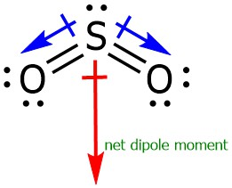
Figure 5: Lewis Structure and Dipole Moment of Sulfur dioxide
If a central atom with a tetrahedral electron structure has bonded all its valence electrons to four other identical atoms, as in the example methane, the molecular shape is also tetrahedral. As mentioned before, this kind of compound is nonpolar.
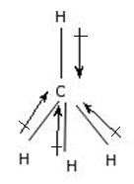
Figure 6: Lewis Structure and Dipole Moment of Methane
If the central atom is bonded to only three other atoms and has one lone pair of electrons, then the molecular shape of the compound is trigonal pyramidal. This structure is not symmetrical and will result in a non-zero net dipole moment. For example, in Ammonia since the valence electrons of nitrogen amount to 5, it will be left with one lone pair on nitrogen after it bonds to 3 hydrogens. Due to the presence of a lone pair on the central atom, this structure will not have a symmetrical distribution of charge, making it a polar compound.
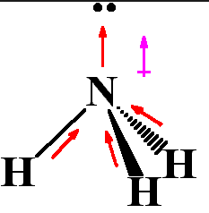
Figure 7: Lewis Structure and Dipole Moment of Ammonia
In compounds, such as water, where the central atom has 2 lone pairs of electrons and bonds to two identical terminal atoms, the molecular structure is bent. There will be a non-zero net dipole moment, so the compound is polar.
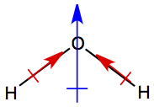
Figure 8: Net Dipole Moment of Water
Trigonal bipyramidal electron structures can have 4 types of molecular shapes.
The first is trigonal bipyramidal shape in which the central atom has a total of 5 valence electrons, and it uses all of them to bond with 5 identical terminal atoms. Compounds like phosphorus pentachloride that exhibit this molecular shape are nonpolar.
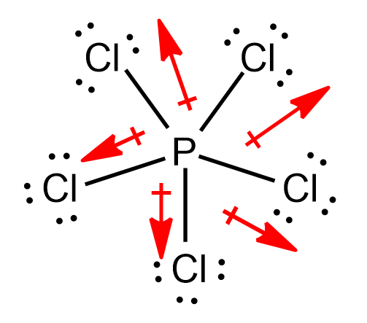
Figure 9: Lewis Structure and Dipole Moment of Phosphorus pentachloride
Seesaw shapes occur when the central element bonds to 4 identical terminal atoms and has one lone pair left. This shape has an asymmetrical distribution of charges, so it is polar. A good example is sulfur tetrafluoride.
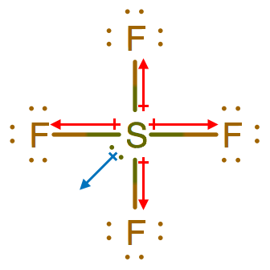
Figure 10: Lewis Structure and Dipole Moment of Sulfur tetrafluoride
T-shaped compounds are the result of trigonal bipyramidal electron structures having 3 bonds and 2 lone pairs on the central atom. Compounds with this shape, like iodine trichloride are polar.
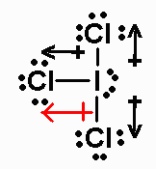
Figure 11: Lewis Structure and Dipole Moment of Iodine trichloride
The last kind of shape this type of electron structure can have is a linear geometry, which is one of the exceptions where we find a symmetrically distributed charge in the presence of lone pairs on the central atom. Compounds, like Xenon fluoride, exhibit this shape and are non-polar.
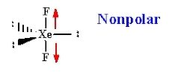
Figure 12: Lewis Structure and Dipole Moment of Xenon fluoride
Lastly, let’s look at the various molecular shapes an octahedral electron structure can have.
If the central atom has a total of 6 valence electrons and it uses all 6 of them to form bonds with identical terminal atoms, the molecular shape of the compound is called octahedral. And as we saw earlier in the video, compounds with this molecular geometry are non-polar because there is a symmetric distribution of charges. Sulfur hexafluoride is a good example for this.
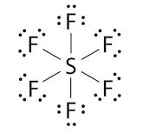
Figure 13: Lewis Structure of Sulfur hexafluoride
If only 5 of the electrons are bonded and one lone pair is left on the central atom, as seen in bromine pentafluoride, the compound will have a square pyramidal shape rendering an asymmetrical distribution of charges, which makes it polar.
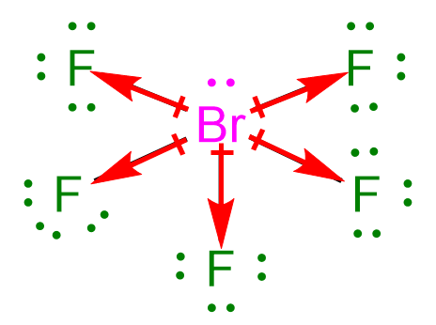
Figure 14: Lewis Structure and Dipole Moment of Bromine pentafluoride
Finally, when there are 4 bonds formed and 2 lone pairs left on the central atom, in compounds like Xenon tetrafluoride, the shape will be a square planar. This is the second instance where we see the dipole moments of the bonds canceling each other out even though there are lone pairs on the central atom. The compound is therefore non-polar.
Figure 15: Lewis Structure and Dipole Moment of Xenon tetrafluoride

Outro
Thank you for watching TutorTube! I hope you enjoyed this video. Please subscribe to our channel for more exciting videos. Check out the links in the description below for more information about The Learning Center and follow us on social media. See you next time!

References
Figure 1: Lavelle, L. “Dipole Moment understanding”. University of California, Los Angeles. https://lavelle.chem.ucla.edu/forum/viewtopic.php?t=3250
Figure 2: Gunawardena, G. “Dipole Moment”. Utah Valley University http://www.ochempal.org/index.php/alphabetical/c-d/dipole-moment/
Figure 3: Home, S. “Beryllium Hydride”. University of Wisconsin-Platteville and The Board of Regents - University of Wisconsin System. https://people.uwplatt.edu/~sundin/114/plbeh2.htm
Figure 4: “If BCl₃ bond has a dipole moment, explain why BCl3​ molecule has zero dipole moment”. Discourse. https://ask.learncbse.in/t/if-b-cl-bond-has-a-dipole-moment-explain-why-b-c-l---3-molecule-has-zero-dipole-moment/4974
Figure 5: Savitri. “Is SO2 Polar or Nonpolar?”. Techie Scientist. https://techiescientist.com/is-so2-polar-or-nonpolar/#:~:text=The%20calculated%20dipole%20moment%20of,sulfur%20dioxide)%20is%201.6%20debyes.
Figure 6: “Relationship between the dipole moment of a compound and electronegativities of constituent atom”. Stack Exchange. https://chemistry.stackexchange.com/questions/34897/relationship-between-dipole-moment-of-a-molecule-and-electronegativities-of-cons
Figure 7: “Relationship between the dipole moment of a compound and electronegativities of constituent atom”. Stack Exchange. https://chemistry.stackexchange.com/questions/34897/relationship-between-dipole-moment-of-a-molecule-and-electronegativities-of-cons
Figure 8: “Intermolecular Forces and Liquids and Solids”. Long Island university. https://myweb.liu.edu/~nmatsuna/chm3/lect/ch11.html
Figure 9: “How many of the following molecules are polar?”. Clutch Prep. https://www.clutchprep.com/chemistry/practice-problems/133824/how-many-of-the-following-molecules-are-polar-hint-all-of-the-bonds-in-these-mol
Figure 10: “Identify the molecules with a dipole moment”. Clutch Prep. https://www.clutchprep.com/chemistry/practice-problems/87453/identify-the-molecules-with-a-dipole-moment-a-sf4-b-cf4-c-cl2ccbr2-d-ch3cl-e-h2c
Figure 11: Laposa, J. D. “CHEMISTRY 1E03-01 TUTORIAL #7”. McMaster University. https://chemistry.mcmaster.ca/~chem1a3/tutorial/tu98arch/tu7-98a.htm
Figure 12: Nair, A. “Why are these compounds CO2, XeF2 and XeF4 non-polar?”. Quora.
https://study.com/academy/answer/what-has-a-higher-boiling-point-1-i-2-or-so-2-2-ch-2oh-or-o-2-3-nh-3-or-ch-4-4-hcl-g-or-cl-2.html
Figure 13: “General Chemistry: Principles, Patterns, and Applications”. Saylor Academy.
https://saylordotorg.github.io/text_general-chemistry-principles-patterns-and-applications-v1.0/s13-05-end-of-chapter-material.html
Figure 14: “Determine whether each molecule is polar or nonpolar:BrF5”. Clutch Prep.
https://www.clutchprep.com/chemistry/practice-problems/107612/determine-whether-each-molecule-is-polar-or-nonpolar-brf5
Figure 15: “Does xef4 have a permanent dipole moment?”. Doubtnut.
https://doubtnut.com/questions/does-xef4-have-a-permanent-dipole-moment-47223
Chemical Bonds. Khan Academy. Sept 12, 2020. Retrieved from https://www.khanacademy.org.
Valence-Shell Electron-Pair Repulsion Theory (VSEPR). Sept 12, 2020. Retrieved from http://chemed.chem.purdue.edu/genchem/topicreview/bp/ch8/vsepr.html
Helmenstine, A. Polar and Nonpolar Molecules. May 7, 2020. Retrieved from https://sciencenotes.org/polar-and-nonpolar-molecules/

