TutorTube: Present Perfect Spring 2021
Introduction
Hello and welcome to TutorTube, where The Learning Center’s Lead Tutors help you understand challenging course concepts with easy-to-understand videos. My name is Darren Churn, Lead Tutor for Spanish. In today’s video, we will explore the Present Perfect Tense. Let’s get started!

What is the Present Perfect?
When looking at tenses in Spanish, it is best to understand them in English first. The present perfect tense in English is best understood as “I have …ed.” This simplified explanation includes “I have, you have, he/she has, we have, and they have” along with the past participle version of the verb. In Spanish, we get the same idea. Instead of saying “have” the verb “haber” is conjugated based on the subject.

Present Perfect “Haber”
“Haber” in the present perfect has its own set of conjugations. The yo form is “he.” Tú is “has.” Él/ella/usted “ha.” Nosotros “hemos.” And ellos/ellas/ustedes “han.” These correspond to each of the different subjects used when conjugated in Spanish.

Forming the Past Participle
In order to form the present perfect, a past participle must be paired with the correct conjugation of haber. For regular past participles, there are two different endings for -AR verbs and -ER/-IR verbs. If a verb ends in -AR, the ending is dropped from the infinitive and replaced with “-ado.” Both -ER and -IR verbs end with “-ido.” Let’s do an example. If I said, “I have helped,” I would conjugated haber and then put ayudar into the past participle form. The sentence is now “He ayudado.” He has eaten” is “Ha comido.”
There are also irregular past participles. Below are some examples.

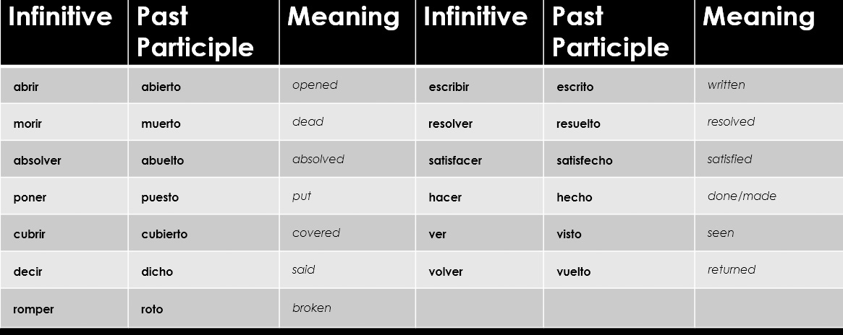
Figure 1
These irregulars will be used instead of adding “-ado” or “-ido” to the end of the verb. “I have returned” is “He vuelto.”

Present Perfect Subjunctive
Along with the present perfect, there is the present perfect subjunctive. The subjunctive tense is used for Wishes, Emotions, Impersonal Statements, Recommendations, Doubts, and Ojála, aka “WEIRDO.” When forming the present perfect subjunctive, there will now be two separate clauses: a present tense clause and the present perfect subjunctive clause. Before discussing the sentence structure further, there are new conjugations to learn.
When looking at haber in the present perfect subjunctive, we get the following conjugations: yo – “haya,” tú – “hayas,” él/ella/usted – “haya,” nosotros/-as – “hayamos,” and ellos/ellas/ustedes – “hayan.” With all of these conjugations, the part participle is still added after the verb “haber.”
The sentence structure of the present perfect subjunctive includes two individual clauses. The beginning there is a present tense clause which is followed by “que” which is then followed by our present perfect subjunctive clause. Let’s look at some examples. A good example is “I hope that he has bought a car.” In this example, our present tense clause is “I hope.” In Spanish, this translates to “Espero.” Then we add “que.” The we have our present perfect subjunctive clause of “he has bought a car.” In Spanish, we use the él/ella/usted form of haber for the tense and the past participle for comprar, which is “comprado.” The entire sentence is “Espero que haya comprado un coche,” “I hope that he has bought a car.”
Another example that revolves around doubt is “My father doubts that I have finished my homework.” Our first clause is “My father doubts” which is “Mi padre duda.” Our second clause is “I have finished my homework” which is “haya terminado mi tarea.” The entire sentence translates to “Mi padre duda que haya terminado mi tarea.”

Outro
Thank you for watching TutorTube! I hope you enjoyed this video. Please subscribe to our channel for more exciting videos. Check out the links in the description below for more information about The Learning Center and follow us on social media. See you next time!

