TutorTube: Discrete Probability Distributions Fall 2020
Introduction
Hello, welcome to another edition of TutorTube, where the Learning Center’s Lead Tutors help you understand challenging course concepts with easy to understand videos. My name is Kelly Schmidt, Lead Tutor for statistics at the Learning Center. In today’s video, we will explore a few of the fundamental topics and skills related to chapter 6 and probability distributions that will help you to be successful in the course. Let’s get started!
Discrete Probability Distributions
First, let’s look at what a discrete probability distribution is. This table is an example.
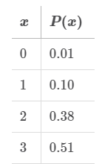
Figure 1: Probability Distribution for a Random Variable, x
The first column gives us the four possible values of some random variable, $x$. For example, the data in this table might be representing the results you would expect to get if you had spun a spinner that looked like this:

Figure 2: Spinner Representing P(x)
You have a 51% chance of landing on 3, a 38% chance of landing on 2, a 10% chance of landing on 1, and only a 1% chance of landing on 0.
There are two main conditions that our probability distributions have to meet.
- First, all the values in the P(x) column must add up to be exactly 1.
- Second, none of the values of P(x) can be negative.
If we think of this in terms of the spinner, it makes sense. We can’t have a total of more than 1 (which would be more than 100%). It wouldn’t fit into our circle. For the second rule, a negative probability wouldn’t make sense either; the lowest possible probability is 0.
Now, given a discrete probability distribution like this, we can calculate both the mean (also known as the expected value) and the standard deviation using these formulas.
Mean:
$μ_{x}= \sum{[x∙P\left(x\right)]}$

Standard Deviation:
$σ_{x}= \sqrt{\sum{[{\left(x-μ_{x}\right)}^{2}∙P\left(x\right)]}}$

To find the mean by hand, we would need to plug the values for $x$ and $P(x)$ into these formulas and find each answer. However, StatCrunch lets us do it much faster.
Practice #1:
For practice, let’s find the mean and standard deviation of the following discrete probability distribution using StatCrunch.
x | P(x)
0 | 0.01
1 | 0.10
2 | 0.38
3 | 0.51

First, we open up our data in StatCrunch. We have our $x$ column labeled “x” and our probability column labeled “P(x).” Now, click on Stat, then Calculators, then Custom.
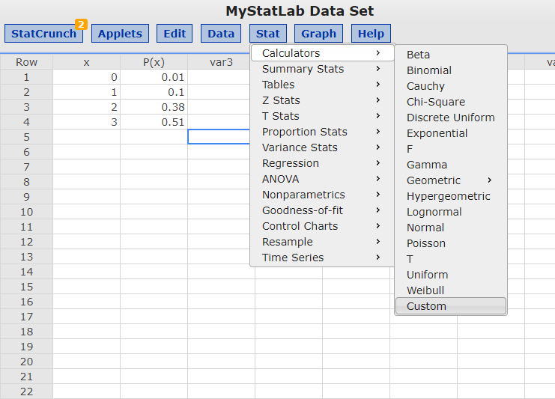
Figure 3: Stat > Calculators > Custom
Enter the column name, x, under Values in. Then enter the probability column, P(x), under Weights in. Now click on Compute.
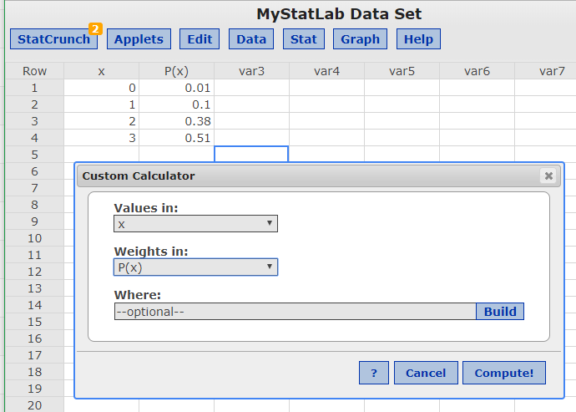
Figure 4: Custom Calculator Window
This will open up our results window.
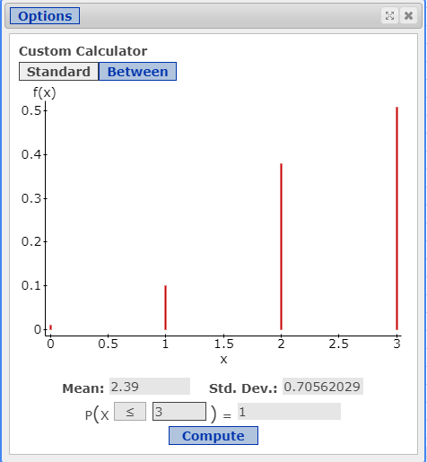
Figure 5: Results Window
We can see that our mean here is 2.39 and our standard deviation is 0.7056.

Practice #2 Roulette
Next, let’s look at an example of how this might be useful in the real world: in gambling.
In a game of roulette, a player can place a $15 bet and have a 1/38 probability of winning. If the player wins, they are awarded $525.
What is the expected value of the game to the player?
We start by making a discrete probability distribution for this situation. The probability of winning is 1/38 and the probability of losing is 37/38.
If the player wins, they are awarded 525 dollars. So, 525 is the value of our variable x in the case of a win. If the player loses, they lose their bet of 15 dollars. So, the value of x in the case of a loss is -15.
$$x$$ | $$P(x)$$
Winning  $$\$525$$ | $$\frac{1}{38}$$
Losing  $$-\$15$$ | $$\frac{37}{38}$$
Figure 6: Probability Distribution for Roulette Problem
To find the value they would expect to win on this game, we need to find the mean of this probability distribution. We can do this on StatCrunch by inputting these values and following the same steps we did before, or we can simply find the value by hand since this is a small dataset.
Recall that the formula for the mean of a discrete random variable (also known as the expected value) is $μ_{x}= \sum{[x∙P\left(x\right)]}$. While this may look intimidating, all it means is that we need to multiply each x value by its associated probability and add the results together.
For example, here we take the first value of x (525) and multiply it by its probability (1/38). Then we do the same for the second value of x (-15). We multiply it by its probability of 37/38.
$$\left(525\right)\left(\frac{1}{38}\right)+\left(-15\right)\left(\frac{37}{38}\right)$$
= $-0.79$
Finally, we add everything together and get a final answer of -0.79 or -79 cents. Interpreting this, we would say that we could expect to lose an average of 79 cents per game if we played this game many times.
Practice #3 Lottery
Next, we can look at how the concept of probability distributions can be applied to lottery problems. Let’s say that we have the problem below:
Given the following information about a fictional lottery, how big would the grand prize need to be so that a person might expect to break even with a purchase of a $1 ticket.
Prize | Number of Tickets
Grand Prize | 1
$1000 | 2
$5 | 3
$0 | 9994
Figure 7: Lottery Distribution
Based on the table here, we know that there is only one grand prize ticket available. There are two tickets in the pool that will win a person a $1000 prize. There are three possible tickets that will win $5, but the majority of tickets in the pool (the 9994 remaining) are all losing tickets.
Total, we have 10,000 tickets in this lottery.
To solve this problem, we start by setting up an equation:
$$\left(Expected Value\right)-\$1=0$$
The left half of the equation shows the amount we expect to win (the expected value) minus the amount we spent to buy a ticket (one dollar). We set it equal to zero because we are interested in the point at which we break even (where our profit is zero).
Next, we find the probabilities associated with each outcome. There are 10,000 tickets in total, so we divide the number of tickets in each category by this total.
Prize | Number of Tickets | Probability (P(x))
Grand Prize | 1 | $$\frac{1}{10,000}= .0001$$
$1000 | 2 | $$\frac{2}{10,000}= .0002$$
$5 | 3 | $$\frac{3}{10,000}= .0003$$
$0 | 9994 | $$\frac{9994}{10,000}= .9994$$
Figure 8: Lottery Distribution with Probabilities
Now we use these probabilities to construct the formula for expected value.
$$\left(Expected Value\right)-\$1=0$$
$$[Grand\left(.0001\right)+1000\left(.0002\right)+5\left(.0003\right)+0(.9994)]-\$1=0$$
After plugging in our values, we simplify and use some algebra to solve for the value of our unknown, “Grand.”
First, we multiply out our terms.
$$⇒Grand\left(.0001\right)+.2+.0015+0+1=0$$
Then, we combine like terms.
$$⇒Grand\left(.0001\right)-.7985=0$$
Then we add .7985 to both sides.
$$⇒Grand\left(.0001\right)=.7985$$
Then we divide both sides by .0001.
$$⇒Grand=\frac{.7985}{.0001}$$
$$⇒Grand=7985$$
This gives us our final answer of 7,985.
So, we know that our grand prize must be at least $7,985 before we can expect to break even playing this lottery.
Alright, so I hope this gives you a good idea of some of the problems you might encounter when working with discrete probability distributions.
Outro
Thank you for watching this TutorTube presentation! I hope you enjoyed this video. Please subscribe to our channel for more exciting videos. Check out the links in the description below for more information about The Learning Center and follow us on social media. See you next time!
References
Pearson. (2020). MyLab: Statistics. Pearson Higher Education Inc.
*All calculations in this video were performed with Pearson StatCrunch 2020 software.

