TutorTube: SOAP Notes Fall 2020

Introduction
Hello and welcome to TutorTube, where The Learning Center’s Lead Tutors help you understand challenging course concepts with easy to understand videos. My name is Grace, Lead Tutor for Audiology and Speech-Language Pathology. In today’s video, we will explore SOAP Notes. Let’s get started!

Purpose
A SOAP note is used in medical, therapy, or other settings to record and analyze data specific to a client’s ongoing performance in therapy.

What Does It Mean?
S-Subjective
O-Objective
A-Assessment
P-Plan
Let’s look into these sections further.

Subjective
The subjective section focuses on your impressions of the client supported by observed facts. This can include: a description of how the client feels, physical characteristics, sensory characteristics, impressions and comments from the client or family. For instance, “Client’s motivation appears poor. He did not complete any homework and was not finishing therapy tasks.” Since you directly observed this client’s behavior then you are able to report on it in this area. If there is no important information to include here, then it is acceptable to leave it out.

Objective
The objective section is for measurable information about the client’s performance and testing data. For example, “produced /t/ sound correctly in 13/15 utterances.”

Assessment
The assessment section is where you analyze and compare data to assess the session. You write interpretations of the data collected. The assessment section can include: statement of how client is progressing, type/level of cues or prompts, techniques used to facilitate improvement, interpret and summarize objective data, severity of problem, and compare performance to previous sessions. For example, “performance improved from 40% accuracy last session to 60% accuracy this session.”

Plan
The plan section is the outline for the next session. It can include the recommendation for future treatment. For example, “introduce 3 letter words in treatment activities.”

What Not To Do
S: Do not make subjective statements without out supportive facts. Do not use any information that could be biased.
O: Do not write general statements without data
A: Do not re-report data from the objective section
P: Do not re-write the treatment plan

Organization
Your SOAP Note should look something like this:
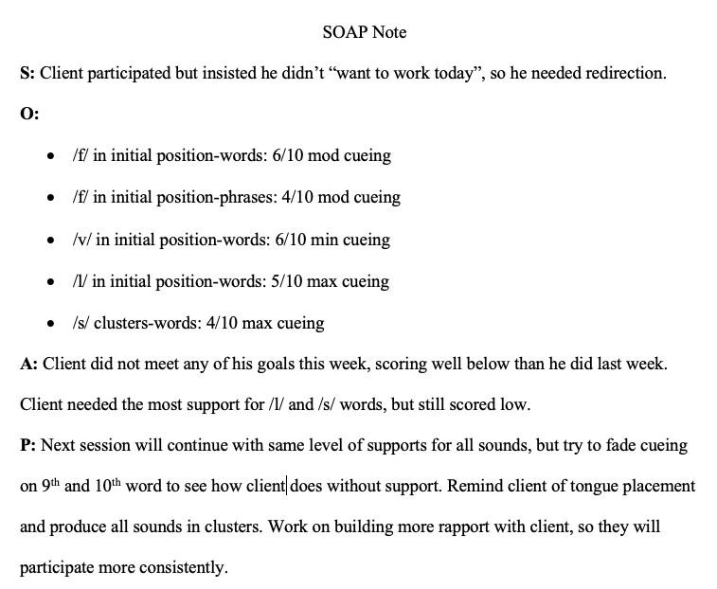
Image 1
Each section is straight forward and organized. Each section starts with the letter and a colon and is followed with the corresponding information. It is appropriate to list data in bullets for the objective.

Practice
We are going to take the information below and sort them into the SOAP Note categories. The first one we have here is: “Produced 9/10 names of farm animals correctly during facilitative play.” Since this is measurable information then it goes under the objective section of the SOAP Note. The second piece of information is: “Client seemed happy. He told me how fun his day had been and how he likes riding in the car to therapy. Client’s mother said he had been having a good day.” This description provides subjective information with supportive facts, so this goes under the subjective category. The third piece of information is: “We will continue current treatment, as well as introducing more general animal vocabulary during the next session.” This is an outline for future sessions, so this goes under the plan category. Our last bit of information is: “Accuracy from the last session increased from 80% to 90% during this session.” This is an assessment of the objective information from the last session and the current session so this is categorized under assessment. Let’s do some more practice.

Practice
The first piece of information we have here is: “Continue current treatment activities.” This is the intention for the next session, so it is the plan. The next piece of information we have is: “Client’s motivation appears good. He completed all homework and asked for more.” This is the clinician’s impression of the client supported by observed facts, so this is the subjective. The third piece of information is: “Without visual cues by clinician, success decreased significantly.” This is a comparison of data (as well as an interpretation of data), so this is the assessment. Our last piece of information is: “Produced /r/ correctly in 18/25 sentences (72%) with cueing from clinician.” This information is measurable data, so this is the objective.

Review
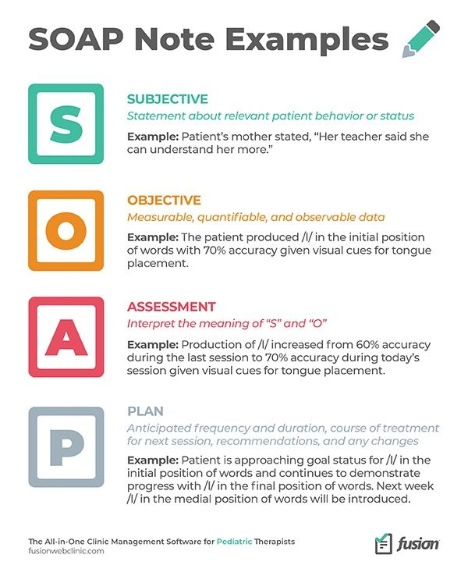
Figure 1 (“Pediatric Therapy”)
Outro
Thank you for watching TutorTube! I hope you enjoyed this video. Please subscribe to our channel for more exciting videos. Check out the links in the description below for more information about The Learning Center and follow us on social media. See you next time!

References
Figure 1: “Pediatric Therapy Clinic Resources.” Fusion Web Clinic, 14 Oct. 2020, fusionwebclinic.com/resources/.

