TutorTube: SPSS – One-Way ANOVA Fall 2020
Introduction
Hello, welcome to another edition of TutorTube, where the Learning Center’s Lead Tutors help you understand challenging course concepts with easy to understand videos. My name is Kelly Schmidt, Lead Tutor for statistics at the Learning Center. In today’s video, we will run through the process of conducting a one-way ANOVA in SPSS. Let’s get started!

Research Question
First, let’s define our research question. In this example, we are interested in examining the levels of social activism among college students. We hypothesize that a student’s year in college (freshman, sophomore, junior, or senior) will impact their level of social activism, but we don’t know how. In order to test this, we gather the following data from a group of 40 students. Each student is either in year 1, 2, 3, or 4 in school, and their scores on a test of activism are recorded.
Year | Activism | Year | Activism | Year | Activism | Year | Activism
1.00 | 52.00 | 2.00 | 53.00 | 3.00 | 35.00 | 4.00 | 60.00
1.00 | 61.00 | 2.00 | 50.00 | 3.00 | 34.00 | 4.00 | 56.00
1.00 | 60.00 | 2.00 | 42.00 | 3.00 | 36.00 | 4.00 | 57.00
1.00 | 50.00 | 2.00 | 40.00 | 3.00 | 37.00 | 4.00 | 55.00
1.00 | 54.00 | 2.00 | 45.00 | 3.00 | 30.00 | 4.00 | 56.00
1.00 | 56.00 | 2.00 | 45.00 | 3.00 | 31.00 | 4.00 | 54.00
1.00 | 58.00 | 2.00 | 50.00 | 3.00 | 33.00 | 4.00 | 58.00
1.00 | 57.00 | 2.00 | 41.00 | 3.00 | 34.00 | 4.00 | 57.00
1.00 | 60.00 | 2.00 | 42.00 | 3.00 | 35.00 | 4.00 | 59.00
1.00 | 56.00 | 2.00 | 45.00 | 3.00 | 36.00 | 4.00 | 58.00

We are interested in comparing the mean scores between these four groups. Looking at the scores themselves, we can see by inspection that it looks like year 3, the juniors, appear to have lower scores than the other three groups. However, in order to get a better sense of this difference and how our sample represents the overall population, we will need to use a one-way ANOVA.

Data Entry
First, we need to input our data into SPSS. When we first open up SPSS, we will see a blank data sheet that looks like this:
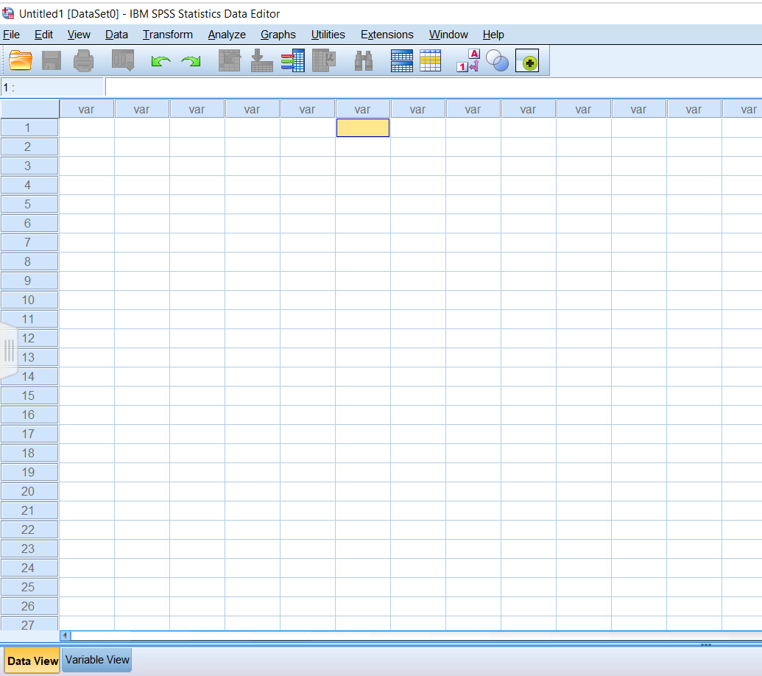
Figure 1. Data View Window
Notice that we are in Data View. This is the place where we can enter our raw data. In the first column, let’s enter the values for our years: either 1, 2, 3, or 4. Remember that in SPSS each row represents a single person, so we can’t enter the data as they appear in our table above. We’ll need to enter them in just two columns: one for Year and one for their Activism score.
Notice that as we enter our data for Year, SPSS automatically names our column VAR00001. We can clean this up later, so for now let’s move on to entering the data for Activism scores.
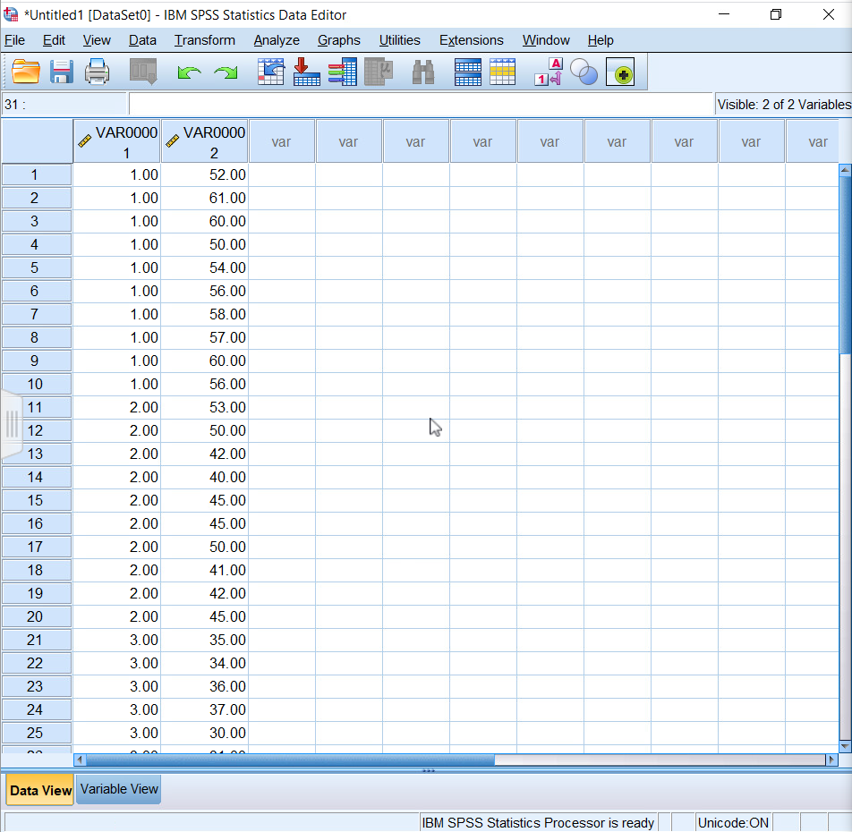
Figure 2. Data View Initial
Ok, now that we’ve entered the raw data, we need to code it so that SPSS knows how to treat it. Click on Variable View in the bottom left to switch the to the Variable View window.
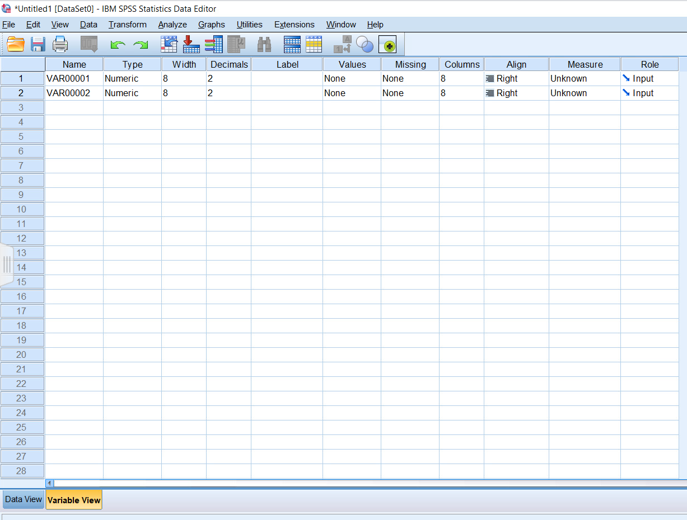
Figure 3. Variable View
The first row here corresponds to our Year column. We can rename this column “Year” instead of VAR0001.
Next, we want to label the values themselves. Click on the box that appears in the “Values” cell. This will open up a new window. Remember that instead of entering the names of the years themselves (freshman, sophomore, junior, senior), we entered dummy coded labels of 1, 2, 3, and 4. Here we can tell SPSS what each of those dummy coded numbers corresponds to. For a value of 1, we have a label of Freshman.
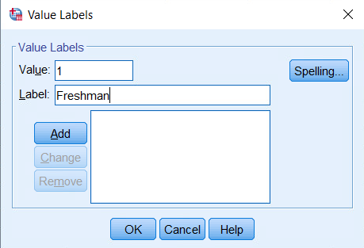
Figure 4. Value Labels Window
Now click on Add. We see that this label has been added to the system. Now every time SPSS sees a 1 in the Year column, it will know to label it as Freshman in the output. We repeat the process with Sophomores, Juniors, and Seniors.
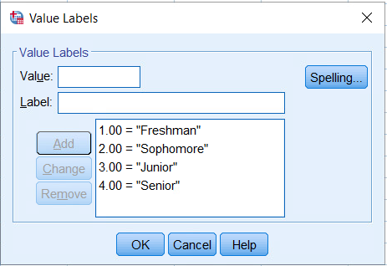
Figure 5. Value Labels Window Final
Now click on “OK” to move back to Variable View. The last thing we need to do for this column is to specify the Measure for this variable. Since Years correspond to names (either Freshman, Sophomore, Junior, or Senior) this is considered Nominal data.
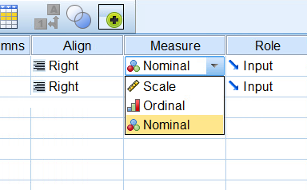
Figure 6. Measure Options
Now we can switch back to Data View to see how this has changed our data.
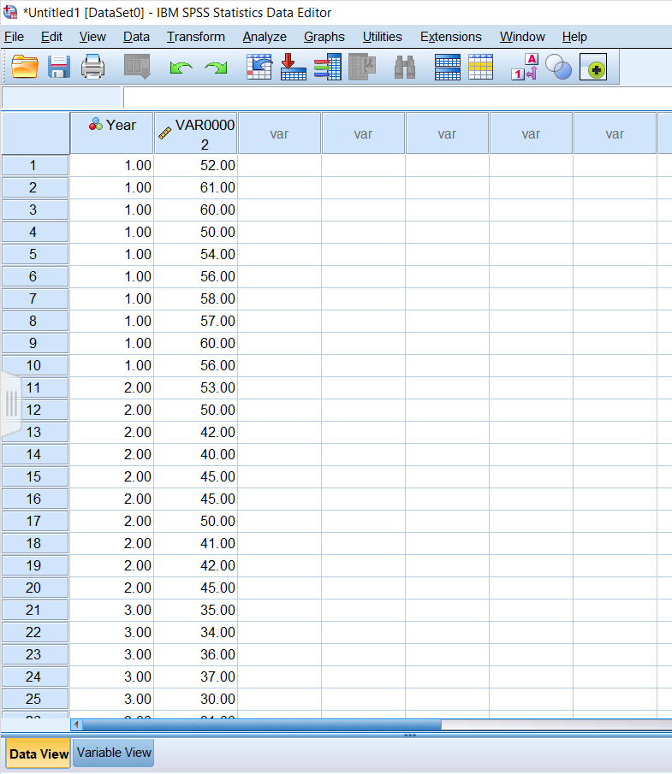
Figure 7. Data View
Notice that the column name has now been changed to Year and that the three bubbles next to it are now denoting this variable as nominal instead of scale. Now we can switch back to Variable View and repeat a similar process for the Activism scores column.
Here, we rename the column “Activism” and change the measure to scale. The scores here are our dependent variable, and in a one-way ANOVA these will always be a numerical or scale measure.
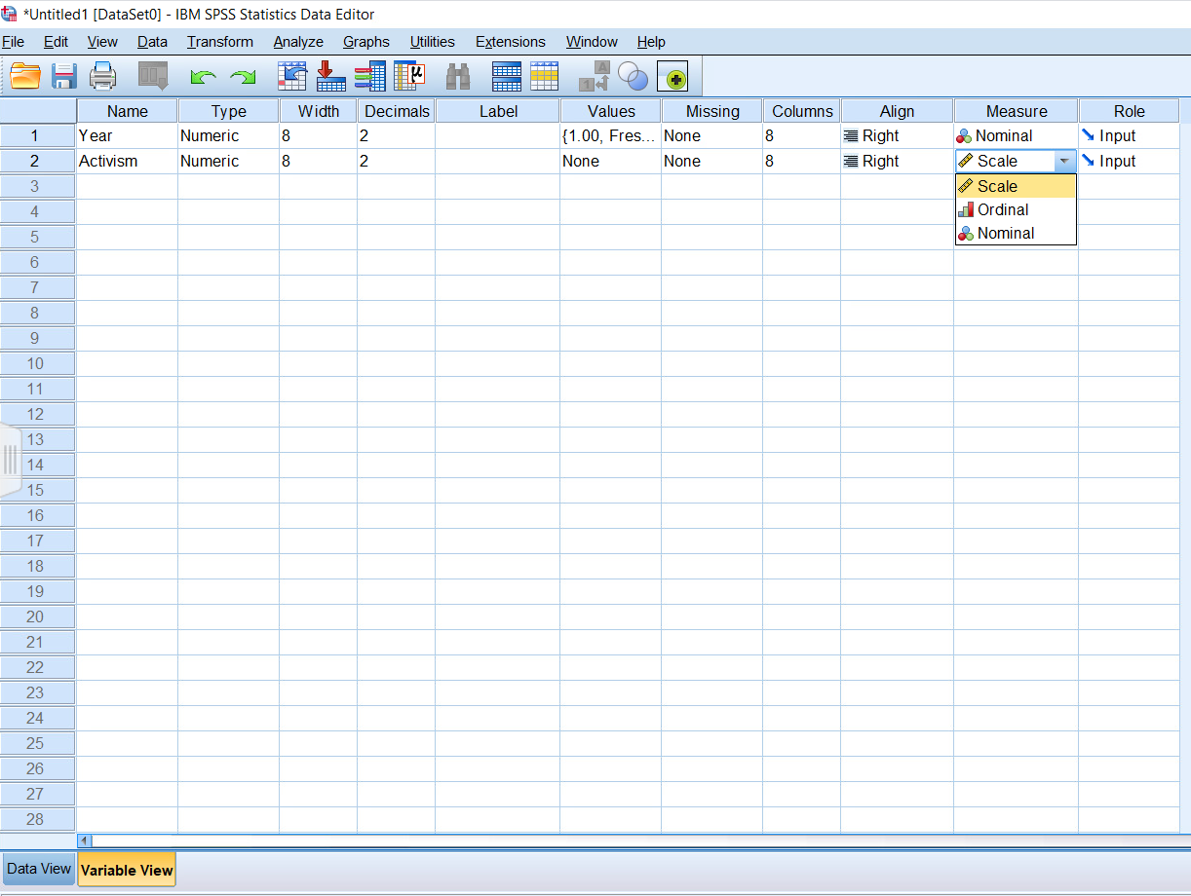
Figure 8. Variable View for Activism

Data Analysis
Now that we have all our data coded, we can move onto the analysis step. There are two ways to conduct a one-way ANOVA in SPSS; they both provide the same results, but one goes a bit more in-depth and you can get a few more values from the output.
Click on “Analyze,” then “General Linear Model,” and then “Univariate.”
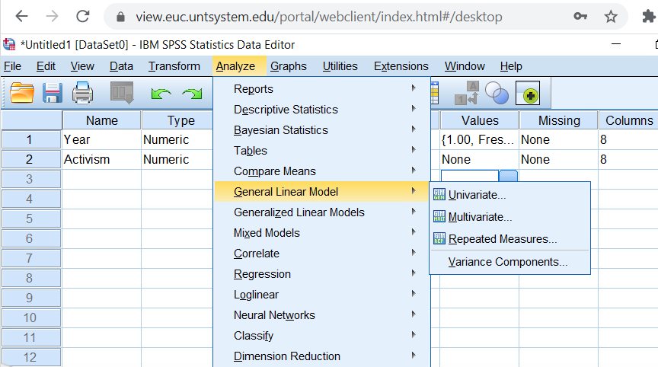
Figure 9. Analyze > General Linear Model > Univariate
This will open up the window for a Univariate analysis, which is what need. First, we choose our dependent variable. For a one-way ANOVA this will be your scale variable: the activism scores we wanted to compare. Click on Activism and then the arrow to add it into the Dependent Variable box.
Next, we select our independent variable: our groups. Click on Year, and then click on the arrow to move it into the Fixed Factors box.
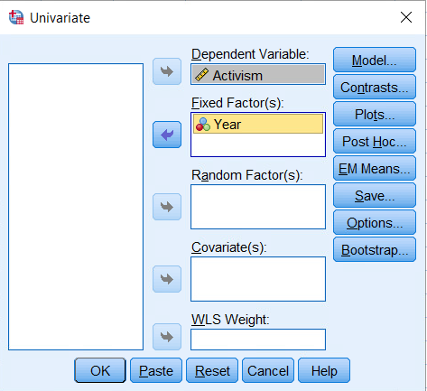
Figure 10. Univariate Window for an ANOVA
Now, we will click on Options and select the boxes next to the statistics we want to see.
Descriptive statistics will give us the summary stats (the mean, standard deviation, standard error, and size) for each group.
Estimates of effect size will calculate the $η^{2}$ for the main effect. In other words, this will give us a way to see if the differences between our groups were big enough to matter.
Observed power is also good to include. Recall that power is essentially your ability as a researcher to detect an effect using the sample we have. Think of power as a magnifying glass that you are trying to use to find a difference between these groups.
We also want to be sure to include Homogeneity tests. This will help us to check our assumption of homogeneity of variance. You’ll also hear this referred to as Levene’s test.
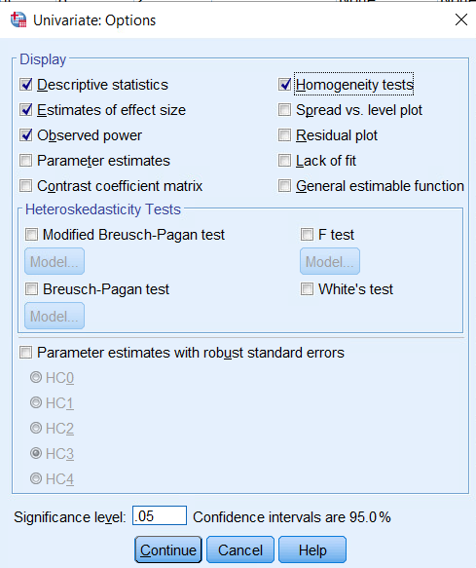
Figure 11. Options Window
Click Continue to move back to the original window. Lastly, we can also include Post Hoc tests by clicking on Post Hoc. Technically, we wouldn’t run the Post Hoc tests until we’ve verified that our variances are roughly equal and that a significant main effect exists, but for demonstration, I’ll run them now.
Click on the factor that you want to test, Year. Use the arrow to move it into the Post Hoc Tests box. Once there, it will allow you to select which types of Post Hoc tests you’d like to run. For a one-way ANOVA like this with roughly equal sample sizes in each group, we can go ahead and run Tukey. Now, click on Continue.
Ok, now we are good to go. Click on OK.
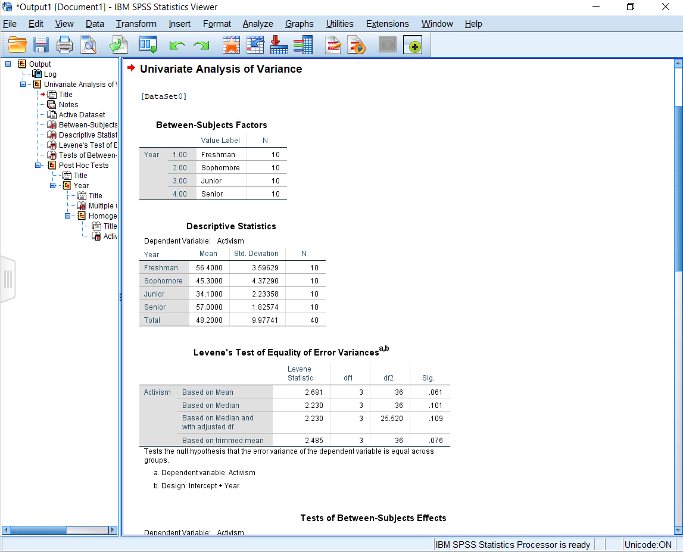
Figure 12. Output Window
From here, SPSS will give us our output file. We can see the title of the analysis we just ran (a Univariate Analysis of Variance or One-Way ANOVA) at the top. We can also see our descriptive statistics, test for homogeneity of variances (which is met at a significance of .061), and the rest of our results as we scroll down.
And with that, we have gone through the process of conducting a one-way ANOVA!

Outro
Thank you for watching this TutorTube presentation! I hope you enjoyed this video. Please subscribe to our channel for more exciting videos. Check out the links in the description below for more information about The Learning Center and follow us on social media. See you next time!

References
*All analyses performed with IBM SPSS Statistics 26.

