TutorTube: Sampling Distribution of the Mean Spring 2021
Introduction
Hello, welcome to another edition of TutorTube, where the Learning Center’s Lead Tutors help you understand challenging course concepts with easy to understand videos. My name is Kelly Schmidt, Lead Tutor for statistics at the Learning Center. In today’s video, we will go through the process of solving a typical problem involving the mean of a sampling distribution using StatCrunch. Let’s get started!

Sampling Distribution of $\overline{x}$
In order to understand how to use StatCrunch to find probabilities involving a sample mean, let’s start by looking at an example of a typical problem one might see.
The IQ of humans is approximately normally distributed with a mean of $μ=100$ and $σ=14.$Find the probability that a simple random sample of 49 people will result in a sample mean greater than 105, $P(\overline{x}>105)$.

Checking Assumptions
In order to use the normal calculator in StatCrunch to calculate this probability, we first need verify that the sampling distribution is normally distributed. There are two conditions we need to look for:
- First, the question might state that the sample comes from a population that is normally distributed. If this happens, we know automatically that we have met our assumption, and we can move on to the next part of the test. For example, our question here says that “The IQ of humans is normally distributed” so we are good to go.
- If the question doesn’t specify that the sample comes from a normal population, we have to check a second condition: the sample size must be greater than 30. In our example, the sample size is 49, so this condition is met as well. By the Central Limit Theorem, we know our sampling distribution will be approximately normal.

Find $μ_{\overline{x}}$ and $σ_{\overline{x}}$
Now that we verified our assumptions, we can move onto the second step: finding the mean and standard error the sampling distribution. The formula for the mean is simple.
$$μ_{\overline{x}}= μ$$
The mean of the sampling distribution is the same as the population mean. In our problem, the mean of the population was given as 100, so this will also be the mean of the sampling distribution.
The standard error of the distribution, $σ_{\overline{x}}$, requires a little calculation, but we can find it by dividing the standard deviation of the population by the square root of the sample size.
$$σ_{\overline{x}}= \frac{σ}{\sqrt{n}}$$
So for our problem, we would take 14 divided by the square root of 49, which is 7. This will give us a standard error of 2. From here, we now have everything we need to go to StatCrunch.

Normal Calculator
In StatCrunch, we will go to Stat, Calculators, Normal.
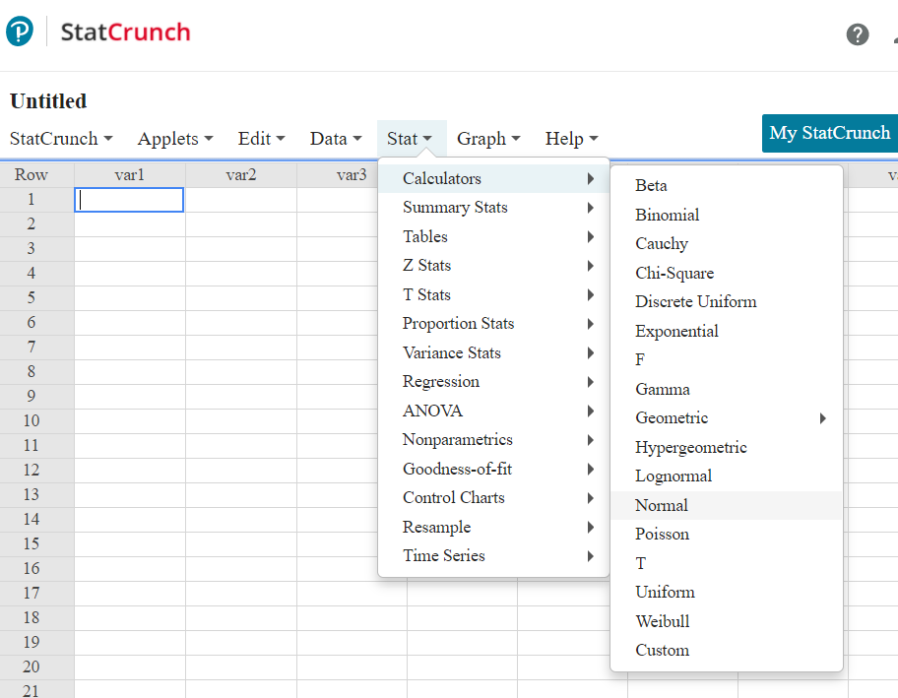
Figure 1. Stat > Calculators > Normal
This will open up the Normal Calculator. Remember the reason we can use this calculator is because we first verified our assumptions of normality of the sampling distribution. Once we are here, we will enter the mean and standard error that we just found: 100 for the mean and 2 for the standard error.
Next, the problem asked us to find the probability of observing a sample mean greater than 105. So, we need to enter 105 in the box and flip the sign to a greater than or equal to.
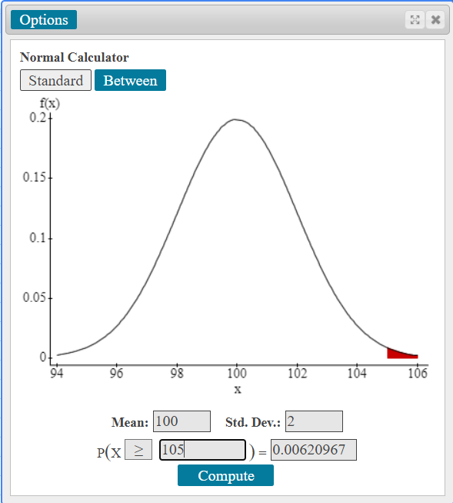
Figure 2. The Normal Calculator
After we click Compute, we can see the answer in the box on the right here, about 0.0062. So if we were to interpret this, we could say that there is only a 0.62% chance of seeing a sample of 49 people with a mean IQ score greater than 105.

Between Calculator
Next, let’s say that the problem asked:
Find the probability of seeing a sample of 49 people with a mean IQ between 98.2 and 103.
Since the mean and standard error haven’t changed from the first part of the problem, we can just click on the Between button on the normal calculator to switch the view.
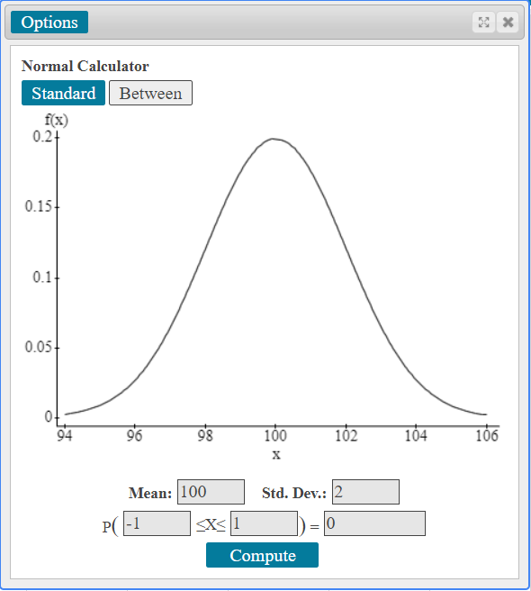
Figure 3. Between Function in the Normal Calculator
Notice that we now have two boxes instead of just one. Here we can enter the upper and lower scores that the problem asked for: 98.2 and 103.
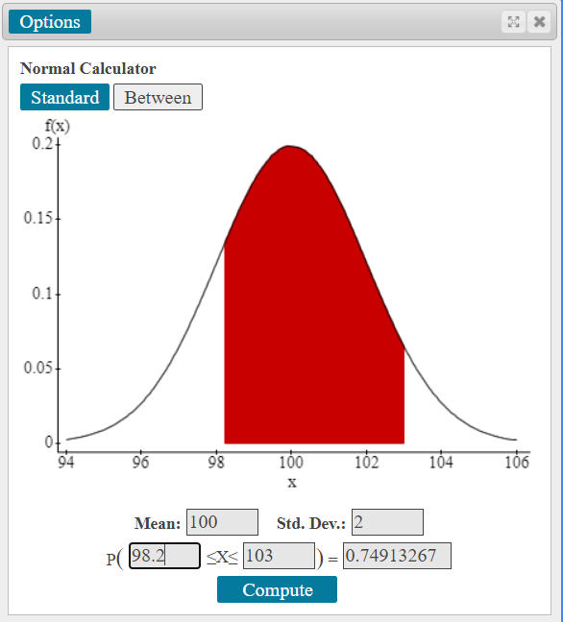
Figure 4. Area between 98.2 and 103
After we hit Compute, we can see that the probability is 0.749. Interpreting this, we would say that there is roughly a 74.9% chance of seeing a sample of 49 people with a mean IQ between 98.2 and 103.

Properties of the Normal Curve
Finally, we might be asked:
Find the probability of obtaining a random sample of 49 people with a mean IQ score more than 4 points from the population average.
We can also use the Between Calculator to solve this, but first we need to find our upper and lower limits. We know that the population average is 100. If we are more than 4 points away from the mean in the positive direction, we will be interested in the probability of seeing values greater than 104.
On the other hand, if we are more than four points away from the mean in the negative direction, we will be looking at the probability of seeing values less than 96.
When we plug in 96 and 104 into the between calculator, we find that the probability of being between these values is 0.9545.
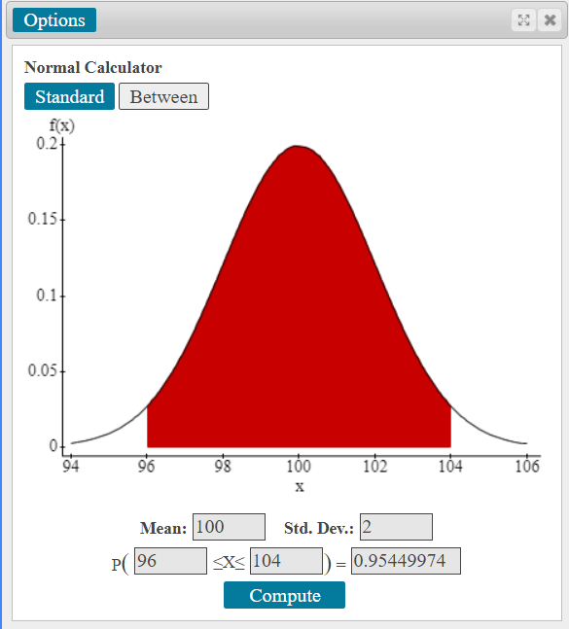
Figure 5. Area between 96 and 104
Using the fact that the total area under the normal curve is equal to one, we can find the probability we need by taking:
$$1-P(96≤ \overline{x} ≤104)$$
which is equal to:
$$1-0.9545=0.0455$$
So, we can say that there is only a 4.55% chance of obtaining a sample of 49 people with a mean IQ that is more than 4 points away from the population mean of 100.
Alright, with that we have covered the basics of a typical sampling distribution problem using StatCrunch.

Outro
Thank you for watching this TutorTube presentation! I hope you enjoyed this video. Please subscribe to our channel for more exciting videos. Check out the links in the description below for more information about The Learning Center and follow us on social media. See you next time!

References
Pearson. (2020). MyLab: Statistics. Pearson Higher Education Inc.
*All calculations in this video were performed with Pearson StatCrunch 2020 software.

