TutorTube: Set Operations Spring 2021
Introduction
Hello and welcome to TutorTube, where The Learning Center’s Lead Tutors help you understand challenging course concepts with easy to understand videos. My name is Ethan Gomez, Lead Tutor for Math. In today’s video, we will explore set operations. Let’s get started!

Operation Comparison
In most of your math classes, you’ve probably had to add, subtract, divide, and multiply numbers, but the way you perform those operations changes depending on the type of numbers you’re dealing with. For example, if we wanted to add the natural numbers 2 and 7 together, we would combine the quantities to get a value of 9:
$$2+7=9$$
However, if we wanted to add the following rational numbers, we have to take a slightly different approach than in the previous example:
$$\frac{2}{3} + \frac{1}{2} = \frac{4}{6} + \frac{3}{6} = \frac{7}{6}$$
Here, we can’t simply add straight across; we need to find a common denominator and then add the numerators together. Again, the same operation can look different based on how you’re using them. This is because we need to understand the nature of the elements that we are trying to operate on. Fractions have a different meaning than natural numbers. Similarly, sets represent something completely different than fractions or natural numbers. Therefore, if we want to perform operations on sets, we need to understand what sets are. We do have another video in our TutorTube library that discusses what sets are in detail if you want to check that out, but generally, sets contain elements. Hence, the operations associated with sets involve the comparison of elements within sets. Let’s take a look at what some of the common set operations look like.

Union Operation
The union operation on sets is the combination of elements within two or more sets to create a new set. If we consider sets A and B, we would notate the union of A and B like this:
$$A∪B$$
This reads, “A union B,” which is then interpreted as the union of sets A and B. The concept of union is described using this set notation:
$$A∪B = \left\{x: x∈A or x∈B\right\}$$
This reads, “The union of sets A and B equals the set of elements x such that x belongs to A or x belongs to B.” In other words, the union of any two sets is itself a set that contains elements who can be found in either set A or B; if an element is at least in one of A or B, then it will also be in the union. Here is an image of a venn diagram representation to help us visualize how the union of sets works, where the shaded region is the union:
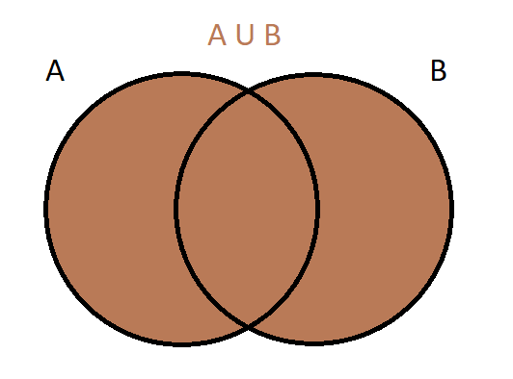
Figure 1
Now let’s look at an example with numbers to get a better understanding of this concept. Let’s consider a set A and a set B:
$$A = \left\{1, 7, 12\right\}$$
$$B = \{1, 3, 4, 7\}$$
Set A contains the elements 1, 7, and 12, whereas B contains 1, 3, 4, and 7. If we want to find the union of sets A and B, then we must consider the elements that belong to either one of them; it’s like putting all the elements of both sets into a single set. Thus, we get the union to be the following:
$$A∪B =\{1, 3, 4, 7, 12\}$$
The union contains the elements 1, 3, 4, 7, and 12. Let’s go through each element individually and double check with the definition of union. Every element in the union must be found in either A by itself or in B by itself. Starting with 1, we can see that it is in both A and B. However, by definition, the fact that it is in at least one of them is good enough. For the element 3, it’s not in A, but it is in B, so it satisfies the conditions. A similar argument can be made for the element 4. The element 7 is in both, so it checks out. Finally, we have 12; 12 is in A, so even though it’s not in B, it will still be in the union by definition.

Intersect Operation
The intersect operation on sets is the similarity of elements within two or more sets to create a new set. If we consider sets A and B, we would notate the intersection of A and B like this:
$$A∩B$$
This reads, “A intersect B,” which is then interpreted as the intersection of sets A and B. The concept of intersection is described using this set notation:
$$A∩B = \left\{x: x∈A and x∈B\right\}$$
This reads, “The intersection of sets A and B equals the set of elements x such that x belongs to A and x belongs to B.” In other words, the intersection of any two sets is itself a set that contains elements who can be found in both set A or B; if an element is in both A and B, then it will also be in the intersection. Here is an image of a venn diagram representation to help us visualize how the intersection of sets works, where the shaded region is the intersection:
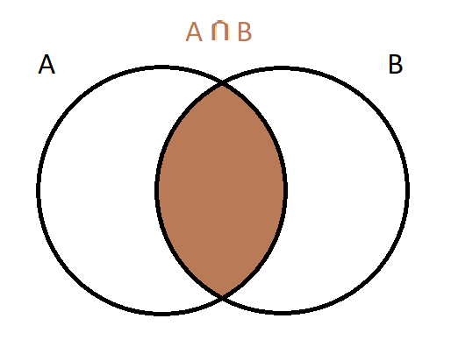
Figure 2
Now let’s look at a few examples with numbers to get a better understanding of this concept. Let’s bring back sets A and B to see the difference between their union and intersection.
$$A = \left\{1, 7, 12\right\}$$
$$B = \{1, 3, 4, 7\}$$
If we want to find the intersection of A and B, we must find the elements that belong to both sets, not just one or the other. In both sets, we see that the only elements A and B have in common are 1 and 7. Therefore, the intersection of A and B will be the set containing elements 1 and 7:
$$A∩B = \left\{1, 7\right\}$$
Now, this begs the question: What if two sets don’t have any elements in common? What would the intersection of those two sets be? Let’s look at an example where this is the case. Let’s define sets C and D so that they don’t share any elements, like this:
$$C = \left\{-5, 0, 1\right\}$$
$$D = \{2, 3, 8\}$$
Since C and D do not share any elements, then the intersection contains no elements. But by definition, the intersection of sets is itself a set, so what is a set that has no elements? We call this the empty set, and it has a special symbol that looks like this:
$$C∩D = ∅$$
Here is an image of a venn diagram representation to help us visualize how the intersection of sets might result in being the empty set:
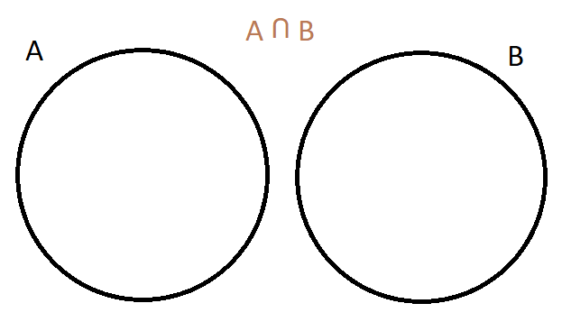
Figure 3
The empty set has a lot of other cool nuances, but the most important is that it is a subset of all sets.

Difference Operation
The difference operation on sets is the difference of elements within two or more sets to create a new set. If we consider sets A and B, we would notate the difference of A and B like this:
$$A-B$$
This reads, “A take away B,” or “A minus B,” which is then interpreted as the difference of sets A and B. The concept of set difference is described using this set notation:
$$A-B = \left\{x: x∈A and x∉B\right\}$$
This reads, “The difference of sets A and B equals the set of elements x such that x belongs to A, but x does not belong to B.” In other words, the difference of any two sets is itself a set that contains elements who can be found in set A but not in set B. Here is an image of a venn diagram representation to help us visualize how the difference of sets works, where the shaded region is the difference:
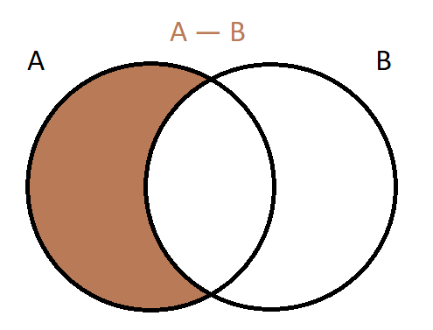
Figure 4
Let’s look at an example with numbers to get a better understanding of this concept. Again, let’s bring back sets A and B from earlier:
$$A = \left\{1, 7, 12\right\}$$
$$B = \{1, 3, 4, 7\}$$
If we want to find A minus B, then we must the elements that are in A but not in B. Let’s start by looking at the first element in A, which is 1. This element is also in B, so it does not satisfy our definition. The next element, 7, also does not satisfy our definition because it is in B. The element 12, however, does satisfy our definition for A minus B because 12 is an A but 12 is not in B. We have now inspected every element in A, and thus A minus B is the following set:
$$A-B = \left\{12\right\}$$
A minus B is a set with only one element, and in this case the element in 12. Sets with only one element also have a special name, and it is called a singleton.

Complement Operation
The complement operation is a type of difference operation. The complement operation on sets creates a new set that contains the opposite elements from an original set. In order to fully understand what I mean by “opposite,” we must first define something called the universal set. Similar to how the empty set is the set that has no elements, the universal set (denoted by U) is the set that has all elements. Thus, every set is a subset of the universal set. This implies that every set does not contain everything, and that there will be elements that exist outside of that particular set (i.e., opposite elements). Hence, if we consider set A, we would notate the complement of A like this:
$$A^{'}=U-A$$
This reads, “A complement equals U minus A,” which is then interpreted as the complement of set A. The concept of complement is described using set notation similar to that of the difference operation:
$$A^{'}= \left\{x: x∈U and x∉A\right\}$$
This reads, “The complement of set A equals the set of elements x such that x belongs to U, and x does not belong to A.” In other words, the complement of any set is itself a set that contains elements who can be found outside of set A; if an element was not originally a part of set A, then it will be in the complement of A. Here is an image of a venn diagram representation to help us visualize how the complement of sets works, where the shaded region is the complement:
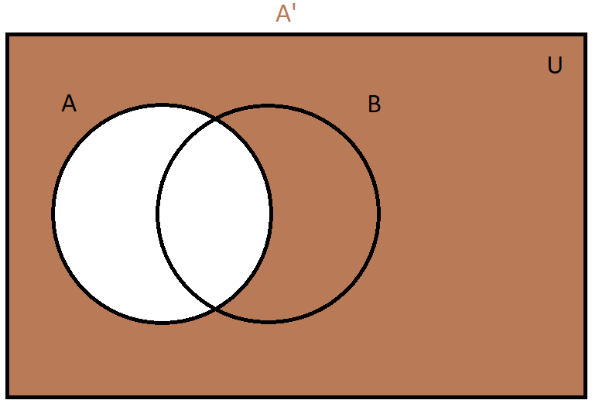
Figure 5
This brings up a noteworthy remark, which is that the intersection of any set with its complement will be the empty set since they do not share any elements by nature:
$$A∩A^{'}=∅$$
Let’s look at an example to get a better understanding of this concept. If you watched the other Sets video in our TutorTube library, you noticed that we used the compliment notation to define the irrational numbers:
$$Q^{'}$$
This is because I defined the universal set to be the real numbers. Since the irrational are all the numbers that are not rational, we can write the irrational numbers as a complement operation, where the set of real numbers is the universal set:
$$Q^{'}=R-Q$$

Outro
Thank you for watching TutorTube! I hope you enjoyed this video. Please subscribe to our channel for more exciting videos. Check out the links in the description below for more information about The Learning Center and follow us on social media. See you next time!

