TutorTube: Sets Fall 2020
Introduction
Hello and welcome to TutorTube, where The Learning Center’s Lead Tutors help you understand challenging course concepts with easy to understand videos. My name is Ethan Gomez, Lead Tutor for Math. In today’s video, we will explore sets. Let’s get started!

Definition with Analogy
So, a set is defined to be a collection of distinct objects/elements. Now, in math, we usually deal with sets as being a collection of numbers, but I think we could have a better understanding of how those sets work by using real-world analogies. For example, as an individual human being, I have different identities. One identity that I have is the fact that I am a younger sibling. But what does it mean to be a younger sibling? Well, that just means that I am not an only child and that I have a sibling who is older than me — those are the conditions for being a younger sibling. If we were somehow able to collect all the people in the world who meet these conditions and group them up, then that would be called a set (more specifically, the set of all younger siblings in the world). I would like to note that our set was defined by two conditions, and we can use these conditions to generalize the elements in the set. However, sets are not required to have conditions, and we can group things that are seemingly unrelated if we so choose. Now that we have a general idea of what a set is, let’s see how we can write them.

General Notation
Usually, sets are denoted using capital letters, such as A, B, C, and so on. To describe the elements within set, we use curly brackets (such as { }). Then, inside the curly brackets, we can write the elements. There are different ways to do that depending on if conditions for the set exist or not. If we decide there are no conditions, we can simply list the elements out and separate them with commas; this is called set-roster notation. If there are conditions that we can use to generalize the elements in the set, we can use set-builder notation. To see the difference between these two notations, let’s consider the vowels of the English alphabet (and for argument’s sake, let’s ignore the letter “y”). In set-roster notation, we would simply list out all the vowels and separate them with commas to look like this:
L = $\left\{a, ⅇ, ⅈ, o, u\right\}$
For set-builder notation, we have to consider the condition, which, in this case, is the fact that we are only looking at the vowel letters in the alphabet. So, we can write something like this:
M = $\left\{\left.θ \right| θ ϵ Vowels\right\}= \left\{θ : θ ϵ Vowels\right\}$
The vertical bar and the colon both mean “such that,” and the “e” symbol indicates membership. It doesn’t really matter what symbol you use for “such that,” just be cautious about the context. Overall, this reads, “The set of $θ$ such that $θ$ is a vowel.” Remember, sets M and L are essentially the same set; they are just written using different notation.
Now, let’s look at a few examples with numbers instead of letters.

Number Examples
Let’s define a set A to contain the numbers 3, 5, and 18.
$$A=\left\{3, 5, 18\right\}$$
This set has no conditions, meaning that there is no way to generalize the elements in the set to know that we are specifically looking at 3, 5, and 18. So the best way to write this set is to use set-roster notation. We can think of 3, 5, and 18 as individual entities that can stand alone, and if we wanted to denote that these entities belong to set A, we would write it like this:
$3∈A$, or $3∈\left\{3, 5, 18\right\}$
$5∈A$, or $5∈\left\{3, 5, 18\right\}$
$18∈A$, or $18∈\left\{3, 5, 18\right\}$
These read, “3 is an element of this set,” and “5 is an element of this set,” and so on. So what about individual entities that exist but do not belong to the set, what do we say then? Well, let’s look at the entity 7. If we look at set A, we’ll notice that 7 does not belong to the set since it only has 3, 5, and 18. So if we want to describe this notion, we would do it like this:
$7∉A$, or $7∉\left\{3, 5, 18\right\}$
This reads, “7 is not an element of this set,” which we know is true. Now, let’s consider a different set; let’s define a set B to contain the numbers 3 and 88.
$$B=\left\{3, 88\right\}$$
Are there any similarities between set A and set B? Well, upon inspection, we can see that both A and B contain the element 3, meaning that 3 belongs to two different sets:
$3∈A$ and $3∈B$
Wait a minute, is this possible? Well, let’s think about that; remember at the beginning when I mentioned I have different identities, and that one of them happened to be the fact that I am a younger sibling? So that means that I, as an individual entity, belong to that set. However, I am also an older sibling, which is a set that has different conditions than the set of younger siblings. Since I meet conditions for both sets, I technically belong to both groups of people, and this makes sense because we know that it is possible for me to be both an older sibling and a younger sibling at the same time. Similarly, it is possible for 3 to be a member of both set A and set B. So let’s add one more set C, and let’s define it to contain the elements 3, 14, 59, and 88.
$$C=\left\{3, 14, 59, 88\right\}$$
Are there similarities between set B and set C? Well, just like before, 3 is an element of both set B and set C. But 88 is also an element of both set B and set C. In other words, every element in set B can be found in set C. When this is the case, we can say that set B is a subset of set C, and we can write it like this:
$$B⊆C$$
This reads, “set B is a subset of set C.” Now let’s see if A is also a subset of C. So 3 is an element of both set A and set C. However, look at 5 and 18; 5 and 18 are elements of A, but they are not elements of C. Since not every element in A can be found in C, then A is not a subset of C:
$$A⊈C$$
So, to quickly summarize, we have talked about elements of sets, how these elements can belong to many sets, and the idea of a subset. However, we mostly talked about these concepts with sets that contain very few elements. There are specific sets of numbers that also have these qualities, but those sets contain much more elements, so let’s take a look at those sets.

Number Sets
There are different ways that numbers have been grouped up based on certain characteristics. Unfortunately, we will not have time to discuss those characteristics today, but I would like to introduce these sets anyways since they are heavily used in math. The first set is the set of natural numbers, which looks like this:
$$N=\left\{1, 2, 3, 4, 5,…\right\}$$
These are sometimes called the “counting numbers” because these are the numbers we use when we count! We start at 1 and continue until we want to stop. But just because we decide to stop counting does not mean that numbers beyond our stopping point do not exist; these numbers extend basically forever, which is what the three dots means. However, we can only use the three dots when there is a clear or obvious pattern. I would like to mention that 0 can sometimes be included in this set, too — it just depends on the context and what your professor prefers, so make sure you ask them for clarification.
Next, we have the set of integer numbers, which looks like this:
$$Z=\left\{…, -5, -4, -3, -2, -1, 0, 1, 2, 3, 4, 5,…\right\}$$
As we can see, it looks pretty similar to the Natural Numbers, but it includes a little bit more, particular the negative counterparts. For example, we not only have the number 1 in here, but we also have -1. It’s also worth noting that every element in the Natural Numbers can be found in the Integers. So, naturally, we can say that set of Natural Numbers is a subset of the Integers, just like in our smaller example earlier with set B and set C:
$$N⊆Z$$
The next number set is the rational numbers. For this set, it’s a little bit harder to use set-roster notation like the other two number sets, so I’m going to write it using set-builder notation:
$$Q=\left\{\frac{p}{q}:p,q∈Z , q≠0\right\}$$
This reads, “the set of p over q such that p and q are Integer Numbers, but q is not zero.” In other words, the set of rational numbers is any number that can be represented as a fraction of integer numbers. Note that if q is equal to 1, then p can be any integer and/or any natural number since dividing by one doesn’t really affect or change the number. So we can take the set of integers and represent those numbers as fractions, which would look like this:
$$\left\{…, -\frac{5}{1}, -\frac{4}{1}, -\frac{3}{1}, -\frac{2}{1}, -\frac{1}{1},\frac{0}{1},\frac{1}{1},\frac{2}{1},\frac{3}{1},\frac{4}{1},\frac{5}{1},…\right\}$$
Therefore, both the set of natural numbers and integer numbers are subsets of the rational numbers:
$$N⊆Q$$
$$Z⊆Q$$
Most numbers can be represented as a fraction of integer numbers, but when numbers can’t be represented in this way, we call those irrational numbers:
$$Q^{'}$$
A few examples of irrational numbers are $π$, $ⅇ$, and $\sqrt{2}$.
Combining all these sets, we end up with the set of real numbers $R$. In other words, all the sets that were previously mentioned are all subsets of the real numbers, and here is an image to visualize these relationships:
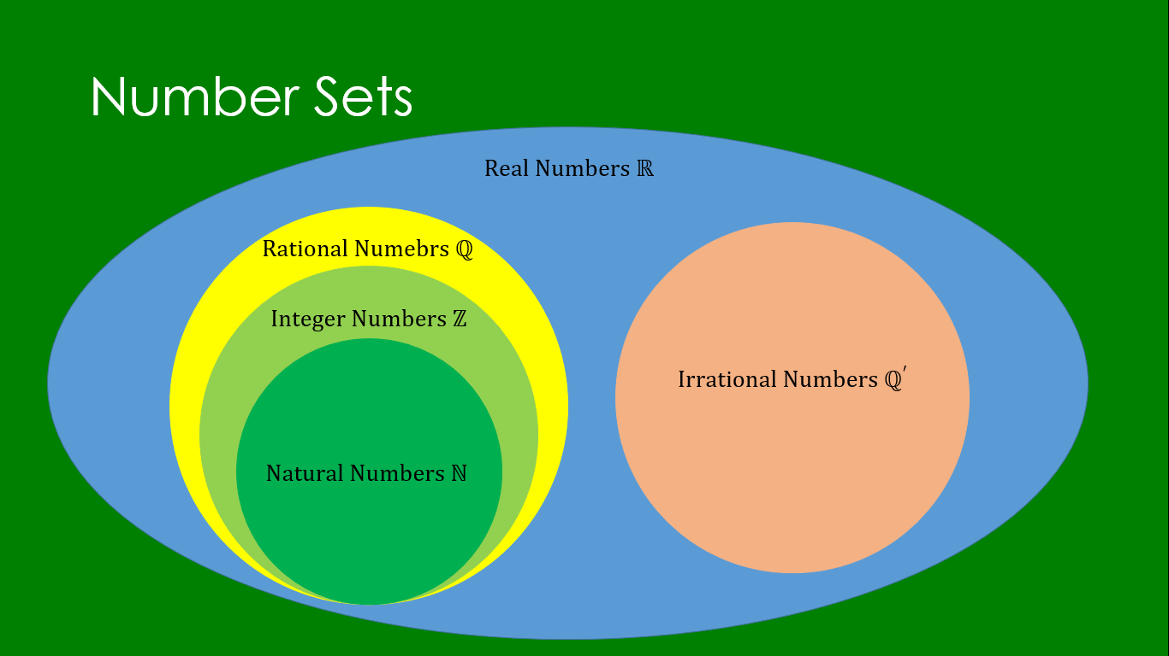
Figure 1: Relationships between sets
The existence of all these different number sets and the way they relate to each other help us understand how to approach certain problems in different contexts.

Outro
Thank you for watching TutorTube! I hope you enjoyed this video. Please subscribe to our channel for more exciting videos. Check out the links in the description below for more information about The Learning Center and follow us on social media. See you next time!

