TutorTube: Speech Audiometry Fall 2020
Introduction
Hello and welcome to TutorTube, where The Learning Center’s Lead Tutors help you understand challenging course concepts with easy to understand videos. My name is Grace, Lead Tutor for Audiology and Speech Language Pathology. In today’s video, we will explore speech audiometry. Let’s get started!
Purpose
The purpose of speech audiometry is to evaluate a listener’s ability to hear and understand speech.
Figure 1 (“Speech Audiometry”)
Threshold Measures
The speech-recognition-threshold (or SRT) is the minimum hearing level for speech at which a listener can recognize 50% of the speech material. The listener would have to repeat exact words or indicate the exact word they heard. The speech-detection-threshold (or SDT) is the minimum hearing level for speech at which a listener can just discern the presence of speech material 50% of the time. The listener would just have to establish they heard something.
Purpose of Testing
The purpose of SRT testing is to evaluate the accuracy of listener’s pure-tone thresholds, which can be obtained through pure tone audiometry. SRT and pure-tone average (or PTA) should be within 10dB of each other. You can see the breakdown of the correlation in figure 2. The SRT is also used to determine degree of hearing loss and to determine the presentation levels for suprathreshold speech measures.
A SDT test is not typically used unless a listener’s SRTs cannot be established. The SDT should be consistent with the best pure-tone threshold.
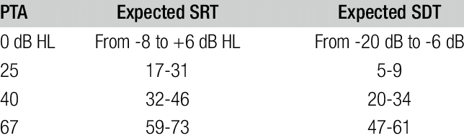
Figure 2 (“Researchgate.net”)
SRT Testing
SRT testing uses spondaic words which are two-syllable words with equal stress on each syllable (for example airplane.) The audiologist would say a list of spondaic words to the listener and they would repeat them back to the audiologist or indicate the exact word.
The response mode of SRT testing is typically the repetition of the target word or indication of target word. For example: If the target word is “bear” then the client could point to a picture of a bear or the client could say the word. You can see an example of SRT testing in figure 3. The listener has headphones on and the audiologist is speaking to him saying “Repeat after me. Plate”. The listener, however hears “Repeat after me. Plane”, which creates a false response.
The basic procedure consists of instructions, familiarization with spondaic words, a single series of descending threshold determination which basically means just lowering volume to determine where the client can no longer hear, and calculation of threshold hearing level.
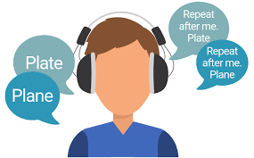
Figure 3 (“Hearing Tests”)
Downs and Minard’s SRT Approach
1. Familiarize the listener with the spondee stimuli. Eliminate words that cannot be repeated. (An example list of spondee words can be seen in figure 4, like “cowboy, baseball, donut, etc.)
2. Instruct the listener to the repeat words, informing them that some words will be faint.
3. Present one spondee at -10 dB HL or at 30-dB below the anticipated SRT or PTA. Continue presenting one word at 10-dB ascending intervals until the listener correctly repeats one word.
4. Descend 15 dB. This is the start level.
5. At the start level, present 2, 3, or 4 spondees. Continue the procedure increasing intensity in 5-dB increments until the patient correctly repeats two words. This is the SRT.
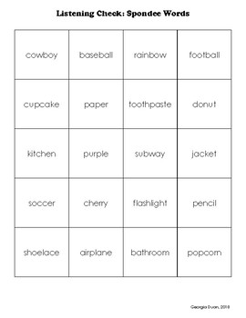
Figure 4 (“Spondee Words”)
SDT Testing
SDT testing uses stimuli like speech babble or familiar words. The audiologist would read a list of words and the listener would have to make it clear they heard the word.
The response mode of SDT testing is typically a verbal response or a non-verbal trained response (like raising your hand or ringing a bell.) An example of this can be seen in figure 5.
Determination of SDTs involves a detection task that is similar to the one used in pure-tone audiometry. Listener does not need to identify the material as speech, but must indicate awareness of the presence of sound.
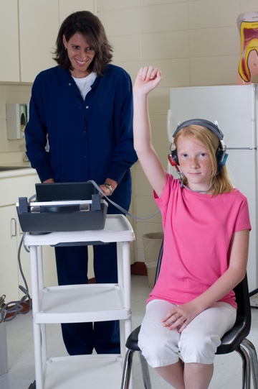
Figure 5 (“What Parents Need”)
Suprathreshold Measures
Word-recognition-score (or WRS) testing is used to measure listener’s ability to understand speech under optimal conditions. Optimal conditions meaning the listener is listening to speech in the quiet with headphones. WRSs reflect listener’s ability to understand speech when it is comfortably loud level for them. A listener’s comfortably loud level is determined by the patient’s SRT results or their pure-tone average.
Review
SRT is the minimum hearing level for speech at which a listener can recognize 50% of the speech material. SDT is the minimum hearing level for speech at which a listener can just discern the presence of speech material 50% of the time. SRT uses spondaic words and SDT uses speech babble or familiar words. SRT requires repetition or indication of target word and SDT only requires confirmation that listener heard something. WRS is used to measure listener’s ability to understand speech under optimal conditions.

Outro
Thank you for watching TutorTube! I hope you enjoyed this video. Please subscribe to our channel for more exciting videos. Check out the links in the description below for more information about The Learning Center and follow us on social media. See you next time!

References
Figure 1: Speech Audiometry, hearingaidrajkot.in/speech-audiometry.html.
Downs and Minard’s Approach: Hearing Loss (Ages 5+): Overview, ASHA, www.asha.org/PRPSpecificTopic.aspx?folderid=8589935335.
Figure 2: Researchgate.net, 2019, www.researchgate.net/figure/16II-Correlation-between-PTA-SRT-and-SDT-in-dB-HL_tbl6_333036497.
Figure 3: “Hearing Tests in Singapore.” Faith Hearing Specialists, faithhearing.com/hearing-tests/.
Figure 4: “Spondee Words.” Teachers Pay Teachers, www.teacherspayteachers.com/Product/Spondee-Words-4022992.
Figure 5: “What Parents Need To Know About Hearing Screening.” National Institute of Deafness and Other Communication Disorders, U.S. Department of Health and Human Services, 2018, www.noisyplanet.nidcd.nih.gov/have-you-heard/what-parents-need-to-know-about-hearing-screening.

