TutorTube: Altered Chords Summer 2020
Introduction
Hello and welcome to TutorTube, where The Learning Center’s Lead Tutors help you understand challenging course concepts with easy to understand videos. My name is Darren Churn, Lead Tutor for Music Theory. In today’s video, we will explore chords with lowered alterations. Let’s get started.
Chordal Alterations
The group of chords containing a bVI, bIII and bII have many things in common. These chords are all altered in a way that makes them major in a specific context. The alterations of these chords come from harmonic mixture that resulted in the lowering of specific scale degrees to create major chords. These chords are used in different situations. Let’s look at each chord, starting with the bVI.
The bVI
A chord with the 6th scale degree as its root is normally minor (vi). With harmonic mixture, our 6th scale degree is now lowered a half step to create a new chord. Let’s look at an example.
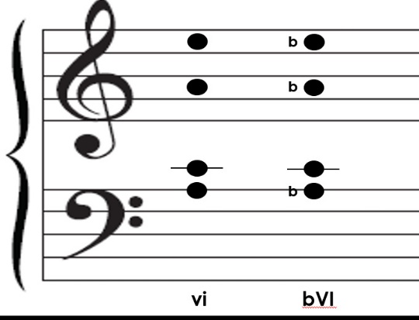
If we were to look at a normal vi in the key of C Major. Our chord would be A C E. Now, with the inclusion of harmonic mixture, an Ab is introduced. Our chord would now be Ab C E. This results in augmented chord that has no context or use for common practice. In order to create a more stable chord, the root is accompanied by another altered pitch to create a major chord. In this example, we get an Ab C Eb chord. When writing a bVI, the flat at the beginning of the chord is showing that the root has been lowered.
Figure 1
Now that we have seen what a bVI, we will look at why and when we use it. As you know, a chord built on the 6th scale degree is the submediant. Even with the alterations, our bVI still acts as such. As a reminder, here are some different ways a bVI can be used.
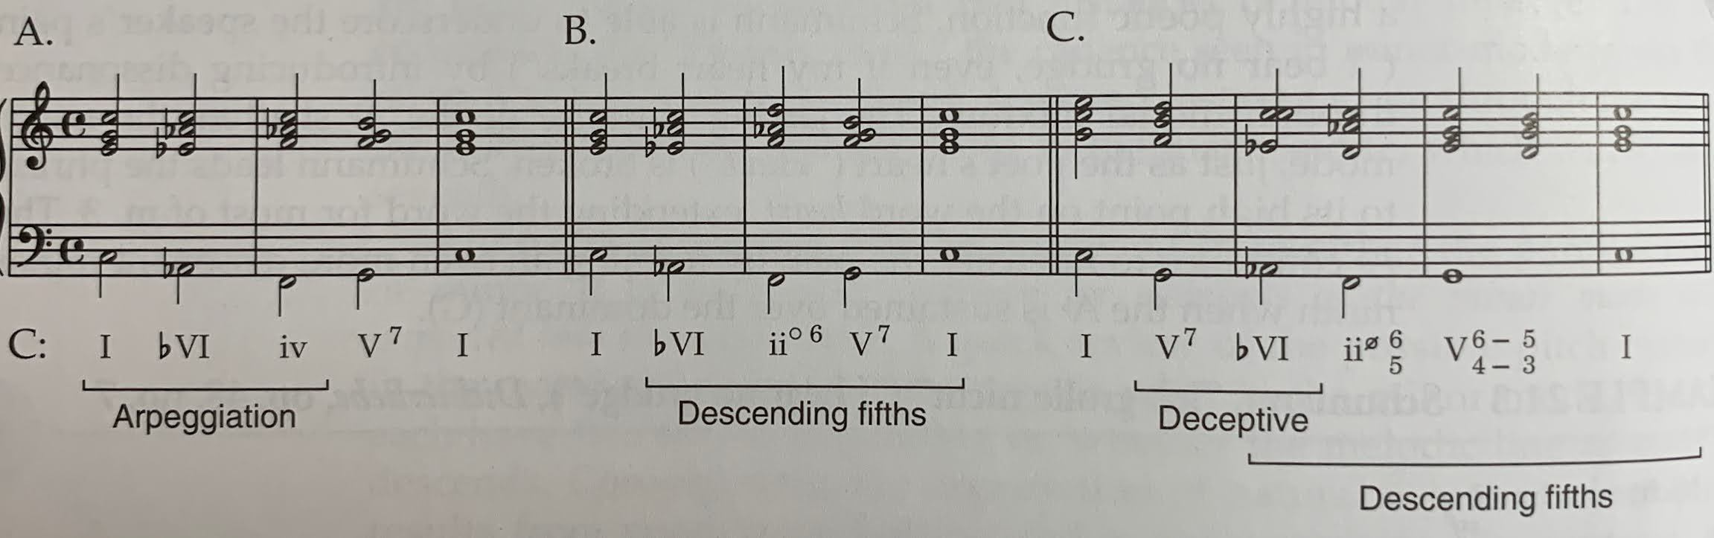
Figure 2: (Laitz)
It can be used as a middle point for a descending arpeggiation progression. It can be part of a descending 5ths sequence. The bVI acts as a predominant. And it can replace the tonic and follow a dominant resulting in a deceptive cadence.
The bIII
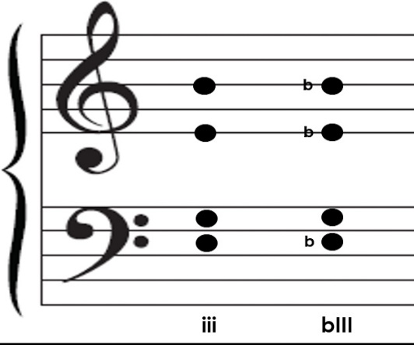
Now that we have discussed the bVI, let’s move onto a similar chord: the bIII. The bIII, like the bVI, is altered by the root being lowered by a half step. In this chord, our 3rd scale degree is lowered creating an unusable augmented chord. To correct this, our 5th of the chord is lowered as well. If we look at the usual iii in the key of C Major, we get E G B. Now, with a lowered 3rd scale degree we get Eb G Bb.
Figure 3
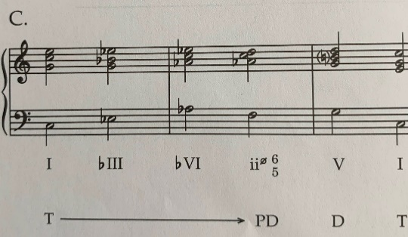
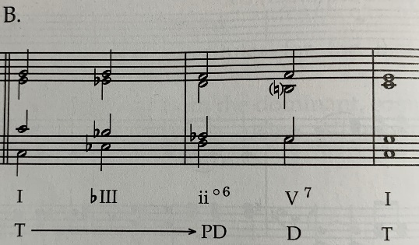
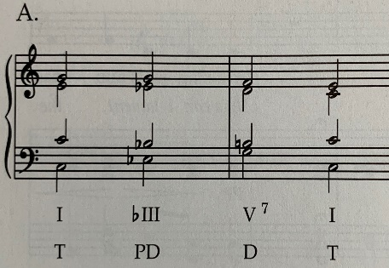
As a mediant, the bIII has different uses than the bVI. The bIII can act as a predominant. It can be used as a bridge between the tonic and predominant. And it can be part of a descending fifths sequence.
Figure 4: (Laitz)
The bII (The Neapolitan)
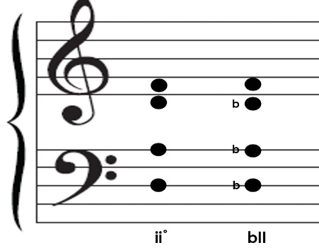
Another altered chord is the Neapolitan, which is also seen as bII. The Neapolitan yet again has a lowered root. Due to the fact that the bII is normally seen in a minor modes, the 2nd scale degree is the only one that is lowered but if it is seen in a major mode the 6th scale degree will need to be lowered as well. Our example of a diminished ii in c minor would be spelled D F Ab. In order to make it a major chord, the D changes to a Db. Now we have Db F Ab.
Figure 5
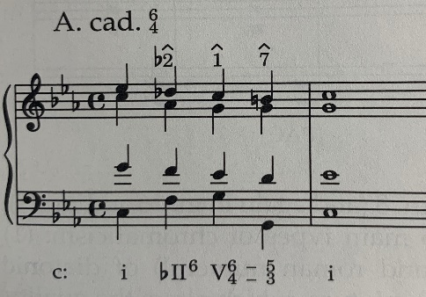
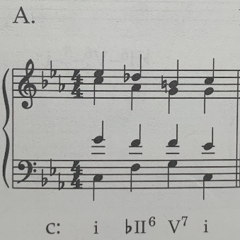
The Neapolitan always needs to get to a V. The problem that occurs is that there not always a direct way to get there. Because of this, the Neapolitan is written in a very specific way. The first part is that the bII is almost always written in first inversion (bII6). When this occurs, the lowered second scale degree will no longer be in the bass and the tritone leap from flat 2 to 5 is avoided. It is also important to double the bass and if need be, the 5th of the chord. Another situation the Neapolitan works is by using stepwise motion down the 5th scale degree in the soprano. This situation requires another chord to act as a passing point to the V. A common way to do this is through a cadential 6/4. This creates stepwise motion from 2 to 1 to 7.
Figure 6: (Laitz)
Outro
Thank you for watching TutorTube! I hope you enjoyed this video. Please subscribe to our channel for more exciting videos. Check out the links in the description below for more information about The Learning Center and follow us on social media. See you next time!
References
Figures 2,4,6: Laitz, Steven G., and Steven G. Laitz. The Complete Musician: an Integrated Approach to Theory, Analysis, and Listening. Oxford University Press, 2016.

