TutorTube: Limits and Derivatives Summer 2020
Introduction
Hello! Welcome to TutorTube, where The Learning Center’s Lead Tutors help you understand challenging course concepts with easy to understand videos. My name is Ebby, Lead Tutor for Math and Political Science. In today’s video, we will explore Limits and Derivatives. Let’s get started!
What is a limit?
It’s easiest to think of the limit like a trajectory. It’s whatever the function seems to be approaching.

How do we find limits graphically?
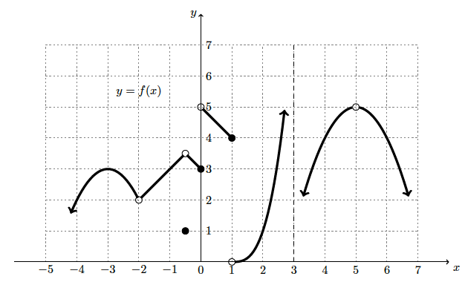
- f(2)
Since f(2) is not a limit, we go straight to the x-value of 2 and assess whether or not there is a closed dot there. Since there is a closed dot at 1, we know that f(2)=1
- f(0)
We do the same thing for f(0) as we did for f(2). Since there is an open dot at 5 we ignore it and look for the closed dot. Therefore, f(0)= 3
- $\lim_{x→2^{+}}{f(x)}$
We want the limit as x approaches 2 from the right, so we will take the trajectory towards the x-value 2 from the right-hand side. Doing so leads us to 1, so $\lim_{x→2^{+}}{f(x)}$ = 1.
- $\lim_{x→2^{-}}{f(x)}$
Now we will approach 2 from the left-hand side, doing so also yields 1. So, $\lim_{x→2^{-}}{f(x)}$ = 1
- $\lim_{x→2}f(x)$
Since the left and right-hand limits approached the same value, we know that $\lim_{x→2}f(x)$ = 1.
- $\lim_{x→0}{f(x)}$
This limit does not specify whether to take the left or right-hand limit, so we must take both. The left-hand limit is 3 but the right-hand limit is 5. Since the left and right- hand limit do not approach the same value, $\lim_{x→0}{f(x)}$ does not exist.
- $\lim_{x→3}{f(x)}$
Evaluating this limit is done in the same manner as number 6, we must check both the left and right-hand limits. The left-hand limit goes off towards +$∞$, while the right-limit goes off towards -$∞$. Therefore $\lim_{x→3}{f(x)}$ does not exist.
How do we find limits algebraically?
There are four common methods that we use to evaluate limits:
- Multiplying by the conjugate
- Factoring/Simplifying
- Combining fractions
- Using identities
Often times we will use multiple methods to evaluate a given limit.
Examples of Evaluating Limits
Evaluate the following limits:
$$1. \lim_{x→3}{\frac{\sqrt{x+1}-2}{x-3}}$$
Solution:
We will first multiply by the conjugate of the numerator
$$\frac{\left(\sqrt{x+1}-2\right)\left(\sqrt{x+1}+2\right)}{\left(x-3\right)\left(\sqrt{x+1}+2\right)},$$
then simplify the function to
$$\frac{x+1-4}{(x-3)(\sqrt{x+1}+2)}$$
$$\frac{x-3}{(x-3)(\sqrt{x+1}+2)} .$$
We can now factor out the “(x-3)” on both the numerator and denominator
$$\frac{1}{\sqrt{x+1}+2} .$$
Finally, evaluate the limit as x approaches 3
$$\lim_{x→3}\frac{1}{\sqrt{x+1}+2}=\frac{1}{4}.$$

$$2. \lim_{x→2}\frac{x^{2}+4x-12}{x^{2}-2x}$$
Solution:
To solve the following limit, we will factor both the numerator and denominator:
$$\frac{\left(x+6\right)\left(x-2\right)}{x\left(x-2\right)}.$$
Then we will simplify the expression to
$$\frac{x+6}{x}$$
and finally let the limit approach 2
$$\lim_{x→2}\frac{x+6}{x}=4$$

$$3. \lim_{x→0}\frac{2tan⁡(4x)}{sin⁡(2x)}$$
Solution:
First, let’s write the function in this form:
$$2\tan{(4x)}÷\sin\left(2x\right),$$
In order to solve this limit, we will use the identity:
$$Tan\left(4x\right)=\frac{2\tan{2x}}{1-\tan^{2}{2x}}.$$
Substituting this identity into the equation will yield:
$$2・\left(\frac{2tan⁡2x}{1-\tan^{2}{2x}}\right)÷ \left(sin⁡2x\right)$$
Now we will re-arrange the function like this
$$4\tan{2x}・\frac{1}{1-\tan^{2}{2x}}・\frac{1}{sin⁡2x} ,$$
which allows us put tan(2x) in terms of sin and cos:
$$\frac{4sin2x}{cos2x}・\frac{1}{1-\tan^{2}{2x}}・\frac{1}{sin⁡2x} .$$
Now, we will simplify the sin(2x) to get
$$\frac{4}{cos2x}・\frac{1}{1-\tan^{2}{2x}} ,$$
which can be combined to form
$$\frac{4}{cos2x \left(1-\frac{\sin^{2}2x}{\cos^{2}2x}\right)} .$$
Distributing the cos(2x) on the denominator yields
$$\frac{4}{\left(cos2x-\frac{\sin^{2}2x}{\cos^{1}2x}\right)} ,$$
which finally allows us to let the limit approach 0:
$\lim_{x→0}$ $\frac{4}{\left(cos2x-\frac{\sin^{2}2x}{\cos^{1}2x}\right)}$
Simplifying to:
$$\frac{4}{\left(1-\frac{0}{1}\right)}=4$$

$$4. \lim_{x→0}\frac{\frac{1}{x+5}-\frac{1}{5}}{x}$$
Solution:
We will combine the fractions on the numerator like so:
$$\left(\frac{5}{5\left(x+5\right)}-\frac{x+5}{5(x+5)}\right)・\frac{1}{x} ,$$
which simplifies to:
$$\frac{5-x-5}{5\left(x+5\right)}・\frac{1}{x}$$
$$\frac{-x}{5\left(x+5\right)}・\frac{1}{x} .$$
The x will then cancel out on the numerator and denominator, leaving
$$\frac{-1}{5\left(x+5\right)} ,$$
where we will let the limit approach 0 and obtain:
$$\lim_{x→0}\frac{-1}{5\left(x+5\right)}= -\frac{1}{25} .$$

$$5. \lim_{x→0}\frac{sin⁡(3x)}{4x}$$
Solution:
To solve this limit, we will use the identity
$\lim_{x→0}\frac{sin⁡(x)}{x}$ = 1
This identity states that the argument of sin must match the denominator in order to simplify, therefore we will use algebra to make that happen:
$$\frac{\sin\left(3x\right)}{(3x)・\frac{4}{3}}= \frac{sin⁡(3x)}{4x} .$$
Since we didn’t change the value of the given function, we know that this is mathematically sound and will allow us to simplify the function to:

$$\frac{\sin\left(3x\right)}{(3x)} ・\frac{1}{4/3}$$
$$1・\frac{1}{4/3}=\frac{3}{4} .$$
Limits at Infinity
There are 3 common types of functions for which we will be evaluating limits at infinity:
- Top Heavy Functions such as $\frac{{3x}^{3}-x^{2}+x+5}{x^{2}+5}$
- Same Degree Functions such as $\frac{-3x^{4}+18x^{2}+5}{7x^{4}+6x^{3}}$
- Bottom Heavy Functions such as $\frac{x^{2}+5}{x^{5}+4x^{3}}$ .
To evaluate Top Heavy Functions at infinity, we will divide by the highest power of the denominator, for Same Degree Functions we will assess the ratio of the coefficients associated with the highest power, and lastly for Bottom Heavy Functions, the limit at infinity will always be 0. Before we solve examples for limits at infinity, it is important to recall some facts about working with infinity:
- $-∞=-1(∞)$
- $∞-∞=∞$
- $-∞-∞=-∞$
- $\frac{any real number}{∞}=0$
Examples of Limits at Infinity
$$1. \lim_{x→∞}{\frac{x^{4}+5x^{2}-7x^{5}+7}{x^{3}+5}}$$
Since this function’s highest power is on the numerator, it is Top Heavy and we will be diving by the highest power of the denominator.
$$\lim_{x→∞}{\frac{\frac{x^{4}}{x^{3}}+\frac{5x^{2}}{x^{3}}-\frac{7x^{5}}{x^{3}}+\frac{7}{x^{3}}}{\frac{x^{3}}{x^{3}}+\frac{x4}{x^{3}}}}$$
which simplifies to
$$\frac{x+\frac{5}{x}-\frac{7}{x^{2}}+\frac{7}{x^{3}}}{1+\frac{5}{x}} ,$$
Letting the limit approach yields
$$\lim_{x→∞}\frac{x+\frac{5}{x}-\frac{7}{x^{2}}+\frac{7}{x^{3}}}{1+\frac{5}{x}}= \frac{∞+\frac{5}{∞}-\frac{7}{∞}+\frac{7}{∞}}{1+\frac{5}{∞}}$$
Using the properties about infinity stated above, we simplify this limit to
$$\frac{∞+0-0+0}{1+0}= ∞$$

$$2. \lim_{x→-∞}\frac{-5x^{3}+x+1}{-x^{2}+x^{3}-7}$$
Since this function’s highest degree is the same on the numerator and denominator, we will divide their coefficients to get
$$-\frac{5}{1}= -5 .$$
Another way to look at this would be to divide by the highest power “$x^{3}$”:
$$\lim_{x→-∞}\frac{-5+\frac{1}{x^{2}}+\frac{1}{x^{3}}}{\frac{-1}{x}+1-\frac{7}{x^{3}}}= \frac{-5+0+0}{0+1-0}→ -5$$

$$3. \lim_{x→∞}\frac{x^{2}+17x}{-x^{3}-7}$$
Since the highest power is on the denominator, this function is Bottom Heavy, and we know that evaluating the limit at either $∞$ or - $∞$ will yield 0. To show this, we will divide the numerator and denominator by the highest power “$x^{3}$.”
$$\frac{\frac{1}{x}+\frac{17}{x^{2}}}{-\frac{x^{3}}{x^{3}}-\frac{7}{x^{3}}}= \frac{\frac{1}{x}+\frac{17}{x^{2}}}{-1-\frac{7}{x^{3}}}$$
Letting the limit approach $∞$yields
$$\lim_{x→∞}\frac{\frac{1}{x}+\frac{17}{x^{2}}}{-1-\frac{7}{x^{3}}}=\frac{0}{-1}→0 .$$
The Limit Definition of The Derivative
The definition of the derivative is the following:
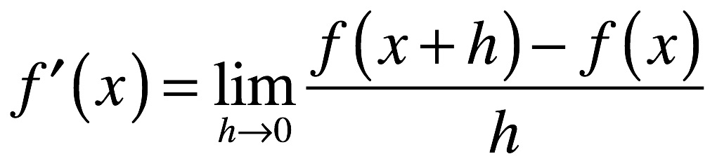.
We can technically use this definition to calculate any derivative, but we often refrain from doing so in practice because there are faster techniques available. However, we will take the derivative of the following function
$$f\left(x\right)= x^{2}-7$$
using the definition in order to illustrate its properties. The first step is to place the function into the definition as such:
$$\lim_{h→0}\frac{\left({\left(x+h\right)}^{2}-7\right)-\left(x^{2}-7\right)}{h} ,$$
then we expand the numerator to
$$\frac{\left(x^{2}+2xh+h^{2}-7\right)-{(x}^{2}-7)}{h}$$
which simplifies to
$$\frac{\left(x^{2}+2xh+h^{2}-7\right)-x^{2}+7}{h}$$
$$\frac{2xh+h^{2}}{h}$$
$$2x+h.$$
Now, Let h approach 0:
$$\lim_{h→0}2x+h →2x.$$
Now, evaluating
g(x) = $\sqrt{x}+2$
using the definition of the derivative will yield:
$$\lim_{h→0}\frac{\left(\sqrt{x+h}+2\right)-(\sqrt{x}+2)}{h} .$$
Distributing the negative will simplify to
$$\lim_{h→0}\frac{\sqrt{x+h}-\sqrt{x}}{h} .$$
Now, we will have to multiply by the conjugate of the numerator in order to further simplify the function:
$$\lim_{h→0}\frac{\left(\sqrt{x+h}-\sqrt{x}\right)(\sqrt{x+h}+\sqrt{x})}{h(\sqrt{x+h}+\sqrt{x})} ,$$
this allows us to write
$$\lim_{h→0}\frac{x+h-x}{h(\sqrt{x+h}+\sqrt{x})}= \lim_{h→0}\frac{h}{h(\sqrt{x+h}+\sqrt{x})} ,$$
which simplifies to
$$\lim_{h→0}\frac{1}{(\sqrt{x+h}+\sqrt{x})} .$$
Finally, evaluating the limit yields:
$$\frac{1}{2\sqrt{x}} .$$

Outro
Thank you for watching TutorTube! I hope you enjoyed this video. Please subscribe to our channel @UNTLC for more exciting videos! Check out the links in the description below for more information about The Learning Center and follow us on social media. See you next time!

