TutorTube: Mitosis v. Meiosis Spring 2020
Introduction
Hello and welcome to TutorTube, where The Learning Center’s Lead Tutors help you understand challenging course concepts with easy to understand videos. My name is Manal, Lead Tutor for sciences. In today’s video, we will explore mitosis and meiosis. Let’s get started!
Cell Cycles
All living cells in multicellular organisms undergo a cell cycle, and at the end of the cycle they will divide. Depending on the type of cell, it will divide by either mitosis or meiosis. In this video, I will go through each of the steps in both mitosis and meiosis. We will look at key similarities and differences between the two processes, as well as visualize the cell during each step.
Mitosis
First, let’s go over mitosis. Mitosis occurs in all cells of multicellular organisms, except gametes. A diploid, or 2n, cell will undergo mitosis to divide into two diploid daughter cells. In this division, the number of chromosomes does not change from the parent to the daughter cell. Before mitosis, the cell is in interphase, in which DNA, in the form of chromatin, is surrounded by the nucleus. Interphase is shown in this image.
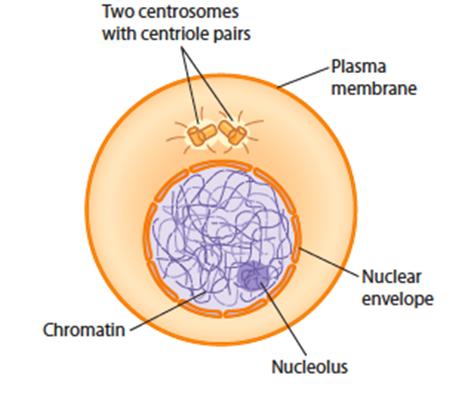
Image 1 (Hardin & Bertoni)
Mitosis has six stages: prophase, prometaphase, metaphase, anaphase, telophase, and cytokinesis.
Prophase, which is shown here, is the longest phase in mitosis. Centrosomes migrate to the poles of the cell and begin to form spindle. Chromosomes condense and are visible as two sister chromatids attached at the centromere. The nuclear envelope is still fully intact.
Image 2 (Hardin & Bertoni)
Next, in prometaphase, which is shown here, the mitotic spindle attaches to the chromosomes at the centromere and the nuclear envelope dissolves.
Image 3 (Hardin & Bertoni)
In metaphase, chromosomes line up at the center of the cell (which is also known as the metaphase plate, as you can see in the image). This is the last phase where sister chromatids exist.
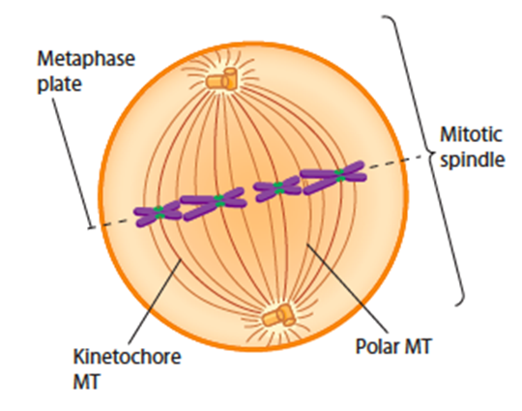
Image 4 (Hardin & Bertoni)
During anaphase, microtubules pull apart the chromosomes and sister chromatids split into separate chromosomes, as shown in Image 5. This is not reduction division because each daughter cell will have the same number of chromosomes as the parent cell. Once the two sister chromatids separate, they become separate chromosomes. We can count number of chromosomes by counting centromeres.
Image 5 (Hardin & Bertoni)
In telophase, the microtubules disassemble, and chromosomes will relax and stop moving. The nuclear envelope reforms. Cytokinesis may occur at the same time as telophase. This is the division of cytoplasm and organelles by the cell membrane pinching inwards. This phase is shown here.
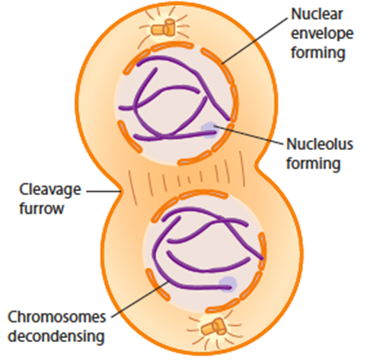
Image 6 (Hardin & Bertoni)
At the end of mitosis, there are two genetically identical daughter cells that are diploid and each have the same number of chromosomes as the parent cell.
Meiosis
Now that we’ve reviewed mitosis, let’s go through meiosis, which occurs in gametes or germ cells (which are the egg and sperm). In meiosis, a diploid cell will divide twice to produce four haploid/monoploid, or 1n, cells. These two divisions are called meiosis I and meiosis II. Within both meiosis I and II, the same six stages will occur.
Meiosis I is reduction division, which means that after meiosis I, the daughter cells (which will be haploid, or 1n) will have half the amount of chromosomes as the diploid parent cell. This is when separation of homologous chromosomes occurs.
In prophase I, chromosomes are visible as two condensed chromatids attached at the centromere, homologous pairs form a tetrad for crossing over at the chiasmata, and centrosomes move to the poles of the cell. The nuclear envelope may begin fragmenting. The images show the beginning and end of prophase I.
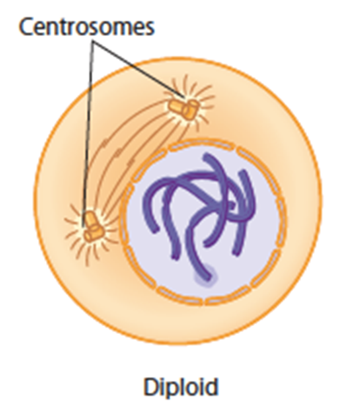
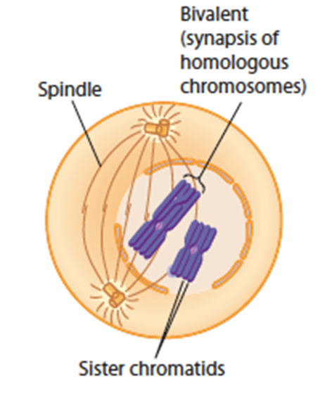
Image 7 (Hardin & Bertoni)

Image 8 (Hardin & Bertoni)

Prometaphase I is similar to prometaphase in mitosis, in which the nuclear envelope completely fragments and spindle fibers attach to centromeres, as shown here.
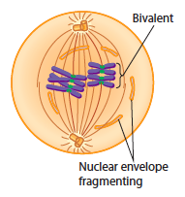
Image 9 (Hardin & Bertoni)
In metaphase I, homologous chromosomes line up in the middle of the cell at the metaphase plate, which can be seen here.
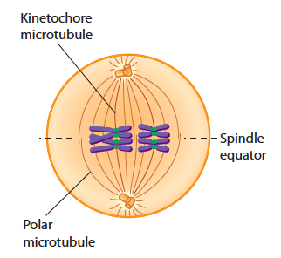
Image 10 (Hardin & Bertoni)
Here we see anaphase I, in which homologous chromosomes get pulled apart toward the poles of the cell.
Image 11 (Hardin & Bertoni)
Shown here, in telophase I, the chromosomes reach the poles of the cell. Cytokinesis will also occur.
Image 12 (Hardin & Bertoni)
Interkinesis is the time between meiosis I and meiosis II, during which some cells reform the nuclear envelope and spindle fibers break down.
Meiosis II is equational division, where separation of sister chromatids occurs, which is similar to mitosis. The two haploid cells resulting from meiosis I each divide to form four total haploid cells.
In prophase II, the chromosomes condense and spindle fibers begin to reform. The nuclear envelope may begin fragmenting. Here we see both daughter cells in prophase II.
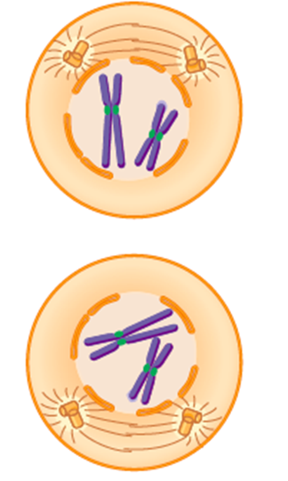
Image 13 (Hardin & Bertoni)
During prometaphase II, the nuclear envelope completely breaks down and spindle fibers attach to centromeres.
Metaphase II consists of the chromosomes lining up at the metaphase plate, as shown here.
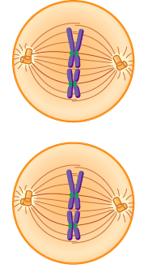
Image 14 (Hardin & Bertoni)
In anaphase II, microtubules pull the sister chromatids apart, which we can see here.
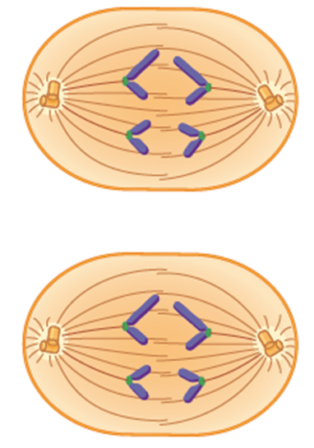
Image 15 (Hardin & Bertoni)
During telophase II, the microtubules disassemble, chromosomes stop moving, and the nuclear envelope reforms. Cytokinesis will also occur. The final stage is shown here.
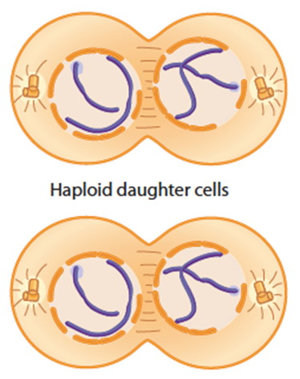
Image 16 (Hardin & Bertoni)
Comparing the Processes
Now that we’ve gone through both mitosis and meiosis, let’s go over the main differences between the two processes. The main differences are highlighted in the table below.
Most prominently, mitosis consists of one division, whereas meiosis has two divisions. This means that after mitosis there are two daughter cells and after meiosis there are four daughter cells. The cells produced by mitosis are genetically identical, and meiosis produces unique cells. Meiosis occurs in germ cells and mitosis occurs in somatic cells. Mitosis serves for growth and repair, and meiosis is used for reproduction and producing genetic diversity. Cells that undergo meiosis form homologous chromosomes, but mitotic cells do not. Because of the pairing of homologous chromosomes, crossing over will only occur during meiosis I, specifically during prophase I.

 | Mitosis | Meiosis
Number of divisions | 1 | 2
Number of daughter cells produced | 2 | 4
Resulting daughter cells | Genetically identical | Genetically different
Cell Type | Somatic cells | Germ cells
Purpose | Growth and repair | Genetic diversity
Homologous chromosomes | No | Yes (during meiosis I)
Crossing over | No | Yes (during prophase I)

Outro
The images used in this video came from Becker’s World of the Cell 9th edition by Hardin and Bertoni. Thank you for watching TutorTube! I hope you enjoyed this video. Please subscribe to our channel for more exciting videos. Check out the links in the description below for more information about The Learning Center and follow us on social media. See you next time!
References
Images 1-16: Hardin, Jeff and Gregory Bertoni. Becker’s World of the Cell. 9th ed., Pearson, 2017.

