TutorTube: Applied Chords Summer 2020
Introduction
Hello and welcome to TutorTube, where The Learning Center’s Lead Tutors help you understand challenging course concepts with easy to understand videos. My name is Darren Churn, Lead Tutor for Music Theory. In today’s video, we will explore Applied Chords. Let’s get started.
Applied Chords
Applied chords are types of nondiatonic chords that are created by relating themselves to the chord that follows. Similar to modulation, applied chords will temporarily adopt the key signature of the following chord. For example, an applied chord followed by a G chord would base the notes of its chord on the key of G, no matter what the original key signature was for the progression. There are 2 types of applied chords: secondary dominants and secondary leading tones. Let’s look at some specific examples of these applied chords.
Secondary Dominants
Secondary dominants are applied chords that create a dominant or Major minor 7th chord. A dominant chord is built by a Major triad and a minor 7th. It can also be seen as a Major triad with a minor third stacked on top. In terms of secondary dominants, the succession of intervals will be created using notes that do not exist in the original key. Let’s look at an example.
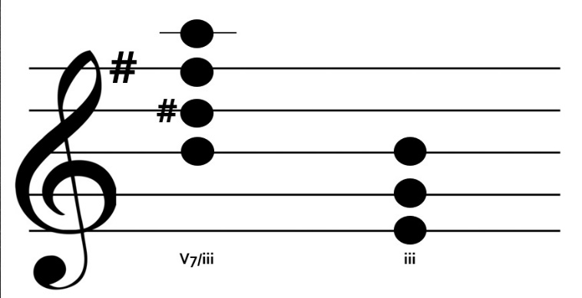
If we are in the key of G Major, there is one sharp, F#. The dominant or V7 of G major would be D F# A C. This chord that we have built is B D# F# A. Normally a B chord in a Major key would be a iii. The question is how we got a dominant 7th in this key. The answer is by relating it to a different key. The chord following our B7 is E G B, This iii acts as the reference for the dominant before it. Using the key signature of E harmonic minor (or E major because there is no difference), we would now include a D#, even though the key of G Major uses a D natural. By temporarily adopting the key of E, a B dominant 7th is formed.
Figure 1
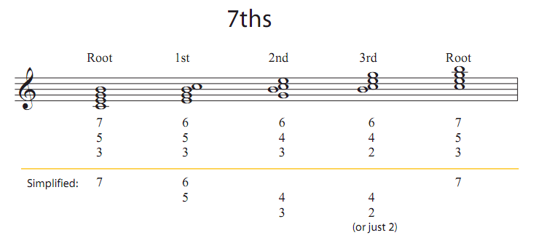
It is important to note that secondary dominants can also be seen in inversions and resolve to the following key as V7 to I. Secondary dominants can be seen in root position (7), first inversion (6/5), second inversion (4/3), and third inversion (4/2).

Figure 2: (Chord Symbols with Inversions of 7th Chords)
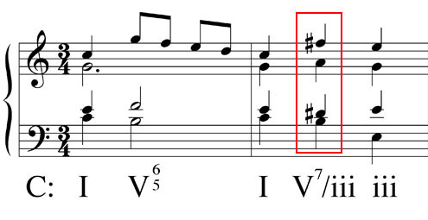
All of these inversions require a resolution to the one in the proper manner. Let’s look at an example of how we do that.
Figure 3: (Rubin)
This example shows how a secondary dominant chord words in the context of a progression. As you can see, our original key is C. This key signature has no sharps or flats. Our color chord that is not diatonic to the key possesses the nonharmonic tones of D# and F#. The secondary dominant is the V7 of the key of E, not C. As you can see, our leading tone of D# resolves up to E and our chordal 7th resolves down by step to G. The rules for resolving seventh chords are that leading tones always resolve up by step and the seventh of the chord always resolves down by step. These two rules are appropriately shown in the progression.
Secondary Leading Tones
Now on to secondary leading tones. Secondary leading tones are formed similarly to secondary dominants. The chord will still be formed using the following chord again, but instead of forming a Major minor chord, you will form either a diminished or half-diminished chord. A half-diminished chord is formed with a diminished triad and a minor 7th. A fully diminished chord is formed with a fully diminished triad and a diminished 7th.
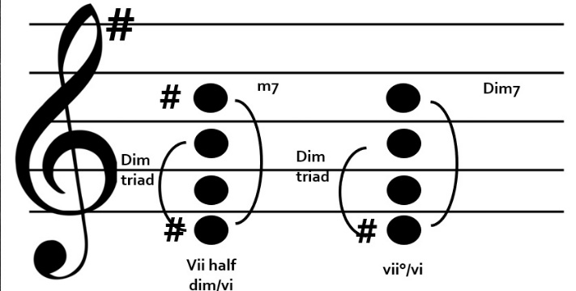
Then, using the key of G again, our normal vii diminished would be F# A C. Now, we are going to build secondary leading tone chords using the notes that are harmonic to a different key. If we use E again, the vii chord would be built on D#. Our half-diminished chord would be D# F# A C#. This includes our diminished triad and minor 7th. Our fully diminished would be D# F# A C, with a diminished triad and a diminished 7th. These chords also exist in inversions.
Figure 4
This example contains our secondary leading tones in the key of C. The first progression shows a fully diminished vii of ii. The ii of C is D. The diminished vii is built using the leading tone of D which is C#. A fully diminished vii built on C# is C# E G Bb. The second progression is also in C but our secondary key is now F. The leading tone of F is E which creates a fully diminished vii that is E G Bb Db or in this example C#. Yet again, the 7th chords are resolved following our rules.
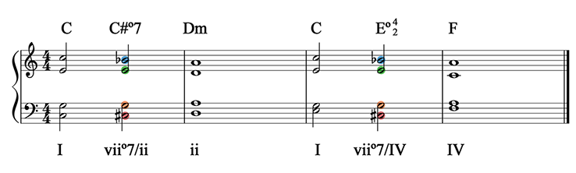
Figure 5: (Music Student 101)
Outro
Thank you for watching TutorTube. I hope you enjoyed this video. Please subscribe to our channel for more exciting videos. Check out the links in the description below for more information about The Learning Center and follow us on social media. See you next time.
References
Figure 2: pxc3110pxc3110 18311 gold badge11 silver badge44 bronze badges, et al. “Chord Symbols for Inversions of 7th Chords.” Music, 1 July 1964, music.stackexchange.com/questions/26837/chord-symbols-for-inversions-of-7th-chords.
Figure 3: “Secondary Dominants.” Justin Rubin Theory Resources, www.d.umn.edu/~jrubin1/JHR Theory Sec Dominants.htm.
Figure 5: “55-Secondary Leading Tone Chords: Music Student 101.” 55-Secondary Leading Tone Chords | Music Student 101, musicstudent101.com/55-secondary-leading-tone-chords.html.

