TutorTube: Continuity in Calculus Summer 2020
Hello, welcome to another edition of TutorTube, where The Learning Center’s Lead Tutors help you understand challenging course concepts with easy to understand videos. My name is Ebby, Lead Tutor for Math and Political Sci. Today we will explore Continuity.
Defining Continuity
For a function to be continuous at a point a, 3 things must be true:
$1. \lim_{x→a^{-}}f\left(x\right)=L$
$$\underset{x→a^{+}}{2. lim}f\left(x\right)=L$$
$3. f\left(a\right)$ $=$ $L.$
Number one is called the left-hand limit and is read as:
The limit as x approaches “a” from the left, of the function f(x), equals L.
Similarly, number two is the right-hand limit and is read as:
The limit as x approaches “a” from the right, of the function f(x), equals L.
Lastly, you can think of the 3rd condition as “the closed dot” stipulation, meaning that there should be a closed dot at “L” on the graph of f(x). The “a” is the x-value in question and “L” is the y-value associated with the x. All three of the conditions must equal the same y value, “L”, for the function to be continuous. Using this definition, we will determine if the following function, f(x), is continuous at 3.
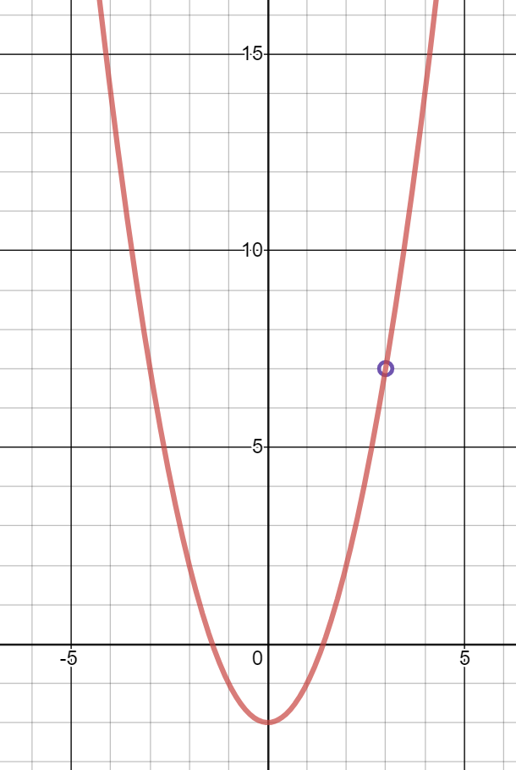
Fig 1. $\frac{x^{3}-{3x}^{2}-2x+6}{x-3}$
The left-hand limit is 7 which means that:
$\lim_{x→3^{-}}f\left(x\right)=7$.
The right-hand limit is also 7:
$$\lim_{x→3^{+}}f\left(x\right)=7.$$
Since both “L” values are the same, we can say that the limit exists. However, since there is an open dot at 3, we know,
$f\left(3\right)$ $is undefined.$
Which means that the function fails the last criterion and since all three conditions were not met, the function is discontinuous.
Types of Discontinuities
There are three types of discontinuities that arise: holes, jump and infinite. Holes, also known as removable discontinuities, look like this:
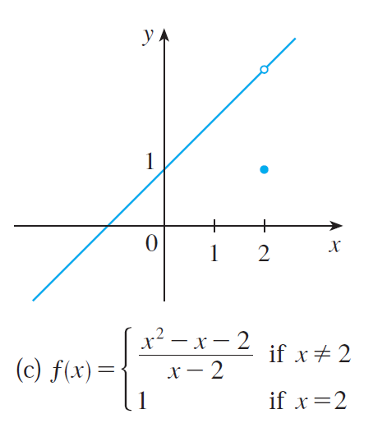
Fig. 2. (Stewart, 120)

Both the left-hand limit,
$$\lim_{x→2^{-}}f\left(x\right),$$
and the right-hand limit,
$$\lim_{x→2^{+}}f\left(x\right),$$
Approach the same value, which means that the limit exists. However, since the closed dot at 2 is not at the same point as the limits, the third condition,
$f\left(a\right)$ $=$ $L$
is not satisfied and the function is discontinuous. On the other hand, jump discontinuities like this one,
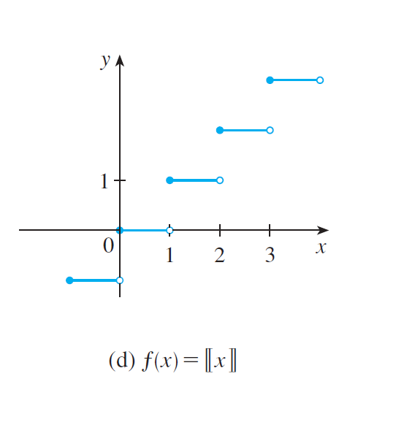
Fig. 3. (Stewart, 120)
do not have a limit that exists for the specific point in question, nor does it have a closed dot that is the same as the limits. The third type of discontinuity is an infinite discontinuity:
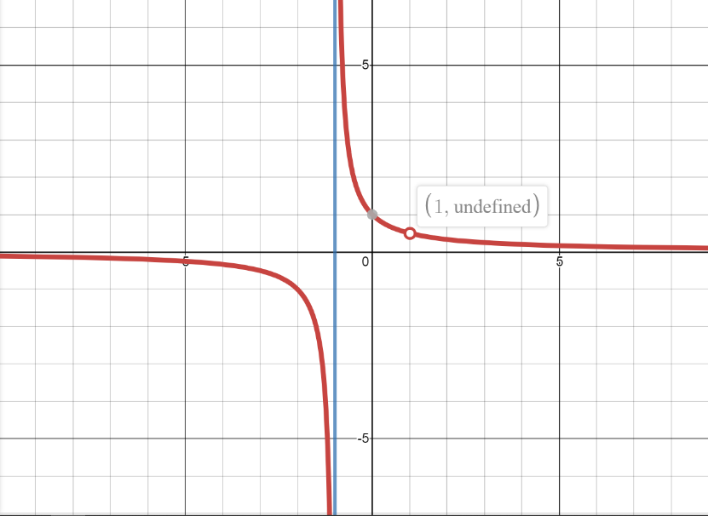
Fig. 4. $f\left(x\right)= \frac{x-1}{x^{2}-1}$
where the right and left-hand limits go off towards infinity and no closed dot exists at -1 (x-value). There is also a hole at 1, which means that the limit exists
but there is an open dot at the point in question.

Using the Continuity Definition
We will now use our knowledge of continuity to determine if the following functions are continuous. First, we will examine:
$$f\left(x\right)=\left\{\begin{matrix}\begin{aligned}\frac{1}{x+2} ⅈf x≠-2 \\ 3^{x},if x=-2\end{aligned} \\ \end{matrix}\right.$$
This piecewise function is set up in such a way that will allow us to plug in the x-value into the functions. The first piece of the graph is:
$$\frac{1}{x+2} when x ≠-2,$$
This represents the first and second conditions of the continuity definition because the x-values can be smaller than -2 (left hand limit) or larger than -2 (right hand limit). By introducing limits, we can get infinitesimally close to -2 on both sides, which means we are essentially at -2. Therefore, we can plug in -2 into the function and determine the value:
$$\frac{1}{-2+2}= \frac{1}{0} →∞.$$
For this function to be continuous, you must get the same value for every unique input. This means that we must also plug in -2 into the second equation $3^{x}$ which yields $\frac{1}{9}$. Clearly,
$$∞ ≠ \frac{1}{9}$$

so, we can say that the function is not continuous at the point x = -2. More specifically, we can say this function is discontinuous at -2 because the limit does not exist. Now, let’s examine the equation:
$$h\left(x\right)=\left\{\begin{aligned}2x-x^{2} if 0 ≤x ≤2 \\ 4-2x if 2 <x ≤3 \\ x-4 if 3 <x <4 \\ e^{\frac{x}{10}} if x ≥4\end{aligned}\right..$$
Since we see x = 2,3,4 in multiple places, we will plug them into the respective places that we see them. Plugging in 2 into the first equation, $2x-x^{2}$, yields 0, and plugging it into the second equation also gives us 0; this means that the function is continuous at 2. However, when we replicate the procedure for 3, we get -2 when plugging into the second equation and -1 after plugging into the 3rd, which means that the function is discontinuous at 3. Specifically, since the graph of both functions looks like this,
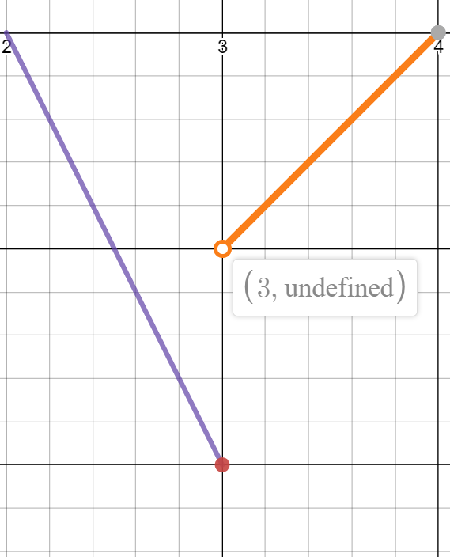
Fig. 5. $\left\{\begin{aligned}4-2x if 2 <x ≤3 (Purple) \\ x-4 if 3 <x <4 \left(Orange\right)\end{aligned}\right.$
we can say that the first two conditions were not met and the limit does not exist. The same can be said at 4.
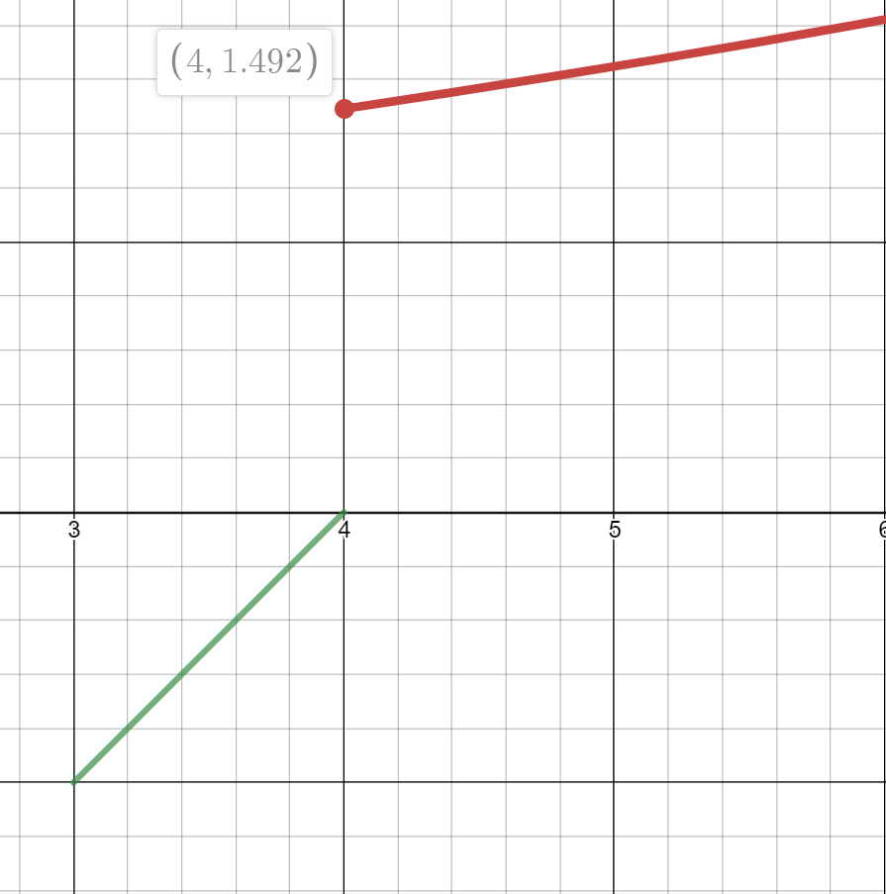.
Fig. 6. $\left\{\begin{aligned}x-4 if 3 <x <4 (Orange) \\ e^{\frac{x}{10}} if x≥4 (Red)\end{aligned}\right.$
Let’s continue solving continuity problems, for example: find k so that the following function is continuous:

$$f\left(x\right)=\left\{\begin{aligned}x^{2}+4x x≥1 \\ kx x<1\end{aligned}\right..$$
In this example, we’ve introduced an extra variable called k that we will solve for by plugging 1 into x and setting the functions equal to each other:
$$1^{2}+4\left(1\right)=k\left(1\right)$$
$$5=k.$$
We are essentially determining the coefficient that will make the second function equal to the first (continuous) after plugging in 1.
Next, we will solve a problem similar to the previous one but this time with multiple variables. Solve for c and d so that the following function is continuous:
$$f\left(x\right)=\left\{\begin{aligned}x^{2}+3x+c if x≤1 \\ {cx}^{3}+d if 1<x<2 \\ 3x+5 if x ≥2\end{aligned}\right.$$
We know that when an x value is seen in multiple places, plugging it into the corresponding functions and setting them equal will help to determine continuity. Therefore, we begin with 1:
$$1^{2}+3\left(1\right)+c=c{\left(1\right)}^{3}+d$$
$$4+c=c+d$$
$$d=4.$$
Now, we will do the same for 2:
$$c{\left(2\right)}^{3}+d=3\left(2\right)+5$$
$$8c+4=11$$
$$c=\frac{7}{8}.$$
So, the following piecewise function,

$$f\left(x\right)=\left\{\begin{aligned}x^{2}+3x+\frac{7}{8} if x≤1 \\ {\frac{7}{8}x}^{3}+4 if 1<x<2 \\ 3x+5 if x ≥2\end{aligned}\right.$$
is continuous over the entire interval.

Outro
Thank you for watching TutorTube! I hope you enjoyed this video. Please subscribe to our channel @UNTLC for more exciting videos. Check out the links in the description below for more information about The Learning Center and follow us on social media. See you next time!
References
Stewart, James. Calculus: Early Transcendentals, 7th Ed., Brooks/Cole Cengage Learning, 2010.

