TutorTube: Lewis Dot Structures Summer 2021
Introduction
Hello and welcome to TutorTube, where The Learning Center’s Lead Tutors help you understand challenging course concepts with easy-to-understand videos. My name is Rebecca Yohannes Lead Tutor for Biology and Chemistry. In today’s video, we will explore Lewis Dot Structures. Let’s get started!

Definitions
Let’s first understand what Lewis structures are. They are a simplified representations of elements’ valence shells using dots, lines and element symbols.
The dots represent the valence electrons. The numbers of the main groups in the Periodic Table are the same as the valence electrons of the elements in the respective group. This rule, however, does not apply to the Transition metals.
For example, fluorine which is in group 7A has 7 valence electrons, oxygen which is in main group 6 has 6 valence electrons, and so on.
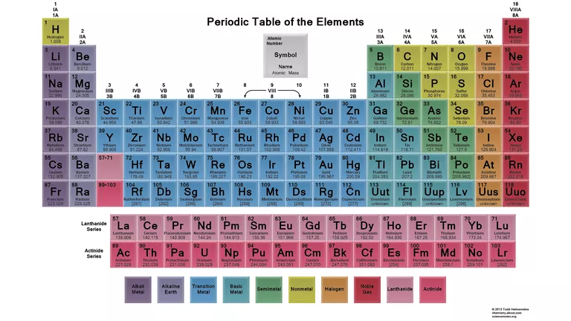
Figure 1: Periodic Table
Valence electrons aren’t just drawn anywhere. Imagining a square around an element’s symbol, there can only be a maximum of 2 dots on each side of the element’s symbol. Chlorine has 7 valence electrons and its Lewis structure is drawn this way:
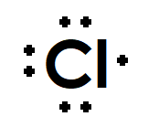
Figure 2: Lewis Structure of chlorine
When drawing the Lewis structures of compounds and molecules, bonds are illustrated by lines. Each line involves 2 electrons. Single bonds are depicted with one line, double bonds are 2 lines and triple bonds are 3 lines.
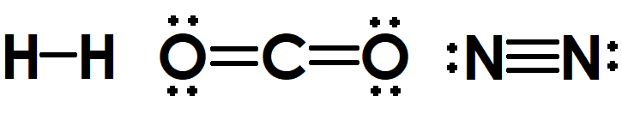
Figure 3: Lewis Structures of hydrogen molecule, carbon dioxide and nitrogen molecule

Octet Rule
The octet rule states that elements lose or gain electrons to have a total of 8 valence electrons and become stable.
Elements that tend to attract electrons to fulfill the octet rule have 4 or more valence electrons and these elements are typically found on the left side of the Periodic Table from group IVA to VIIA.
Elements on the second period of the Periodic Table lack d sublevels and only have s and p sublevels that comprise the octet or the 8 valence electrons. Thus, C, N, O, and F on the second period follow the Octet Rule without any exceptions (Lumen Learning, n.d.).
Let’s take a look at some examples:
C has 4 valence electrons, so must form 4 bonds to have 8 valence electrons to fulfill the Octet Rule.
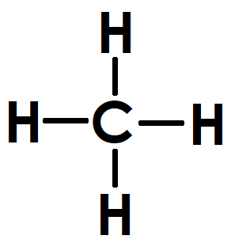
Figure 4: Lewis structure of methane
O has 6 valence electrons so must gain 2 more electrons to fulfill the Octet Rule. It does this by forming 2 covalent bonds.
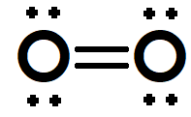
Figure 5: Lewis structure of molecular oxygen
F has 7 valence electrons and only needs one more electron to have 8 valence electrons. Thus, in a molecule or compound, it is likely to form only one bond.
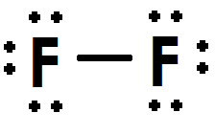
Figure 6: Lewis structure of fluorine molecule

Exceptions to the Octet Rule
Certain elements can have a stable electron configuration while having less than 8 valence electrons after forming bonds. These elements are said to have incomplete octets. Some common examples of elements with incomplete octets are H, Li, Be, B, and Al.
In a hydrogen molecule, each hydrogen has 2 valence electrons in its shell after sharing a bond with the other hydrogen.
Beryllium in beryllium fluoride has 4 valence electrons after bonding with two fluorine atoms.
Boron trichloride is stable with only 6 valence electrons on the boron.
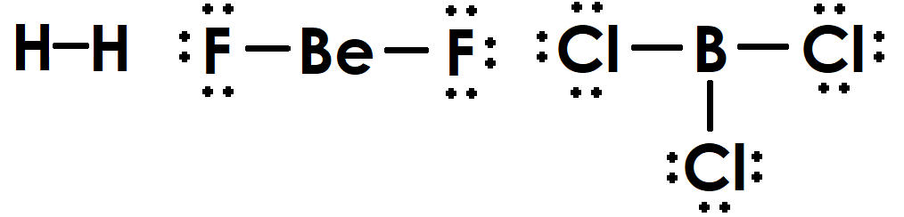
Figure 7: Lewis structures of molecular hydrogen, beryllium fluoride, and boron trichloride as examples of incomplete octets
Elements that can potentially to have more than 8 valence electrons after forming bonds are said to have expanded octets. For elements after Al, a d-sublevel exists that can accommodate more electrons. This allows elements, such as Si, P, S, and Cl to have expanded octets.
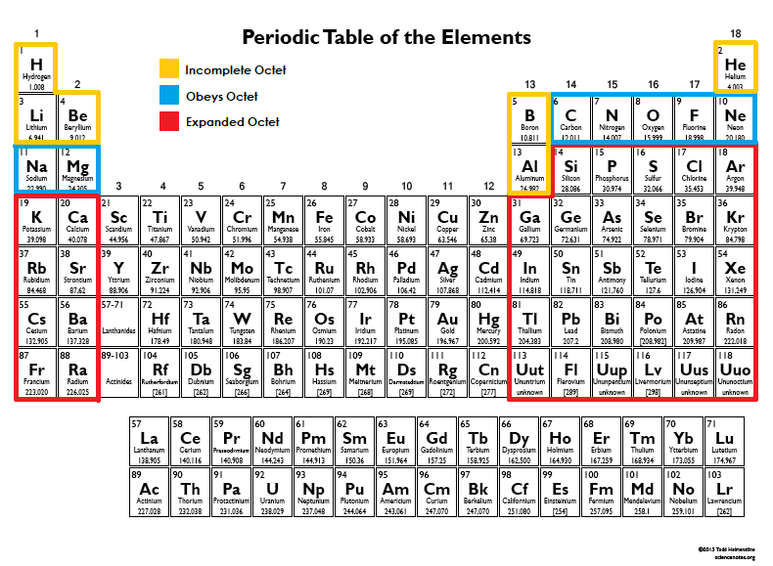
Figure 8: Elements that obey the Octet Rule and elements that can have an expanded octet on the Periodic Table
For example, phosphorus in phosphorus pentachloride has 10 valence electrons after forming single bonds with 5 chlorine atoms.
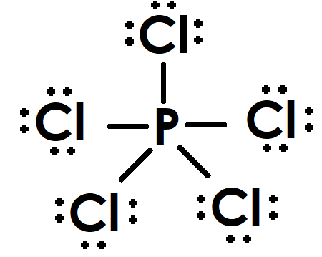
Figure 9: Lewis structure of phosphorus pentachloride

Drawing Lewis structures
Let’s go over the steps of drawing the Lewis structure of a fluorine molecule (F₂)
First, count all the valence electrons involved in the molecule. You can always refer to the main group number to find out what the valence electron of an element is. Since fluorine is found in the 7th group, it has 7 valence electrons. There are 2 fluorine atoms in this molecule, so there are a total of 14 valence electrons.
Next, draw the skeletal structure of the molecule. Don’t worry about the lone electrons just yet, simply draw single bonds between the atoms involved:
Figure 10: Skeletal formula of molecular F
Now, calculate how many valence electrons are left after drawing the bonds. Since a single bond contains 2 electrons and there is only one single bond in the skeletal structure, subtract 2 electrons from 14 which tells us that 12 valence electrons are left. Draw these electrons around each fluorine atom as lone electrons or dots. This will be the resulting structure:
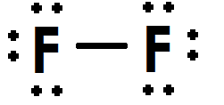
Figure 11: Lewis structure of molecular fluorine
You can now check if both atoms in this diatomic molecule have fulfilled the octet rule. Since both fluorine atoms have 8 electrons around them, this is the correct Lewis structure for molecular fluorine.
Let’s work on the next example, phosphorus trichloride (PCl₃).
First, count all the valence electrons involved in this compound. Phosphorus has 5 valence electrons and chlorine has 7 valence electrons. Since there is only one phosphorus atom and three chlorine atoms in this compound, there will be a total of 24 valence electrons in this compound.
PCl₃: 5 + (3$×$7) = 24 valence electrons
Let’s now determine which element is the central element and which are the terminal atoms. Generally, the least electronegative element is the central atom, except hydrogen which cannot be the central atom because hydrogen can’t form more than one bond. In phosphorus trichloride, phosphorus is the least electronegative element; therefore it is the central atom and the chlorine atoms are the terminal atoms. We can now draw the skeletal structure:
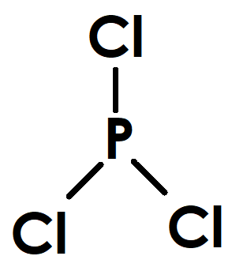
Figure 12: Skeletal structure of phosphorus trichloride
You can try to predict how many bonds each element must form to fulfill the octet rule at this point. Since chlorine has 7 valence electrons, it only needs to form one bond to have a total of 8 valence electrons. Phosphorus has 5 valence electrons, thus is likely to form 3 bonds to have a total of 8 valence electrons around it.
Since 3 bonds take up 6 electrons, then we need to subtract that from the total valence electrons: 24 – 6 = 18 valence electrons remaining
Place the remaining electrons around the terminal atoms first. Then if there are valence electrons left, add them on to the central atom. Since there would still be 2 electrons left after filling the chlorine atoms’ valence shells with lone pairs, draw those 2 electrons on the central atom phosphorus:
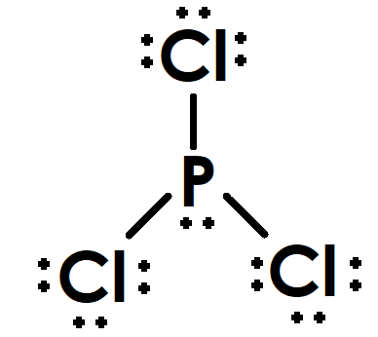
Figure 13: Lewis structure of phosphorus trichloride
Finally, count the electrons around each atom to make sure that all the elements fulfill the Octet Rule. Since each element has 8 valence electrons now, this is the correct Lewis structure for phosphorus trichloride.
Another example we can work on is Nitrosyl chloride, NOCl
First, calculate the total number of valence electrons present in the compound; nitrogen has five valence electrons, oxygen has 6 and chlorine has 7 valence electrons, which gives a total of 18 valence electrons in this compound.
NOCl = 5 + 6 + 7 = 18 valence electrons
Next, identify which element goes in the middle and which are terminal. Since nitrogen is the least electronegative element in this compound compared to oxygen and chlorine, it is the central atom and oxygen and chlorine are the terminal atoms bonded to nitrogen. Now, we can draw the skeletal structure:
Figure 14: Skeletal formula of nitrosyl chloride
We can try to predict the number of bonds each element is likely to form as practice. Chlorine is only going to form one bond since it has 7 valence electrons, nitrogen will probably need to form 3 bonds to fulfill the Octet Rule since it only has 5 valence electrons, and oxygen needs to form 2 bonds since it has 6 valence electrons. So, we can expect to see multiple bonds in this compound, specifically between nitrogen and oxygen. Before we draw multiple bonds, however, let’s first place the remaining valence electrons as lone electrons around this skeletal structure. Remember to first draw the lone electrons on the terminal atoms then move on to the central atom if there are still more electrons left.
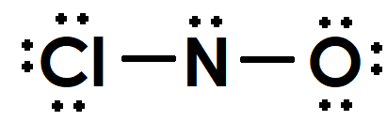
Figure 15: Incorrect Lewis structure of nitrosyl chloride
Check if all the elements fulfill the octet rule. Nitrogen only has 6 valence electrons around it, so it doesn’t satisfy the Octet Rule. This is when we can try to use multiple bonds to ensure that nitrogen has 8 valence electrons. Based on our initial prediction, nitrogen needs 3 bonds and oxygen typically forms 2 bonds to have a total of 8 valence electrons around each of them. Since chlorine already meets our expectation, we can leave it as it is. So, let’s use one of oxygen’s lone pair to form a second bond between N and O. Remember that we can’t simply add an extra pair of electrons into the compound out of nowhere because we already calculated that this compound only has a total of 18 valence electrons. That’s why we have to remove a lone pair from O in order to have a second bond between N and O.
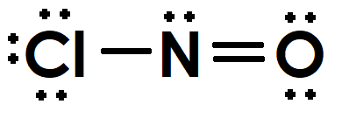
Figure 16: Lewis structure of nitrosyl chloride
Now, all of the elements have 8 valence electrons around them, so this is the final Lewis dot structure of NOCl.

Summarized Steps of Drawing Lewis Dot Structures
- Add up all the valence electrons of the elements in the compound
- Determine the central element and terminal atoms according to their electronegativities
  - Remember that least electronegative element is the central atom
  - Hydrogen can never be the central element since it can’t form more than one bond
- Draw skeletal structure:
  - At this point, try to predict which atoms form bonds and if single or multiple bonds are needed to fulfill the Octet Rule, but don’t draw the multiple bonds just yet. Only draw the single bonds for now
  - Notice if there are elements that can have incomplete or expanded octets
- Compute and place the remaining valence electrons around the elements as lone pairs of electrons
  - Remember to place the lone electrons on the terminal atoms first, then on the central atom if there are still more electrons remaining
- If there are elements that are not fulfilling the Octet Rule, draw multiple bonds
  - Think back to the predictions made earlier when drawing the skeletal structure of the compound (in step 3)

Formal Charges
Sometimes, you may find multiple possible ways to draw the Lewis structure of a compound. In these cases, you must calculate the formal charge to determine the preferred Lewis structure.
FC of an element = valence electron of the element – number of bonds it formed – lone electrons of that element

Choosing among multiple Lewis Structures
- Lewis structures with more zero formal charges are generally preferred.
- Negative formal charges should be on the more electronegative atom and positive formal charges should be on the less electronegative atom.
- Lewis structures with formal charges closest to zero are more stable, thus preferred.
- The further away atoms with opposite formal charges are, the more stable the Lewis structure is.
Let’s look at sulfite ion(SO₃²⁻) as an example. There is one sulfur atom in this ion contributing six valence electrons, three oxygen atoms give us a total of 18 valence electrons, and there are two extra electrons in this ion represented by the negative two charge on the compound, therefore there will be a total of 26 valence electrons in this ion.
SO₃²⁻= 6 + (3$×$6)+ 2 = 26 total valence electrons.
Sulfur is the less electronegative elment, so it is the central atom. The skeletal structure of the compound looks like this:
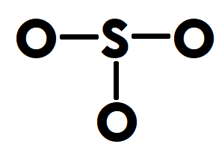
Figure 17: Skeletal formula of sulfite
Let’s predict if there would be multiple bonds in this compound. Oxygen has 6 valence electrons and needs to form 2 bonds to fulfill the octet rule, so we might see some multiple bonds here. Sulfur also has 6 valence electrons and remember that sulfur is one of the elements that can have an expanded octet, so it can form more than 2 bonds and carry more than 8 valence electrons on it.
Now, let’s calculate the remaining valence electrons.
26 – (2$×$3) = 20 valence electrons left.
When we draw the 20 valence electrons on the compound, this is what it looks like:
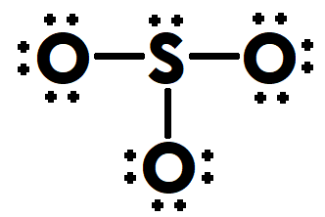
Figure 18: Possible Lewis structure of sulfite
This structure is one possible Lewis structure of sulfite ion because all the elements have satisfied the Octet Rule. However, remember we predicted that oxygen usually likes to form 2 bonds and sulfur can have an expanded octet, so let’s take a one lone pair from one of the oxygen atoms and use it to make a second bond with sulfur.
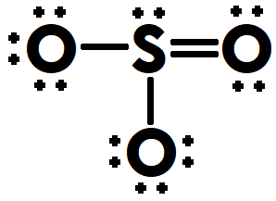
Figure 19: Second possible Lewis structure of sulfite
This is another way to draw the Lewis structure of sulfite.
Let’s calculate the formal charge for each structure to determine the preferred one.
Figure 20: First possible Lewis structure of sulfite
The formal charge of sulfur on the first Lewis structure(figure 20) that we drew is calculated by subtracting its 6 valence electrons with the number of bonds its forming(3) and the lone electrons(2) on it. This results in a positive one charge on sulfur.
FC₁ of S = 6 – 3 – 2 = +1
FC₁ of O = 6 – 1 – 6 = -1, since all three oxygen atoms have the same number of bonds and lone electrons, the formal charge is the same for all 3 of them.
This structure results in multiple formal charges on the atoms. The overall FC is (+1) + (-1) + (-1) + (-1) = -2, which corresponds with the ion charge of the compound (SO₃⁻²)
Let’s do the same thing for the second structure (Figure 21)
Figure 21: Second possible structure of sulfite
FC₂ of S = 6 – 4 – 2 = 0
FC₂ of O = 6 – 1 – 6 = -1, for the 2 oxygen atoms that are forming single bonds with S
FC₂ of O = 6 – 2 – 4 = 0, for the oxygen atom that is forming a double bond with S
The overall FC of this structure is also -2 which makes sense because it is the same as the ion charge of the compound (SO₃⁻²).
Comparing the formal charges on this structure to the first (Figure 20) structure, this second structure (Figure 21) has a greater number of atoms/elements that have a zero formal charge which makes it the preferred Lewis dot structure.

Outro
Thank you for watching TutorTube! I hope you enjoyed this video. Please subscribe to our channel for more exciting videos. Check out the links in the description below for more information about The Learning Center and follow us on social media. See you next time!

References
Figure 1: Helmenstine, A. M., Ph.D. (2020, August 25). What Is the Importance of Color on the Periodic Table? Retrieved from https://www.thoughtco.com/color-on-the-periodic-table-608827
Figure 8: Helmenstine, T. (2015). Printable Color Periodic Table Chart. Retrieved from https://sciencenotes.org/printable-color-periodic-table-chart-2015/
The Expanded Octet. Retrieved from https://courses.lumenlearning.com/introchem/chapter/the-expanded-octet/

