TutorTube: Cross Product of Vectors Spring 2021
Hello, welcome to another edition of TutorTube, where The Learning Center’s Lead Tutors help you understand challenging course concepts with easy to understand videos. My name is Amit, Lead Tutor for Biomedical Engineering and Mathematics courses. Today we will explore cross product of vectors.
Defining Vector and Its Cross Products
A vector is defined as a physical quantity with both magnitude and direction. We can take force as an example of vector. When we talk about force, we want to know its magnitude and the direction it is being applied to. Now, let us talk about cross product.
Cross Product: Cross product of two vectors is the vector multiplication that results in a vector quantity with direction perpendicular to both the vectors and magnitude equal to the area of the parallelogram form by two vectors. We can see the following diagrams to make this concept clear:
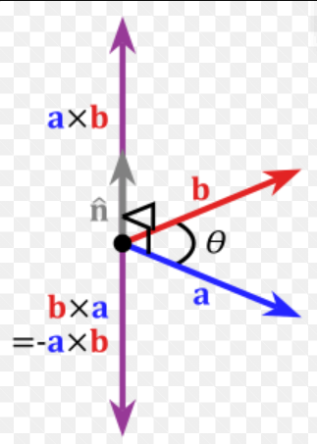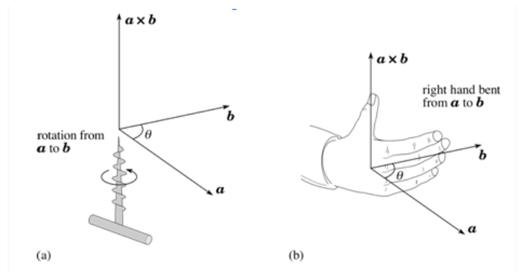
Fig 1: Cross product a and b Fig 2: Screw and Right-Hand Thumb Rule

Figure 1 tells us that cross of product of vectors a and b is perpendicular to both vectors and a cross b is not equal to b cross a as their directions are opposite.
Figure 2 gives us the way to find the direction of cross product. Fig 2a represents the direction of cross product of vectors with screw going up and down depending upon the rotation. Figure 2b demonstrates the right-hand thumb rule where we curl up the fingers of right hand around a line from one vector to another where thumb gives a direction of cross product that is perpendicular to the plane of the vectors a and b.

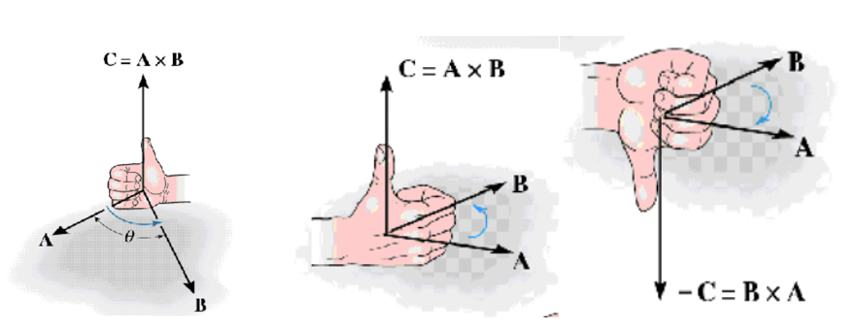
Fig 3: Right hand thumb rule (http://web.aeromech.usyd.edu.au/statics/doc/math3.htm)

Figure 3 makes this concept even clear by showing that thumb would point in the direction of the resultant of cross product of two vector A and B. We can see that when we change the direction of the curl of fingers, the direction of the thumb changes which is the direction of the cross product represented by C.

Finding Cross Products
Now, we know the definition of the cross product and we also learned how we can find the direction of it. Let’s see some mathematical interpretation on how we can find the cross of product of two given vectors.
$\vec{A}$ = $A_{1}ⅈ+A_{2}j+A_{3}k$
$\vec{ B}$ = $B_{1}ⅈ+B_{2}j+B_{3}k$
Here i, j, and k are nothing but just unit vectors along X, Y, and Z-axis respectively. And the letters a1, b1, c1, and a2, b2, c2 represent the magnitude of vectors along those unit vectors I, j, and k.
You may also see above two vectors being represented as follows in some of your mathematics courses:
$\vec{A}$ = <A₁, A₂, A₃>
$\vec{B}$ = <B₁, B₂, B₃>

As we are done setting up the vectors, it’s time to find the cross product and we use following way to do that:
First, set up two vectors like you’re finding determinant of a matrix, if you don’t know what determinant is, that’s fine for now. You just need to set up the two vectors as shown here:

A x B = $\left|\begin{matrix}ⅈ & j & k \\ A_{1} & A_{2} & A_{3} \\ B_{1} & B_{2} & B_{3}\end{matrix}\right|$ = $+ⅈ\left|\begin{matrix}A_{2} & A_{3} \\ B_{2} & B_{3}\end{matrix}\right|-j\left|\begin{matrix}A_{1} & A_{3} \\ B_{1} & B_{3}\end{matrix}\right|+k\left|\begin{matrix}A_{1} & A_{2} \\ B_{1} & B_{2}\end{matrix}\right|$
= (A₂B₃ – B₂A₃)i – (A₂B₃ – B₂A₃)j + (A₂B₃ – B₂A₃)k

And, that’s your final cross product. As we have i, j, k in our final answer we know that cross product gives vector quantity.
Also, the magnitude of Above cross product will be:
|A x B|= $\sqrt{{\left(A_{2}B_{3}-B_{2}A_{3}\right)}^{2}+{\left(A_{1}B_{3}-B_{1}A_{3}\right)}^{2}+{\left(A_{1}B_{2}-B_{1}A_{2}\right)}^{2}}$
To find the angle between the two vectors A and B using cross product you can use:
|A x B|= |A||B|sin(θ) $\hat{n}$

Now, let’s practice some examples to familiarize ourselves with cross product:
- A = 2i + 1j – 1k
B = -3i + 4j + 1k

First, we will have our set up our vectors as follow:

+  i | -  j | +  k
2 | 1 | -1
-3 | 4 | 1

A x B =

= +i{(1)(1) – (4)(-1)} -j{(2)(1) – (-3)(-1)} +k{(2)(4) – (-3)(1)}
= i(1+4) -j(2-3) +k(8+3)
= 5i + j + 11k

|A x B| = √(5²+1²+11²) = 12.12
|A| = √(2²+1²+(-1)²) = 2.45
|B| = √((-3)²+4²+1²) = 5.10

We can now find angle between A and B as follows:
|A x B|= |A||B|sin(θ)
or, 12.12 = (2.45)(5.10) sin(θ)
or, θ = sin⁻¹((12.12)/(2*5.10))
Therefore, θ = 75.9 degree is the required angle between A and B vectors.

Let’s practice some more problems:
Find the cross product of the following vectors A and B:
1. A= 3i + 2j – 6k, B = -2i + 3j + 5k
2. A= -2i + 3j – 1k, B = -1i + 4j + 2k
3. A= 4i + 3j – 5k, B = -7i + 3j + 2k
4. A= 2i + 1j +1k, B = 2i + 1j + 1k
5. A=<2,3,-2>, B = <1,3,-2>
6. A = <2,1,2>, B = <1,2,1>

Outro

Thank you for watching TutorTube! I hope you enjoyed this video. Please subscribe to our channel for more exciting videos. Check out the links in the description below for more information about The Learning Center and follow us on social media. See you next time!

References
Cross Product, Simin Nasseri and the School of AMME, web.aeromech.usyd.edu.au/statics/doc/math3.htm.
Cross Product, www.mathsisfun.com/algebra/vectors-cross-product.html.

